**T.A.P.I. 1.0 – User Manual**



**April 12, 2022**



# **Permanent Communications**

# User Manual

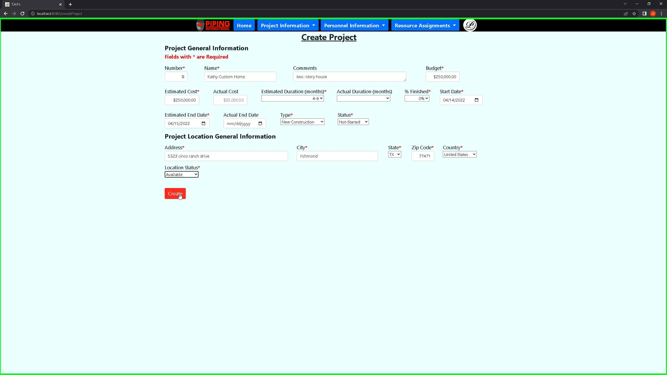

***Screenshot 1: Create Project Intake Form fill out required fields***

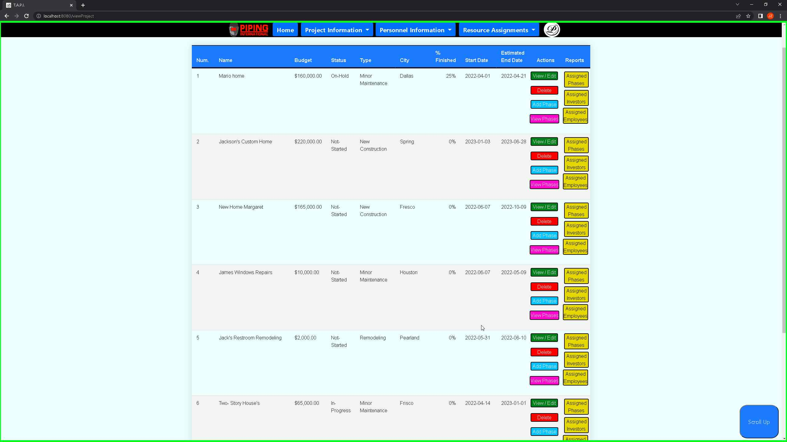 ***Screenshot 2: View Project page to see all projects and their respective columns that are unique to a project number.***

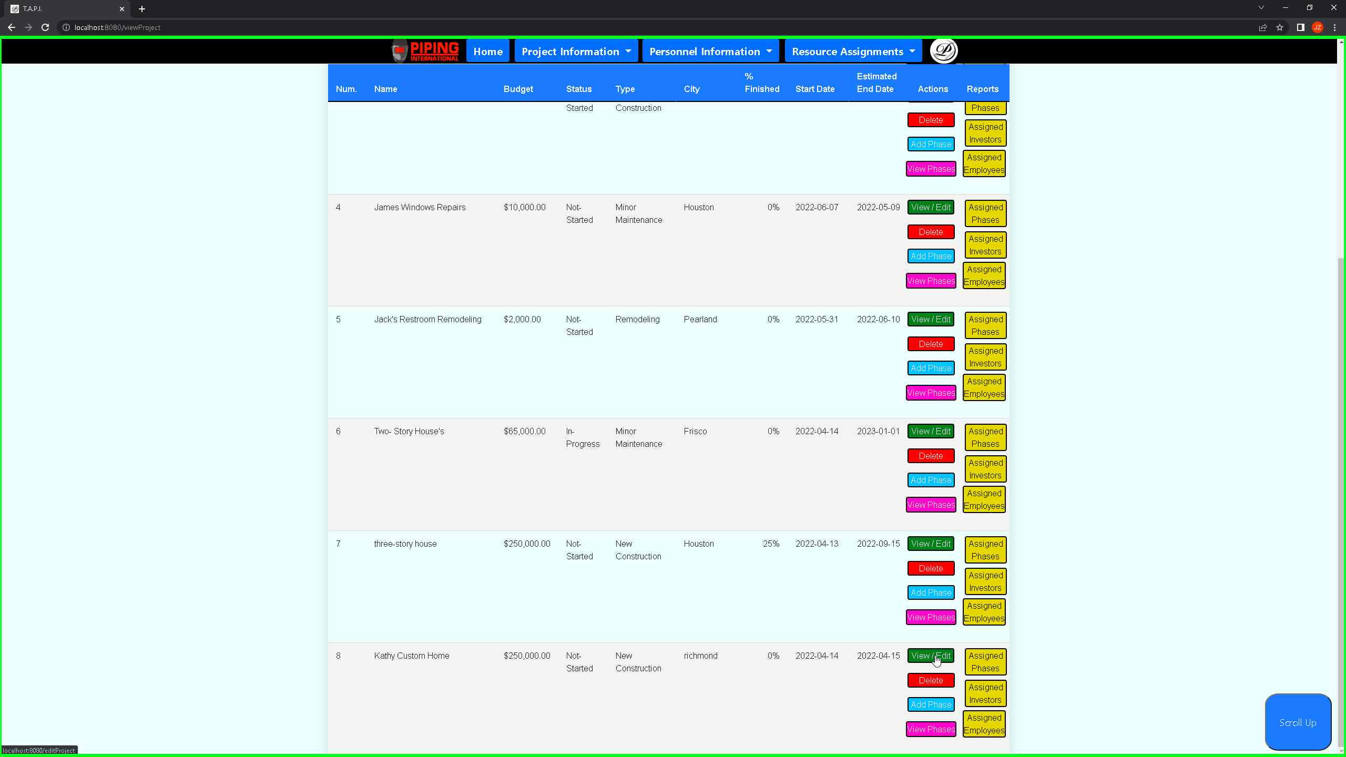 ***Screenshot 3: Sticky table columns as you scroll down can view the projects and scroll up button to take you to the top.***

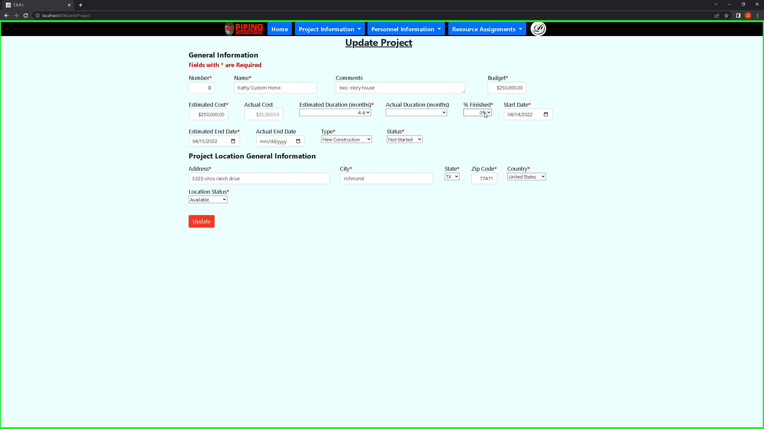 ***Screenshot 4: View Table of the project allows the user to update the current selected project.***

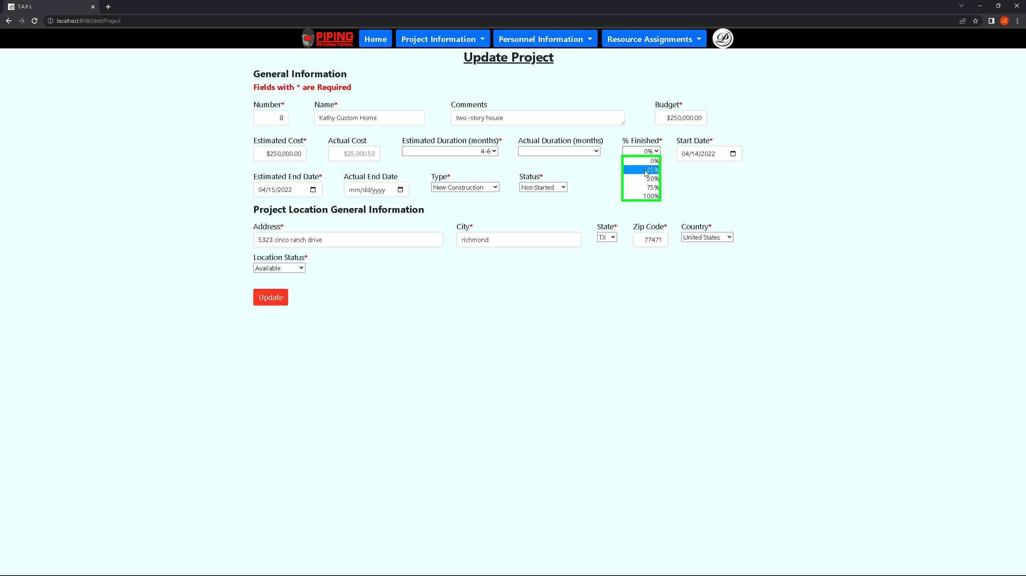 ***Screenshot 5: Showcasing the updated project showing that indeed you can update a field for project 8.***

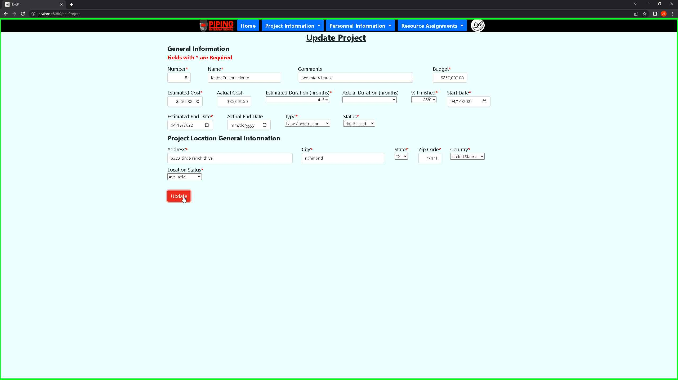 ***Screenshot 6: Clicking on update will update project 8 then take the user to the view project page.***

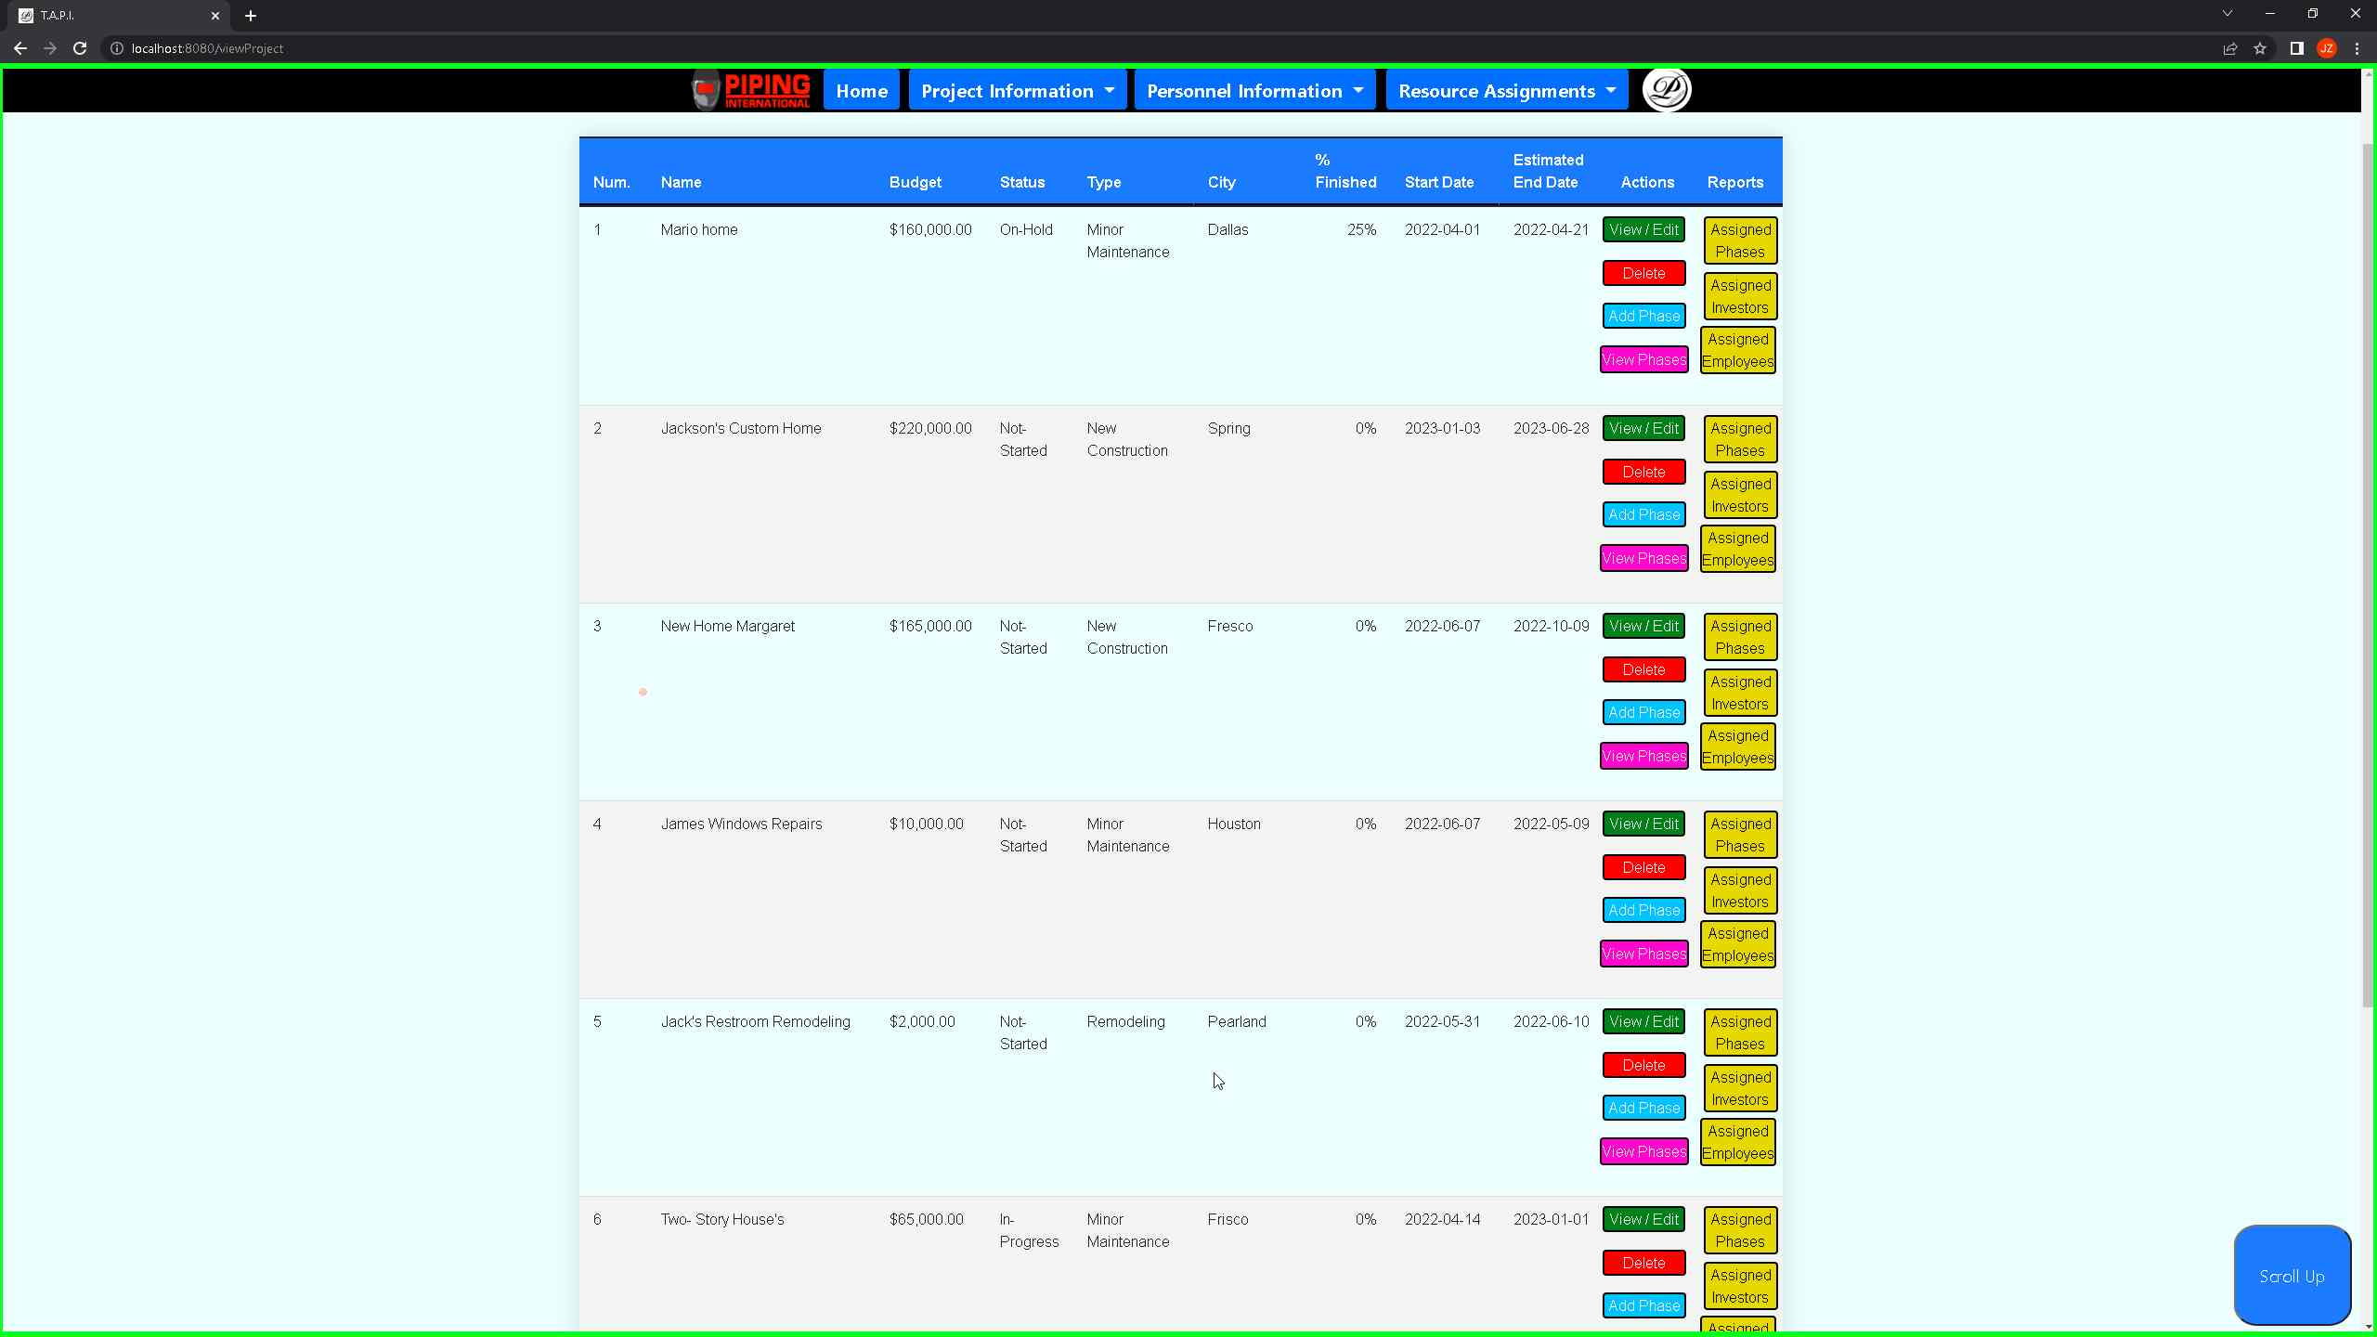 ***Screenshot 7: Back to the project view showcasing that indeed an update was made on project 8.***

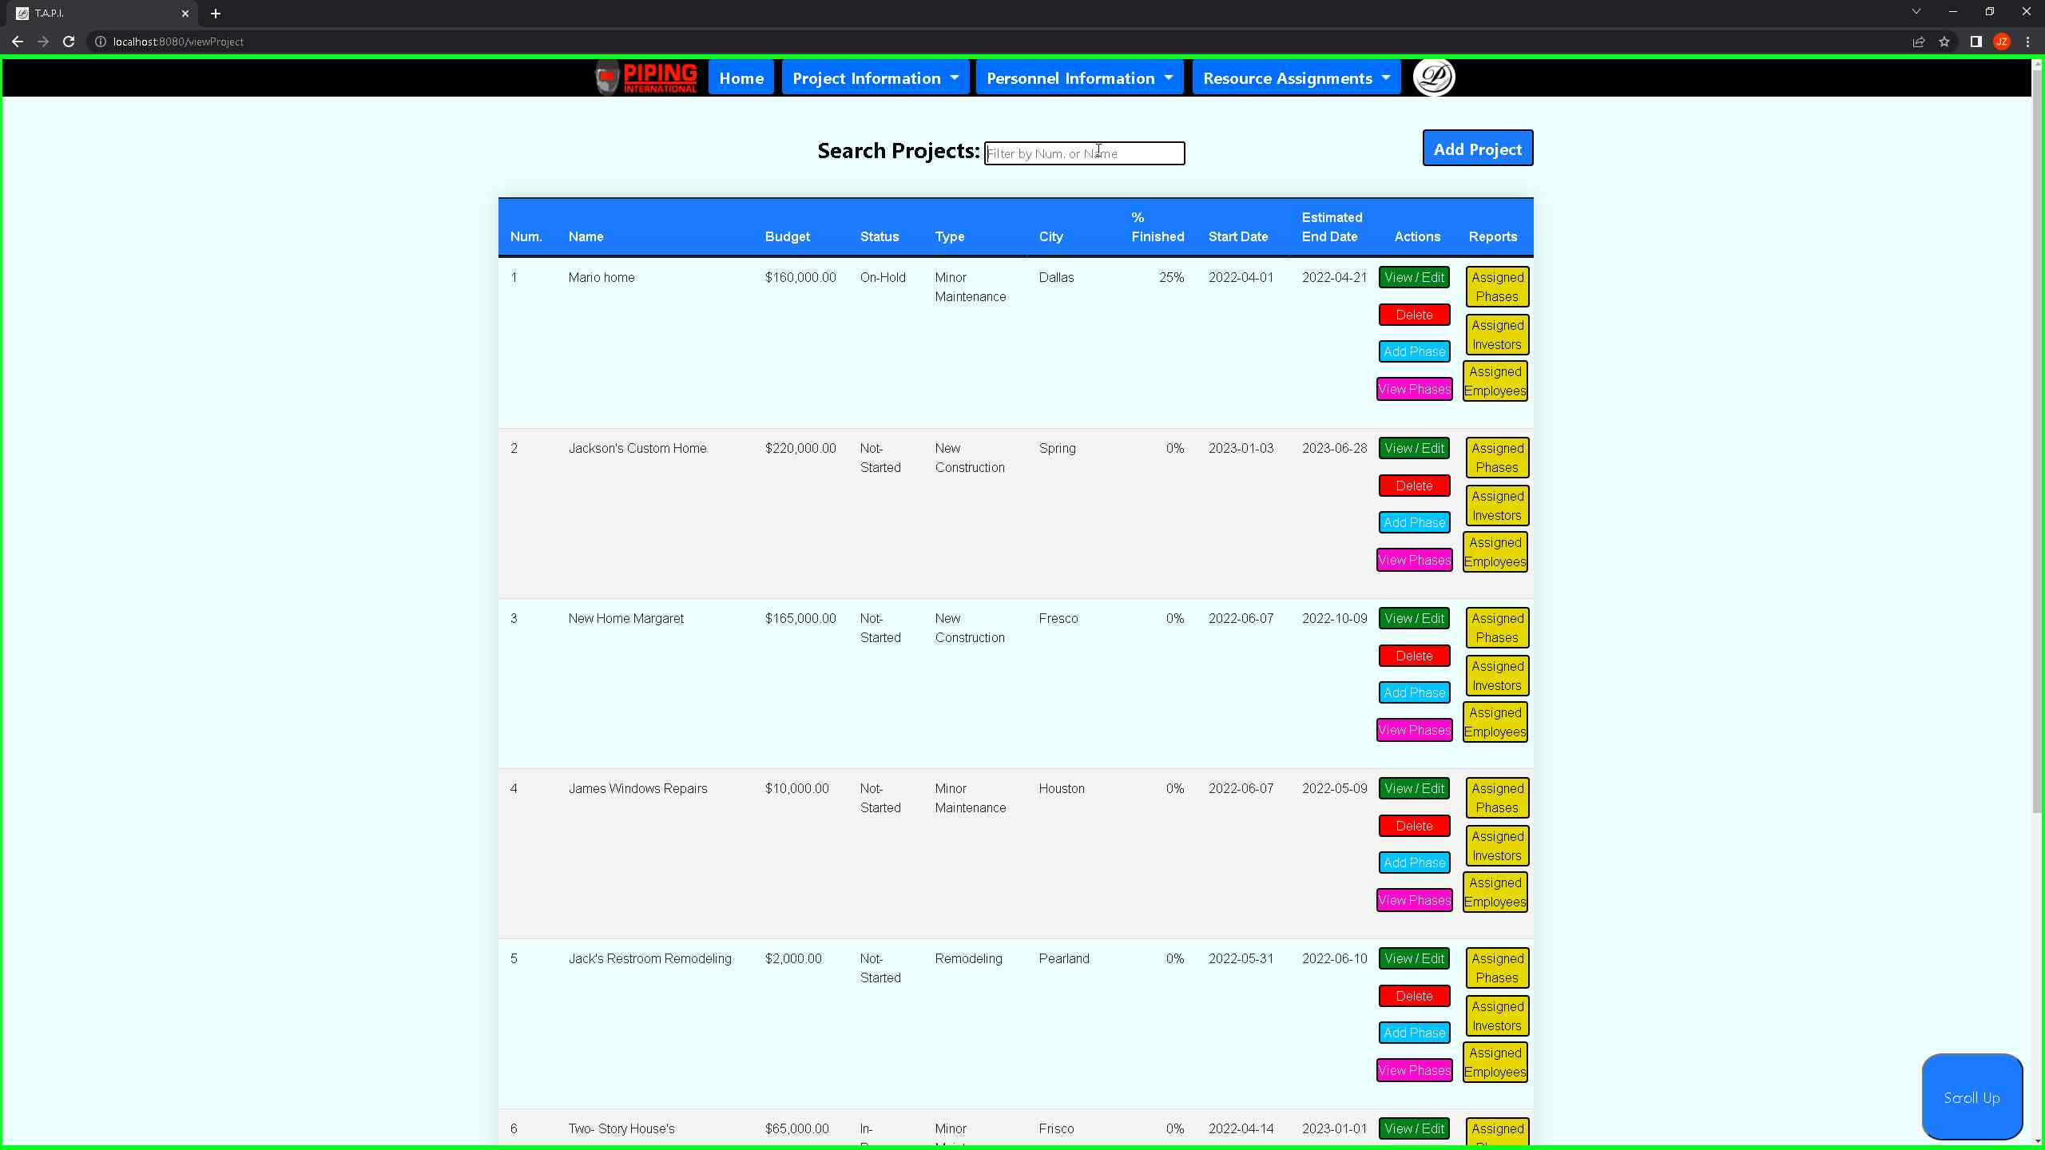 ***Screenshot 8: Showcasing that the filter for the project works as user can search by num and first name, and last name.***

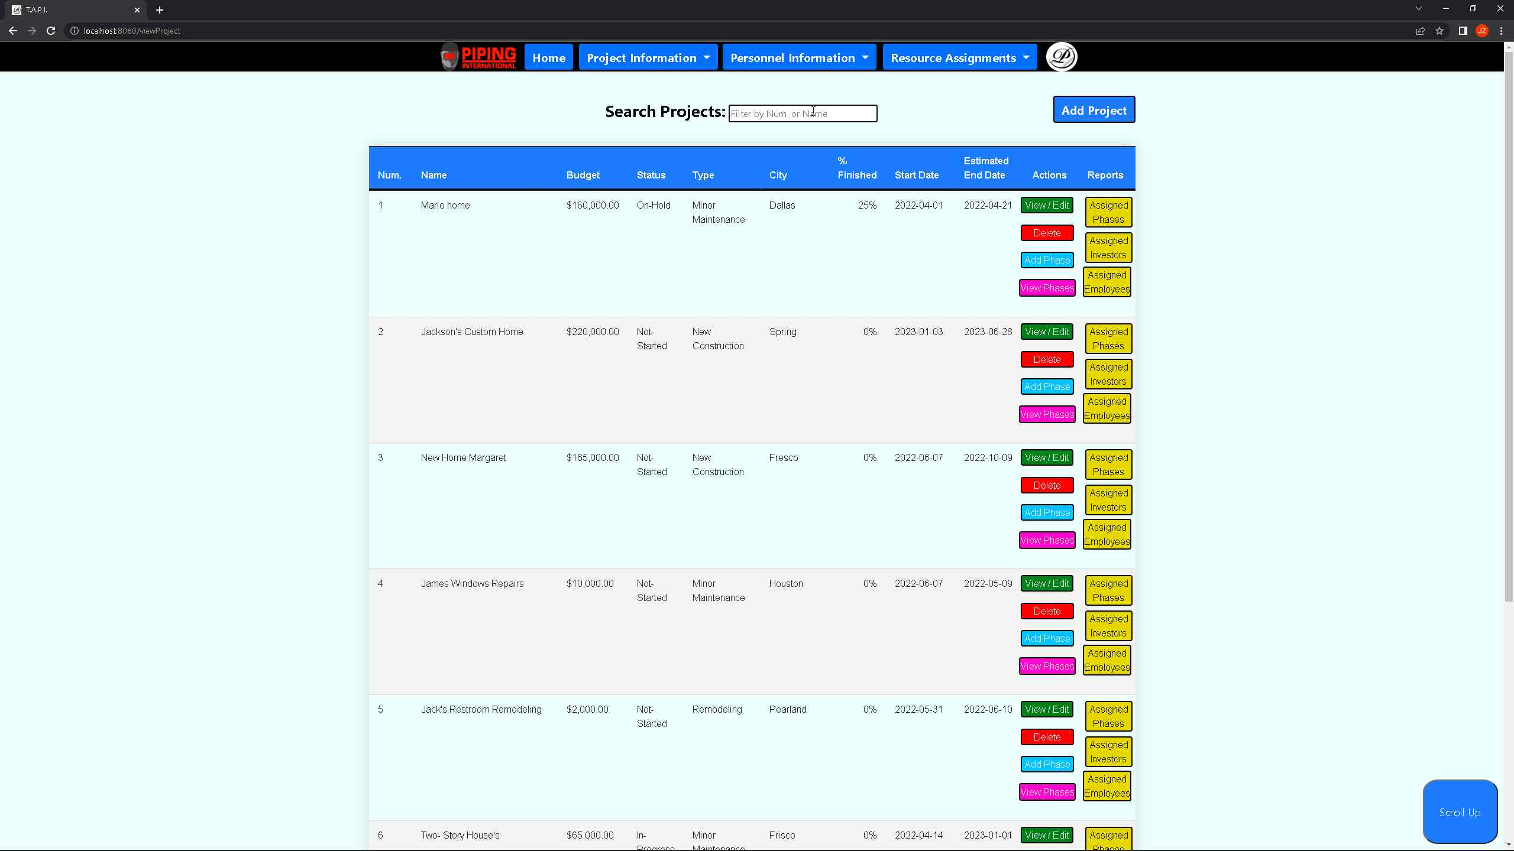 ***Screenshot 9: Showcasing that the filter for the project works as user can search by project number, first name, and last name.***

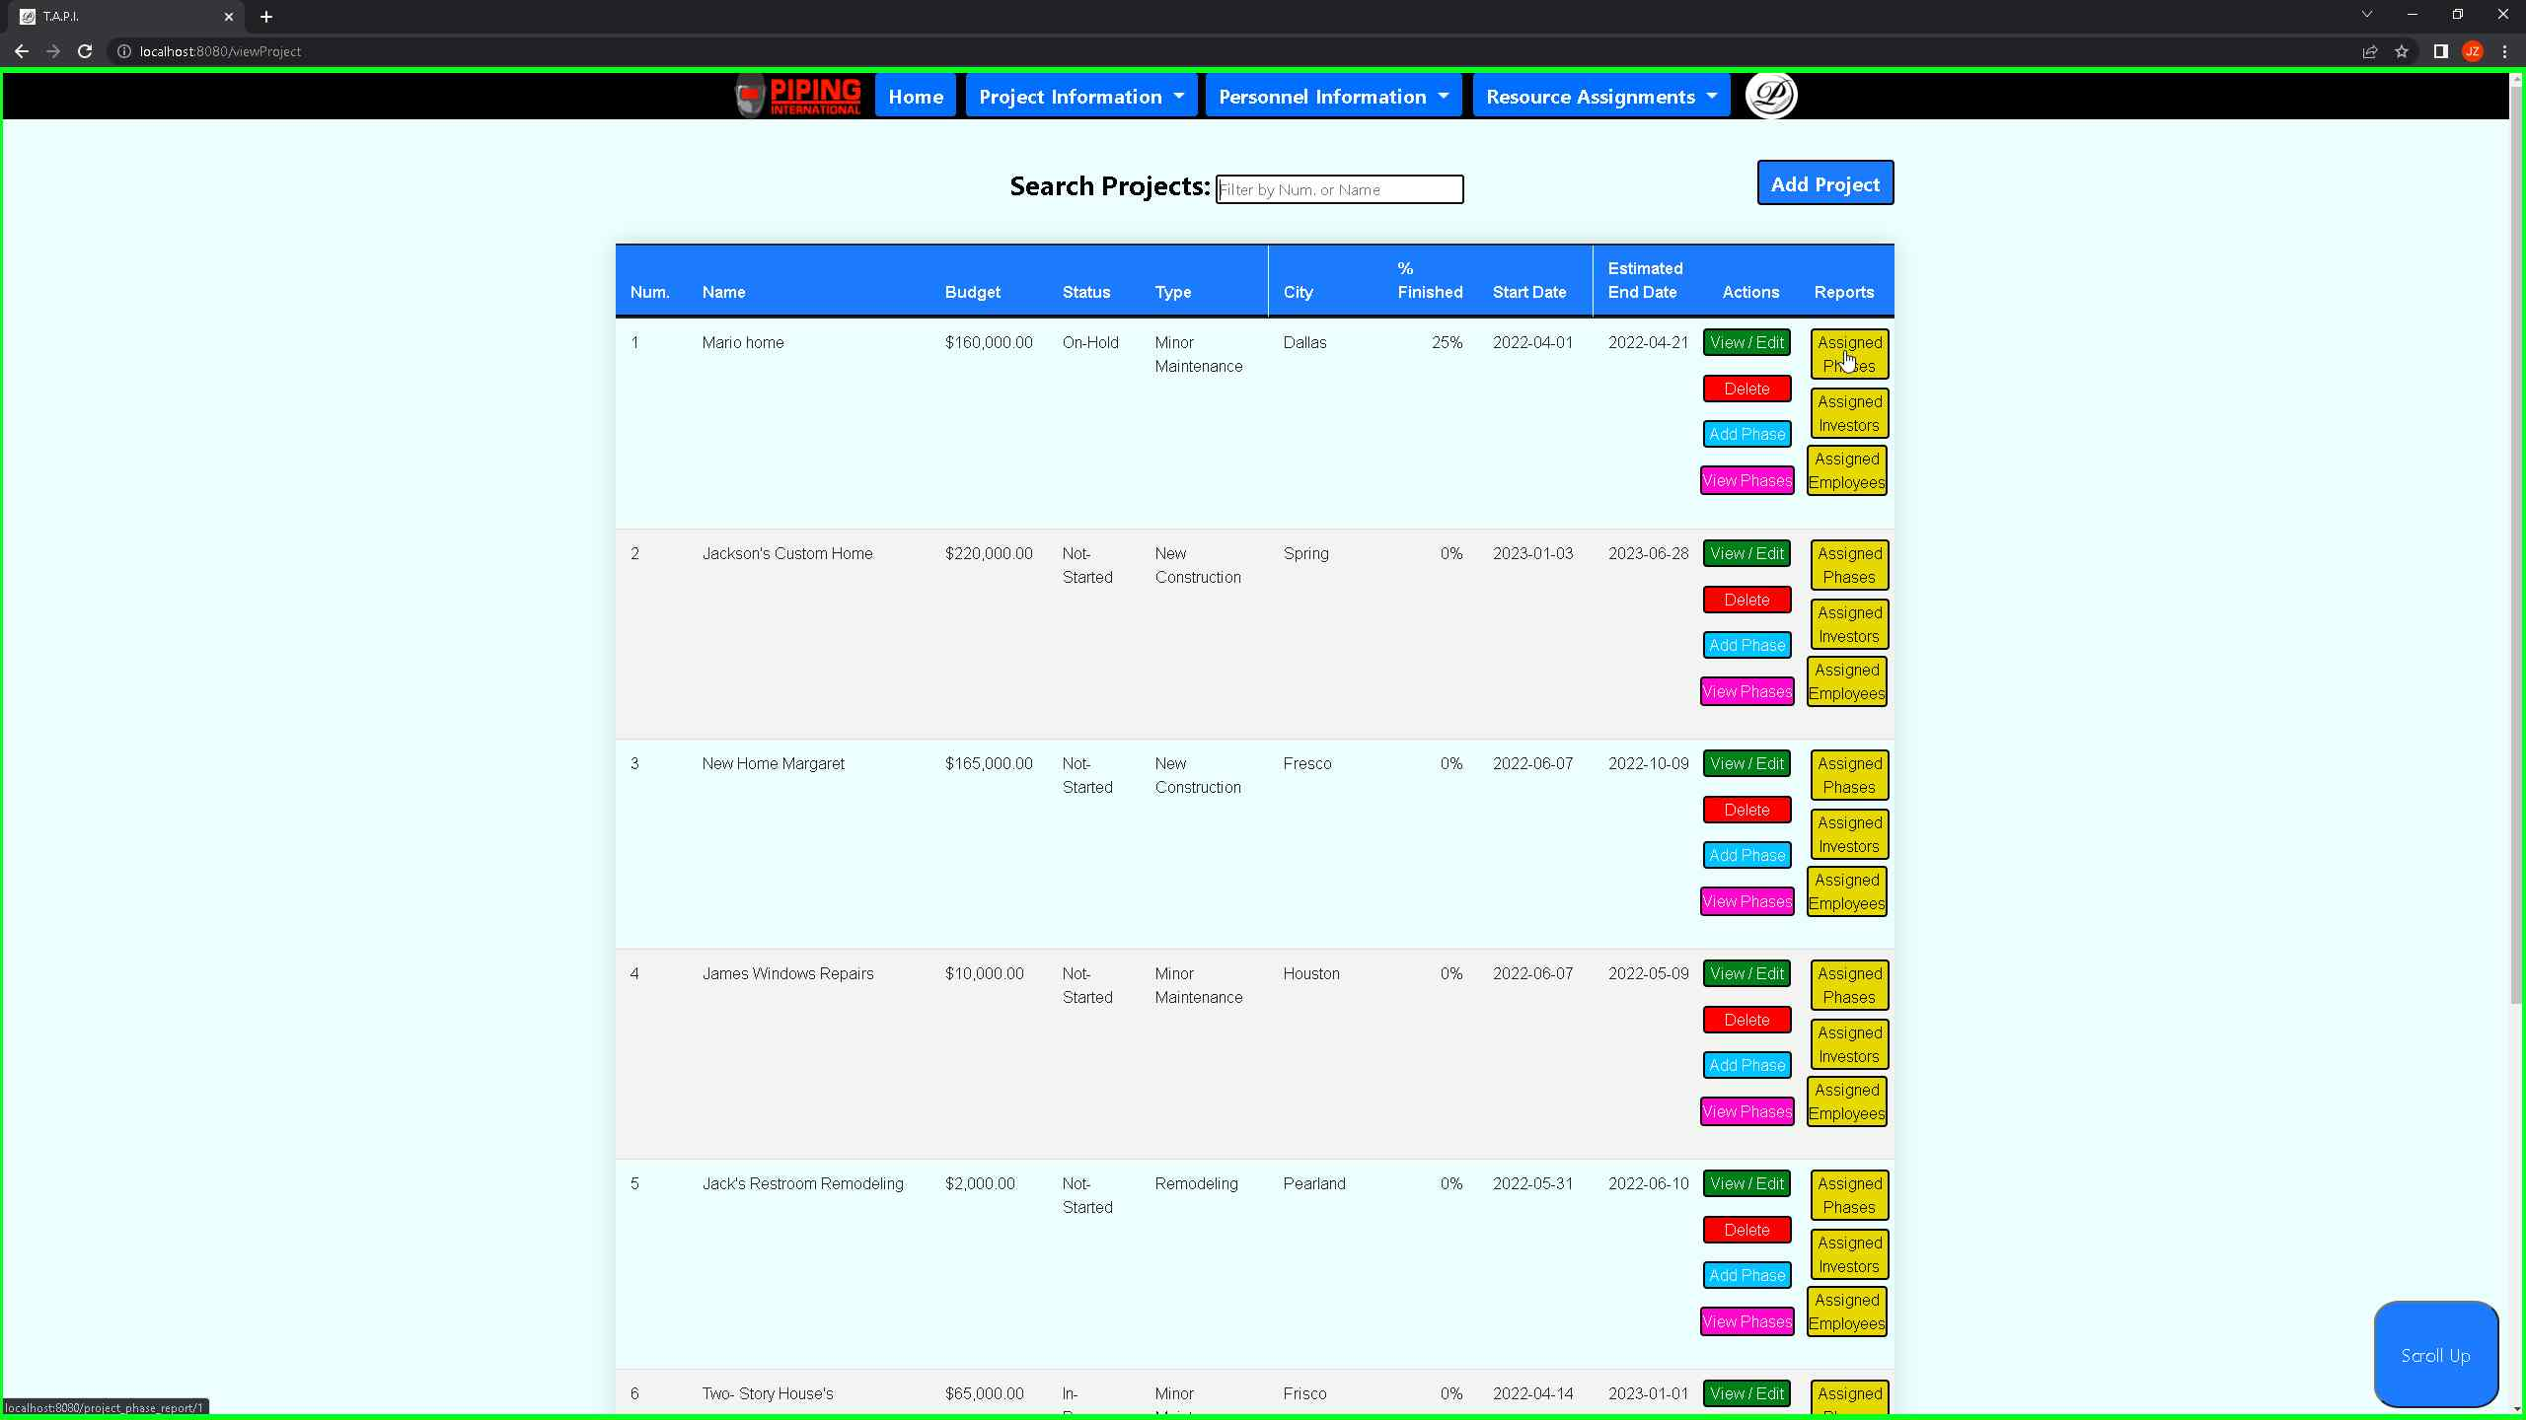 ***Screenshot 10: Showcasing that upon clicking on the assigned phases all phases associated for project number 1 will populate.***

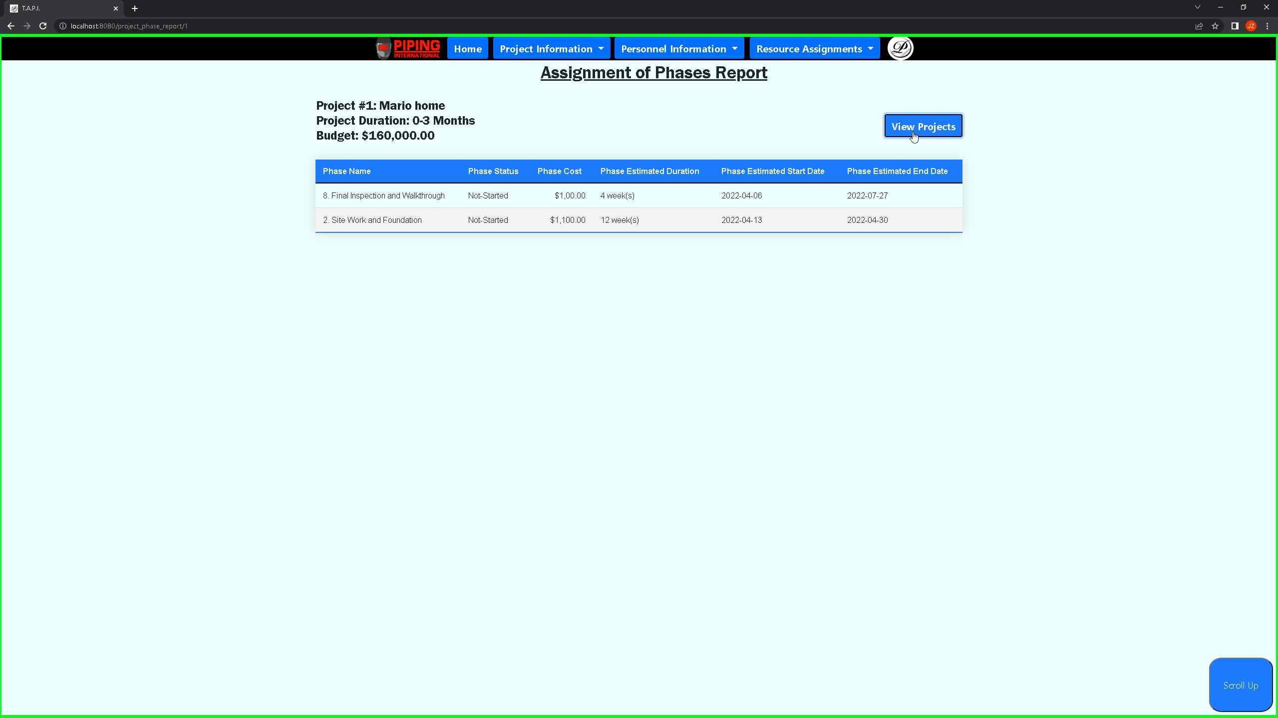 ***Screenshot 11: Showcasing the assigned phases for project number 1.***

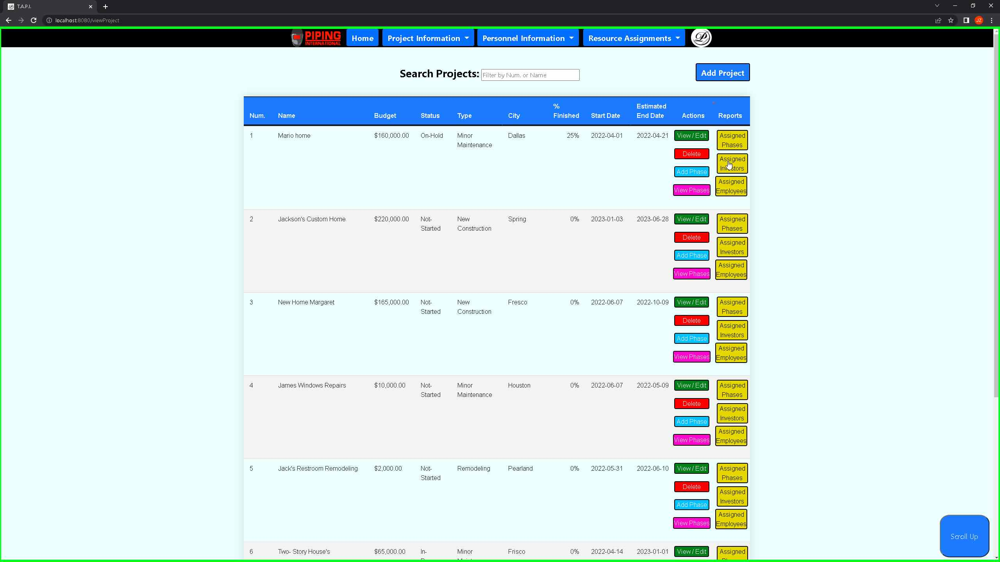 ***Screenshot 12: Showcasing that when clicking on the assigned investors it will show case all the assigned investors for project number 1.***

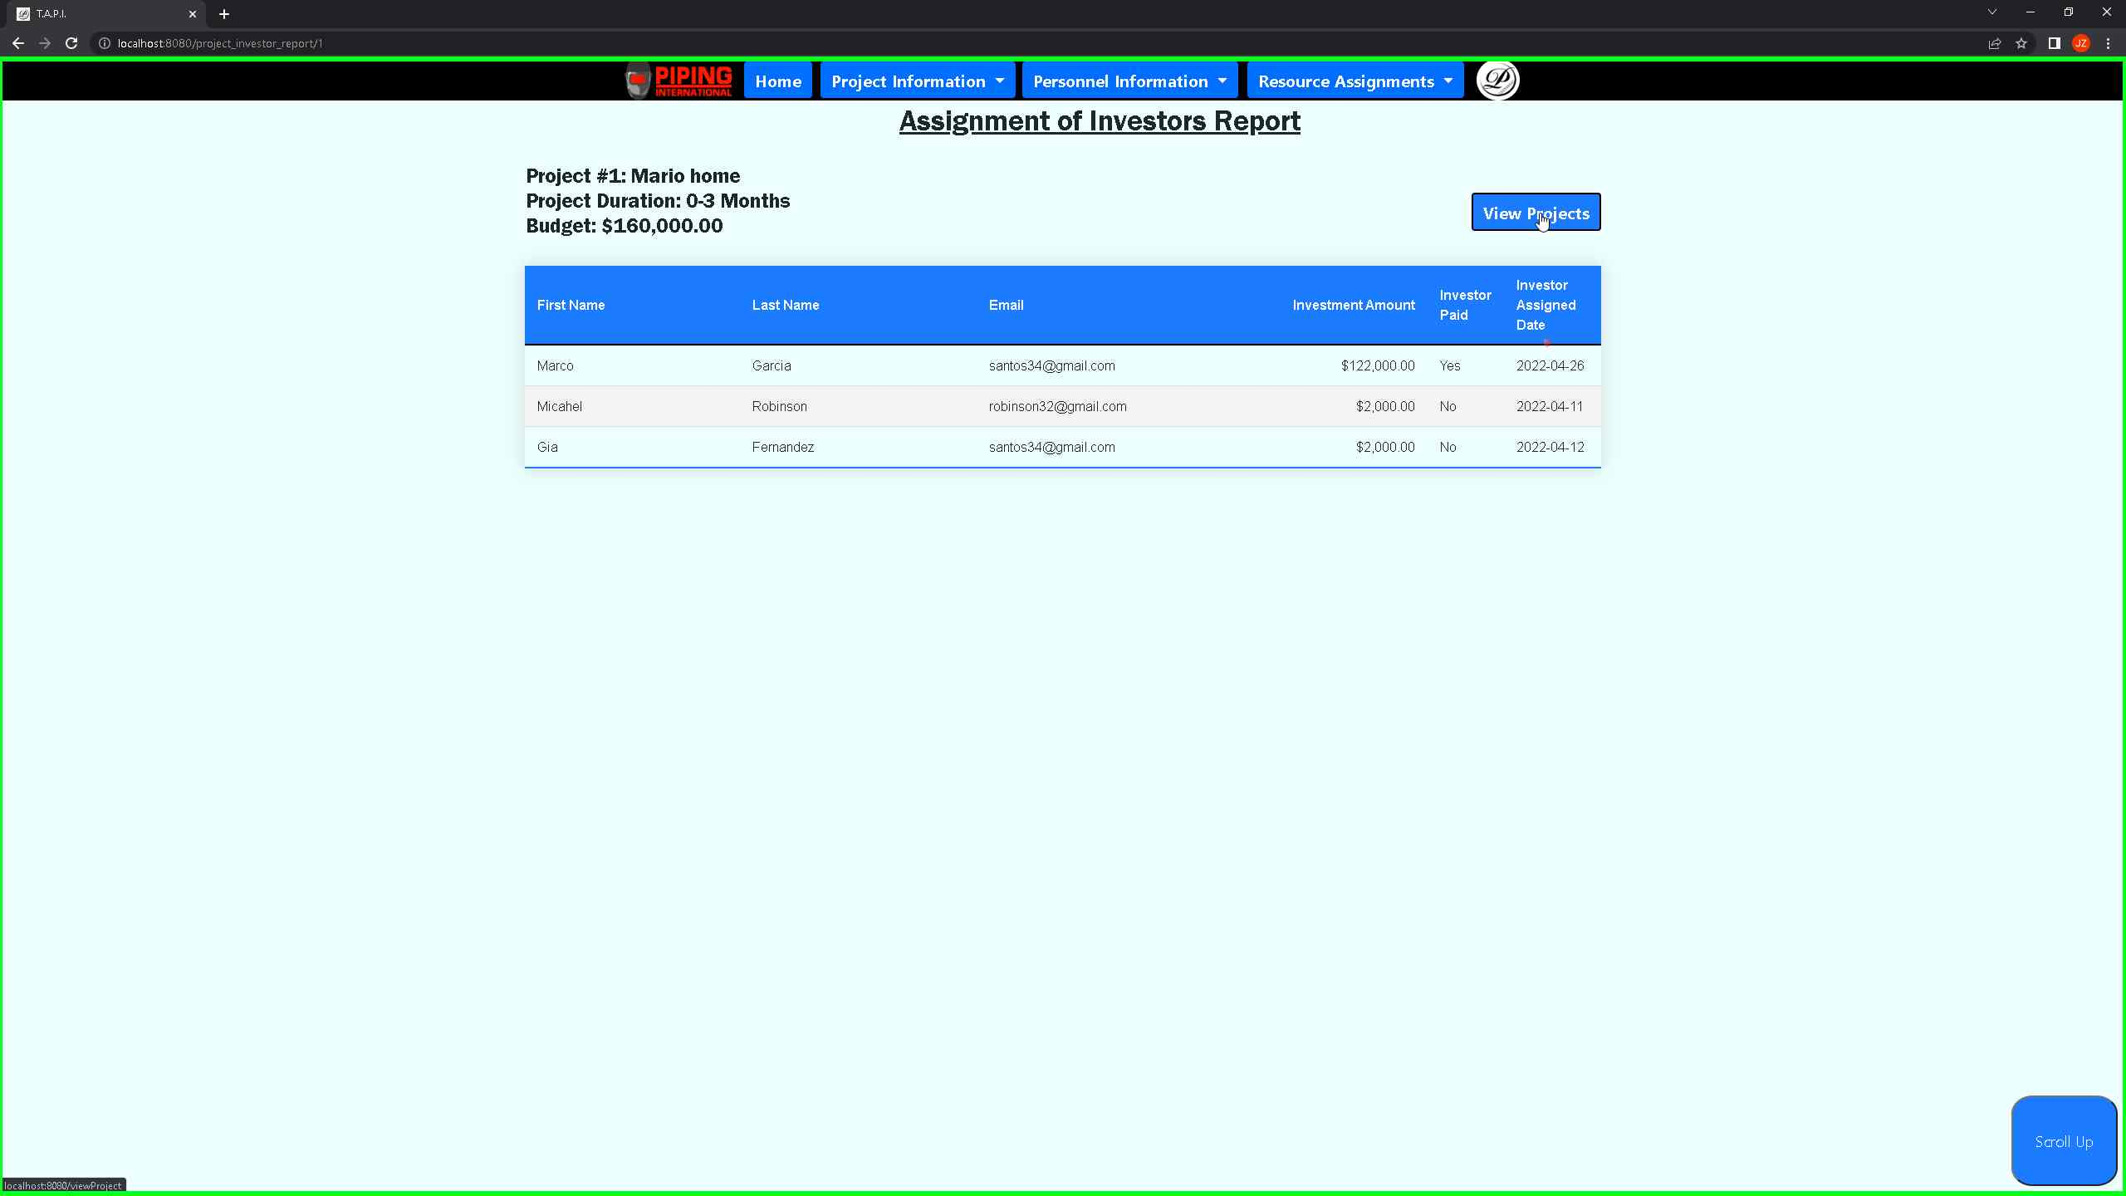 ***Screenshot 13: Showcasing that that a user can go back to projects by clicking on the view projects button.***

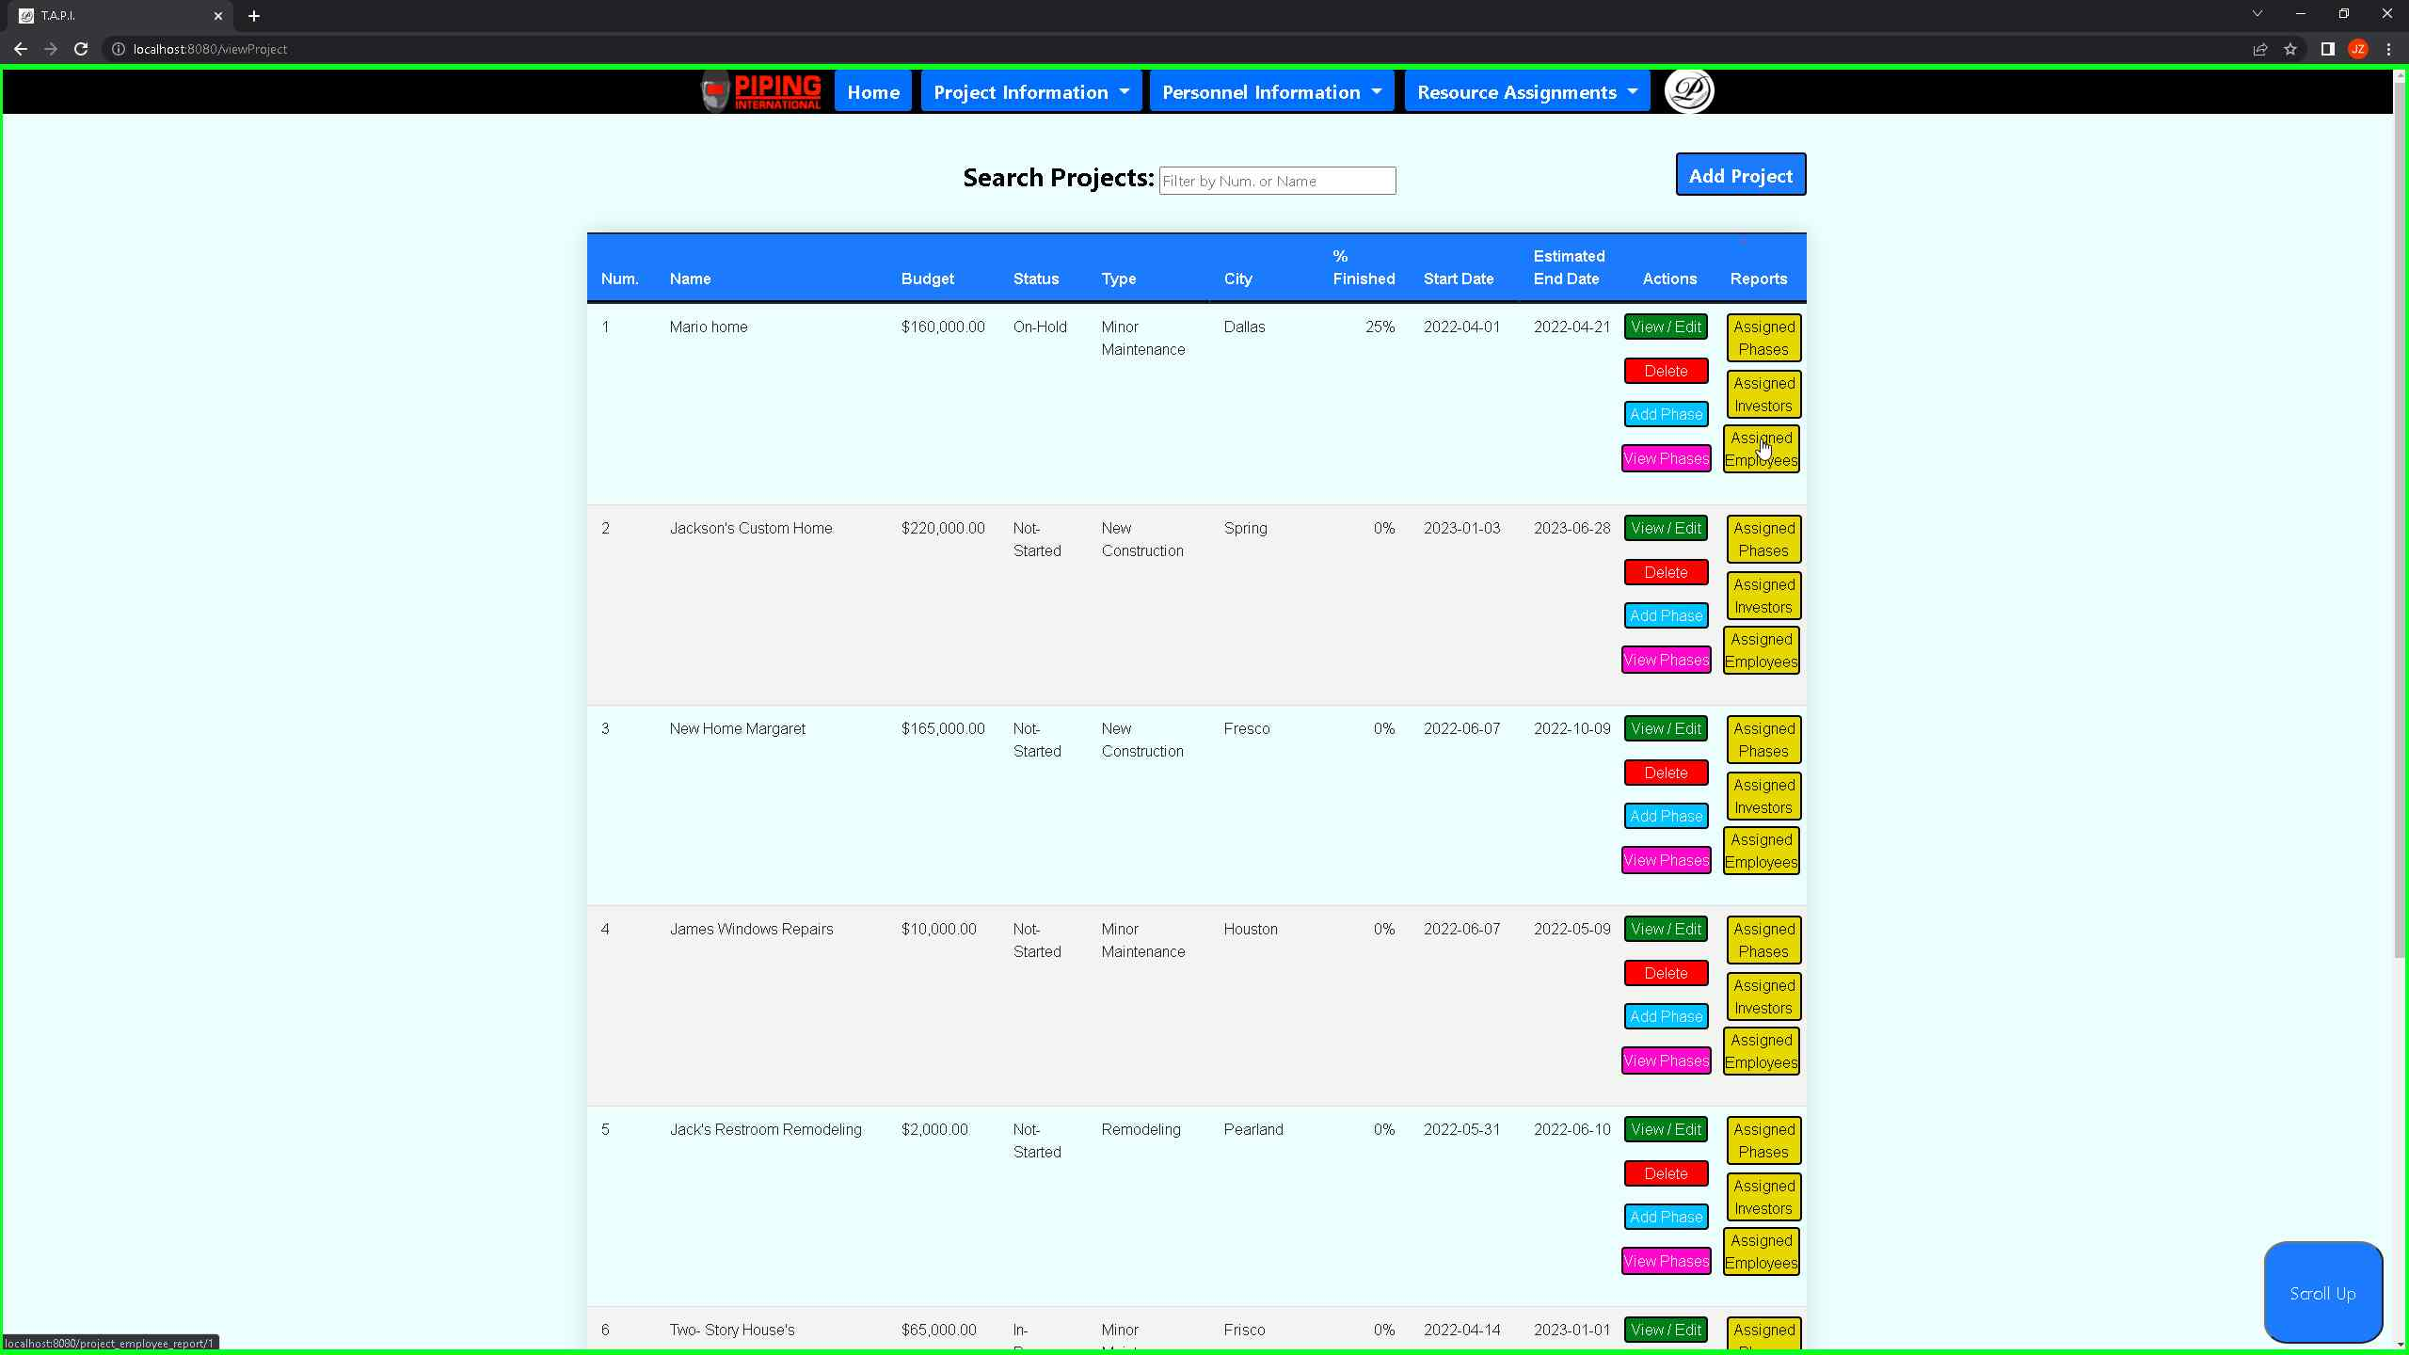 ***Screenshot 14: Showcasing that when the user clicks on the assigned employee’s button, it will take the user to a web page that showcases all the employees assigned to project number 1.***

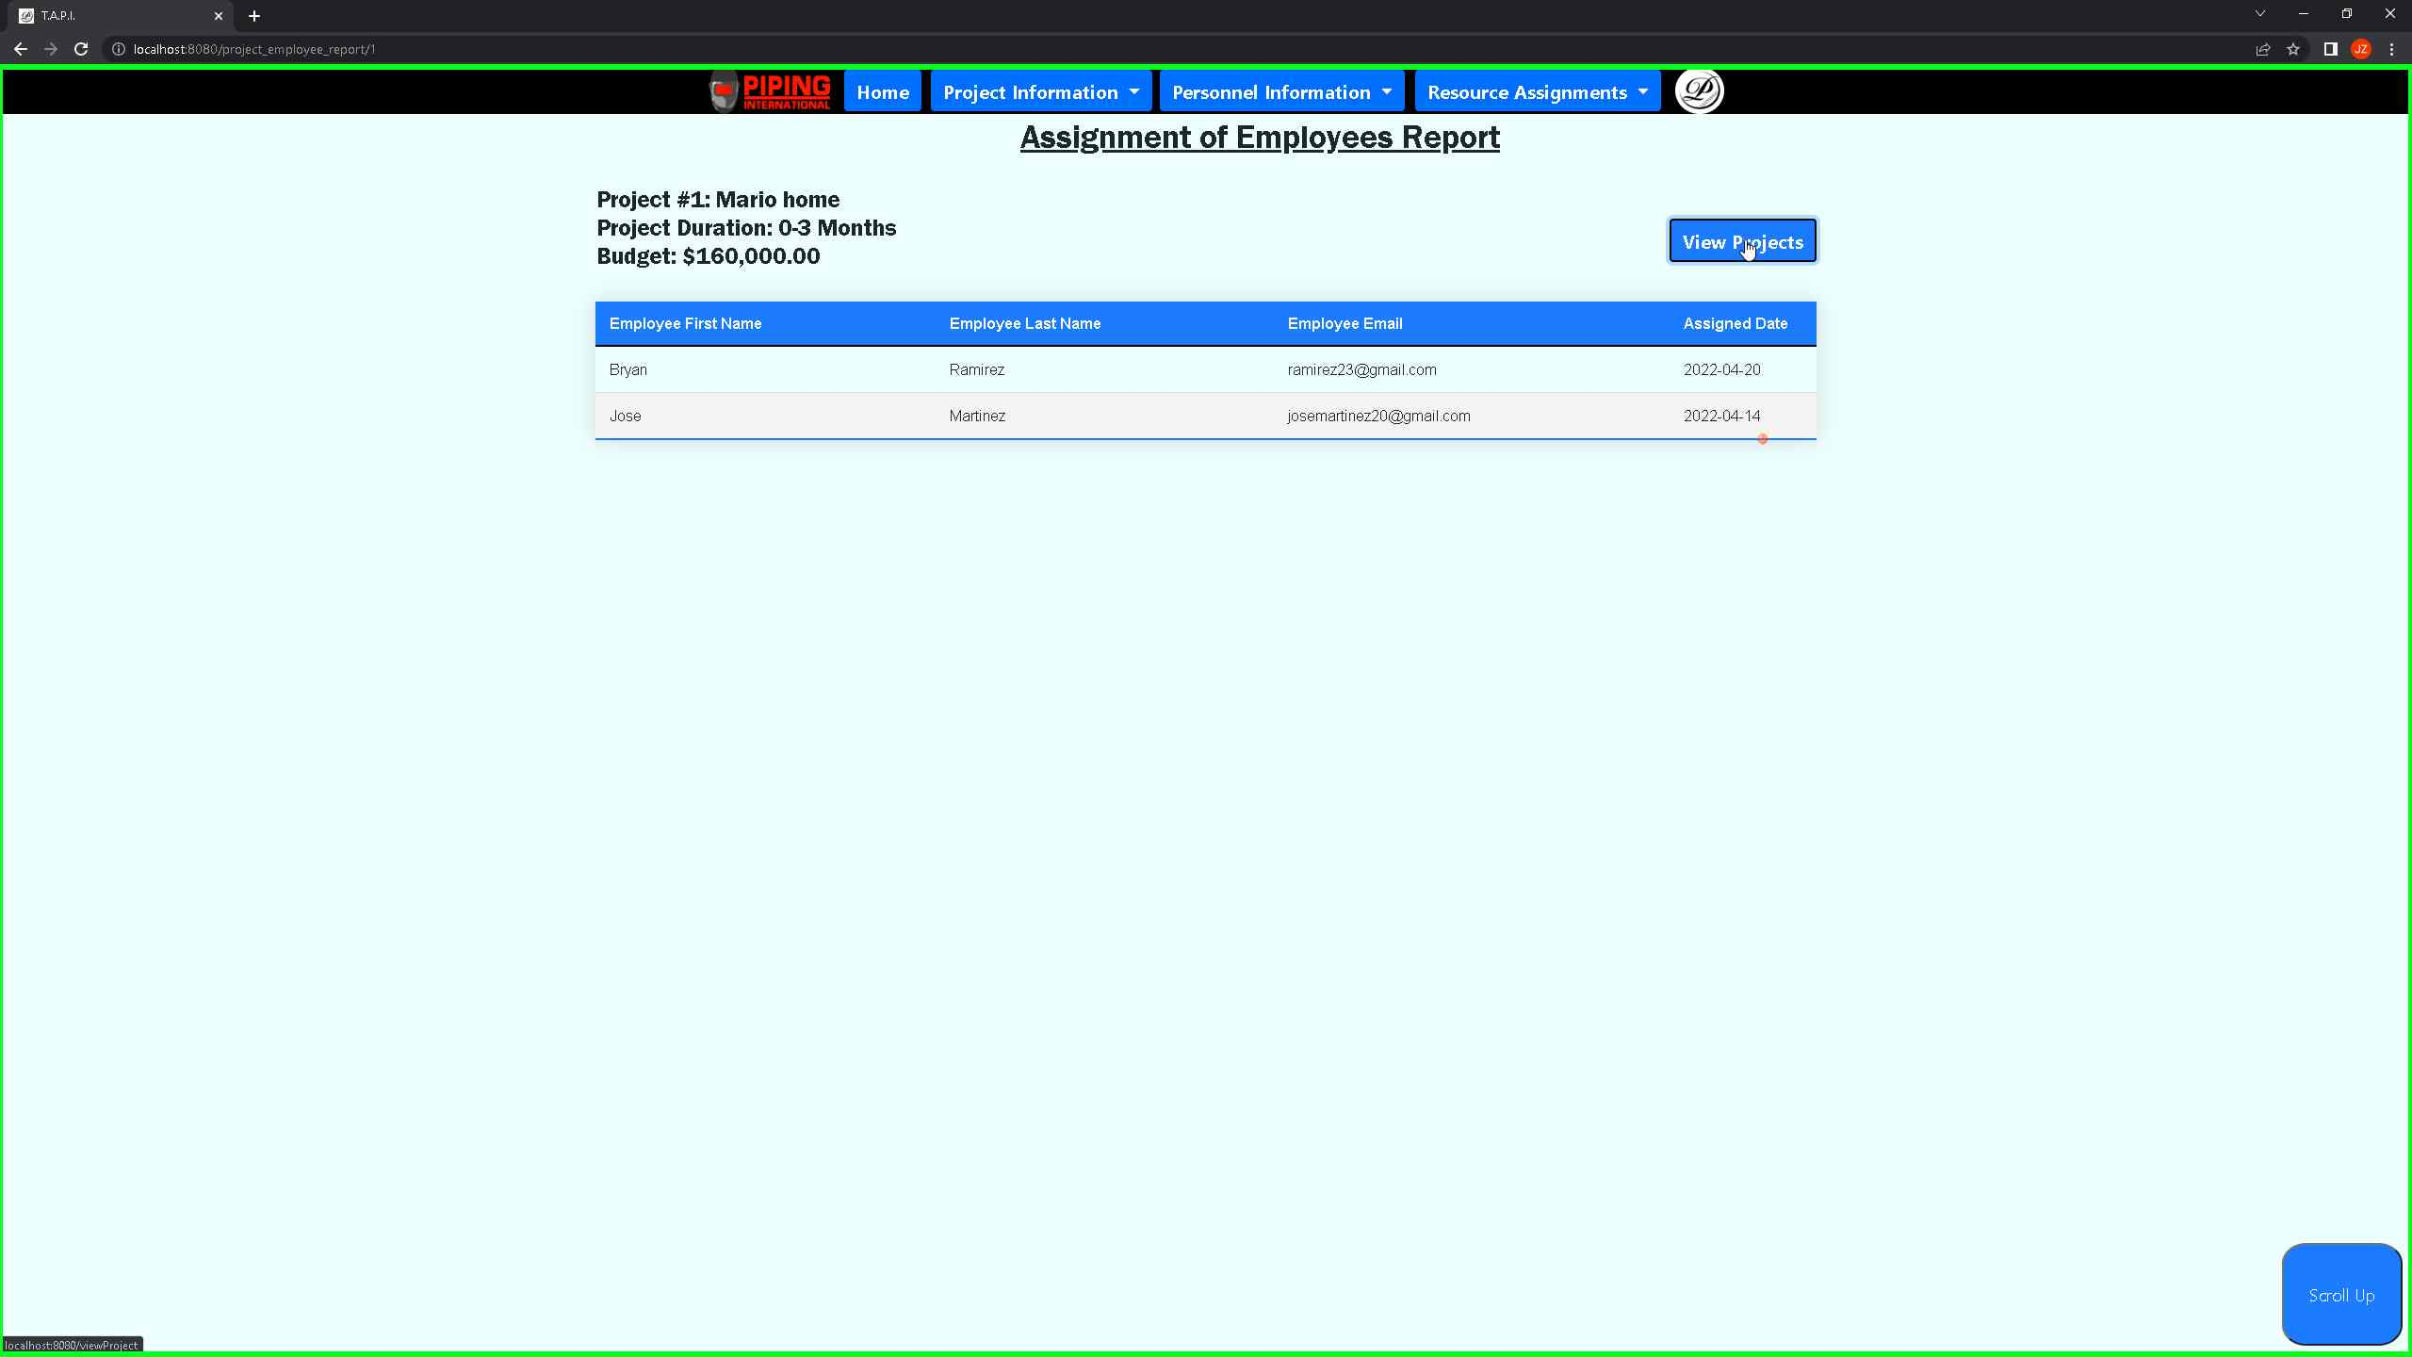 ***Screenshot 15: Showcasing the employees that are assigned to project number 1. User can also click on the view projects that takes him back to the view projects page.***

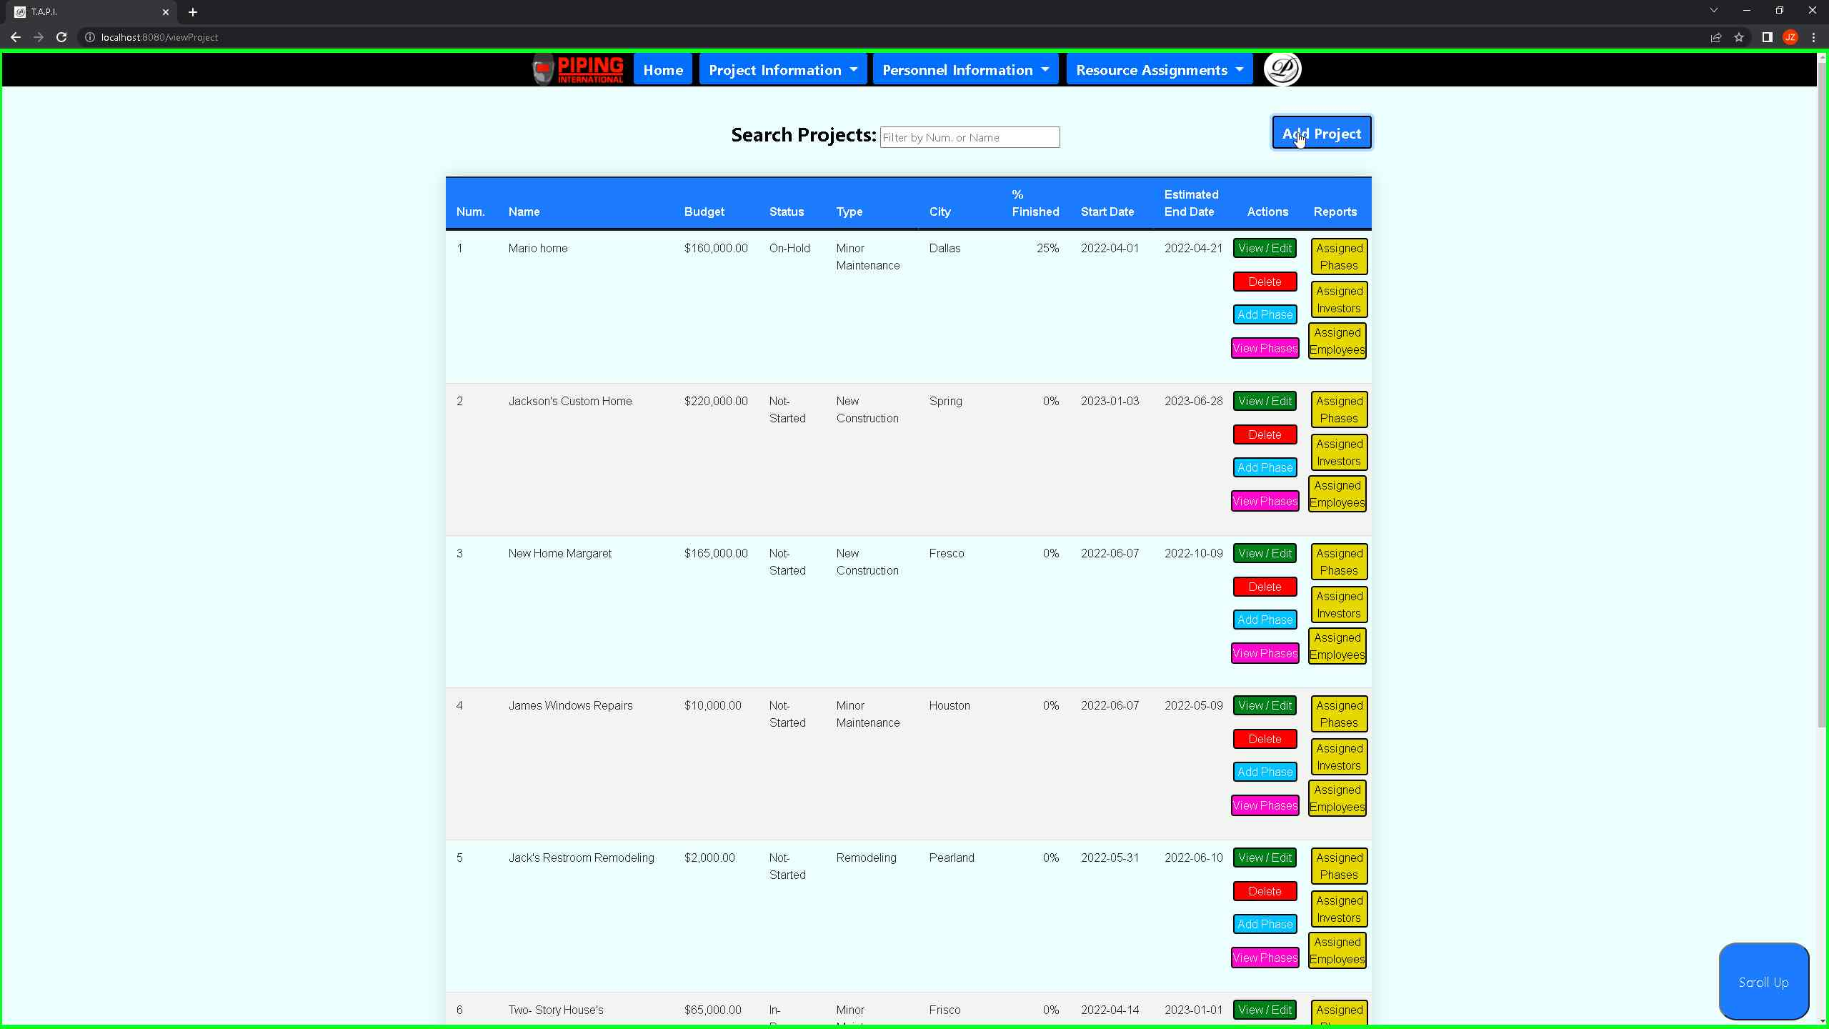 ***Screenshot 16: Showcasing that from the view projects page the user can immediately create a project by clicking the “add a project” button.***

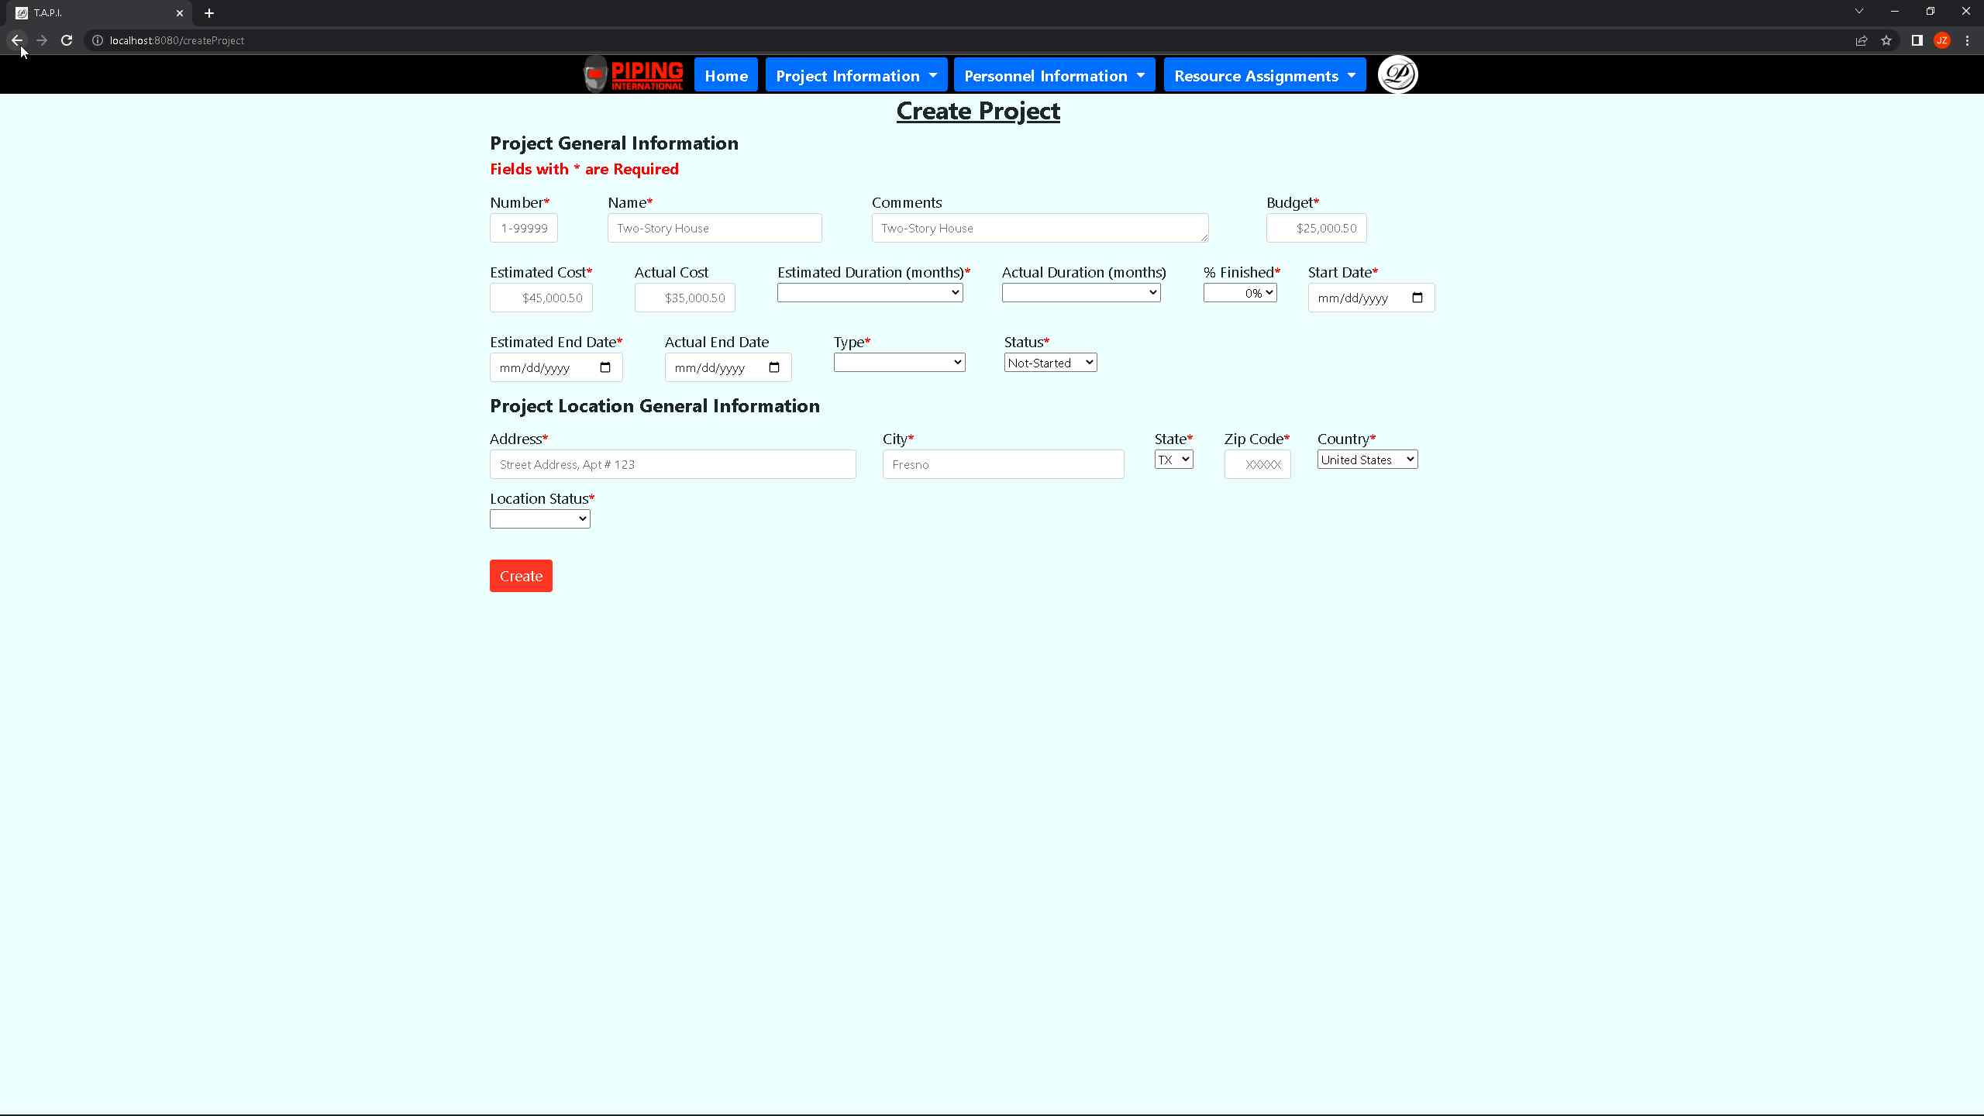 ***Screenshot 17: Showcasing that once the user clicks on the add project button, the create project intake form is populated which allows users to fill out and click the create button that takes him back to the view projects page.***

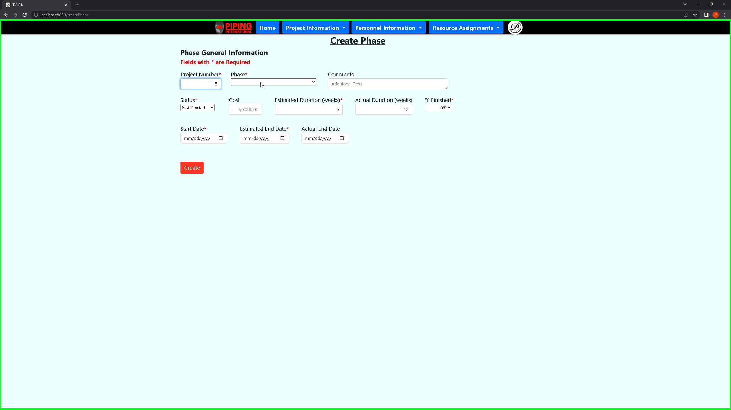 ***Screenshot 18: Above shows the create phase intake form which the user can access from the view projects page which is a add phase button. Once clicked on, it will take them to the create phase intake form.***

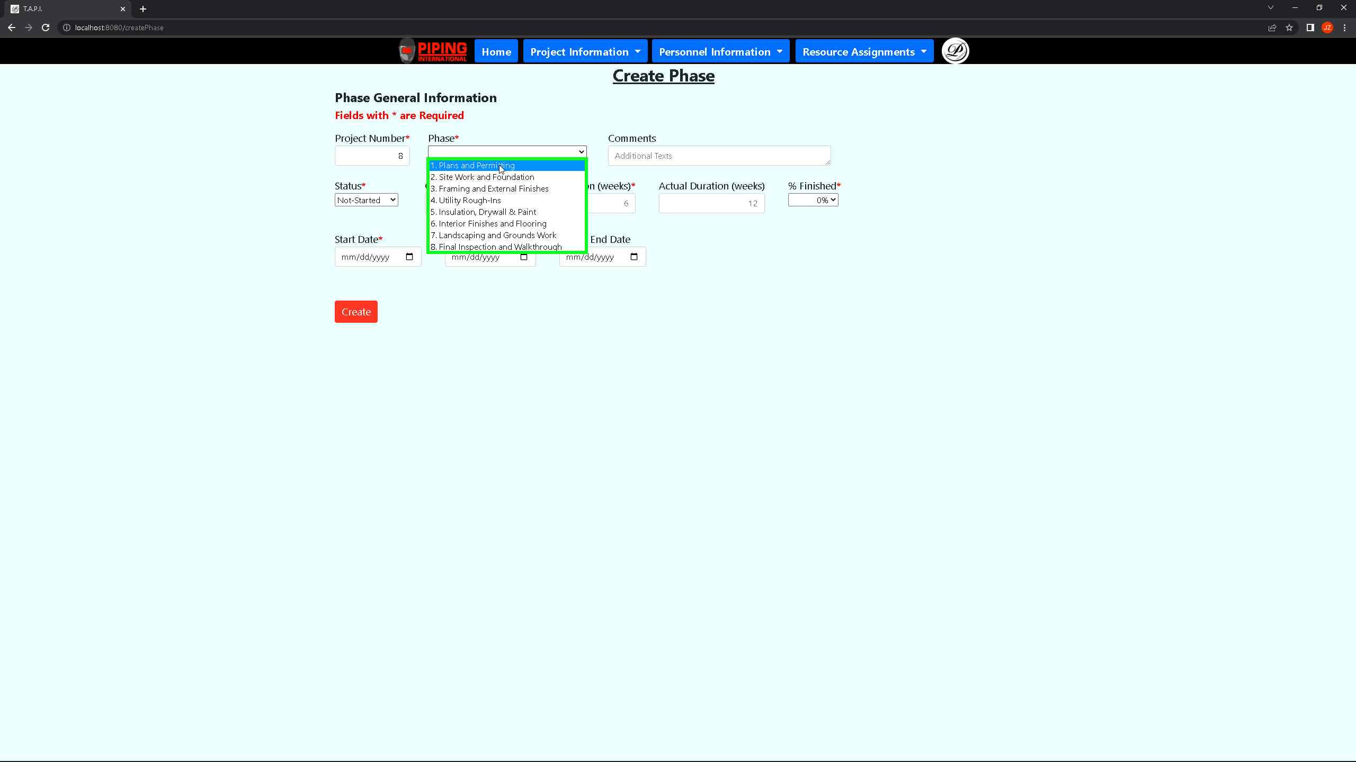 ***Screenshot 19: The above shows the user the process of filling out the create phase intake form and the usage of dropdowns.***

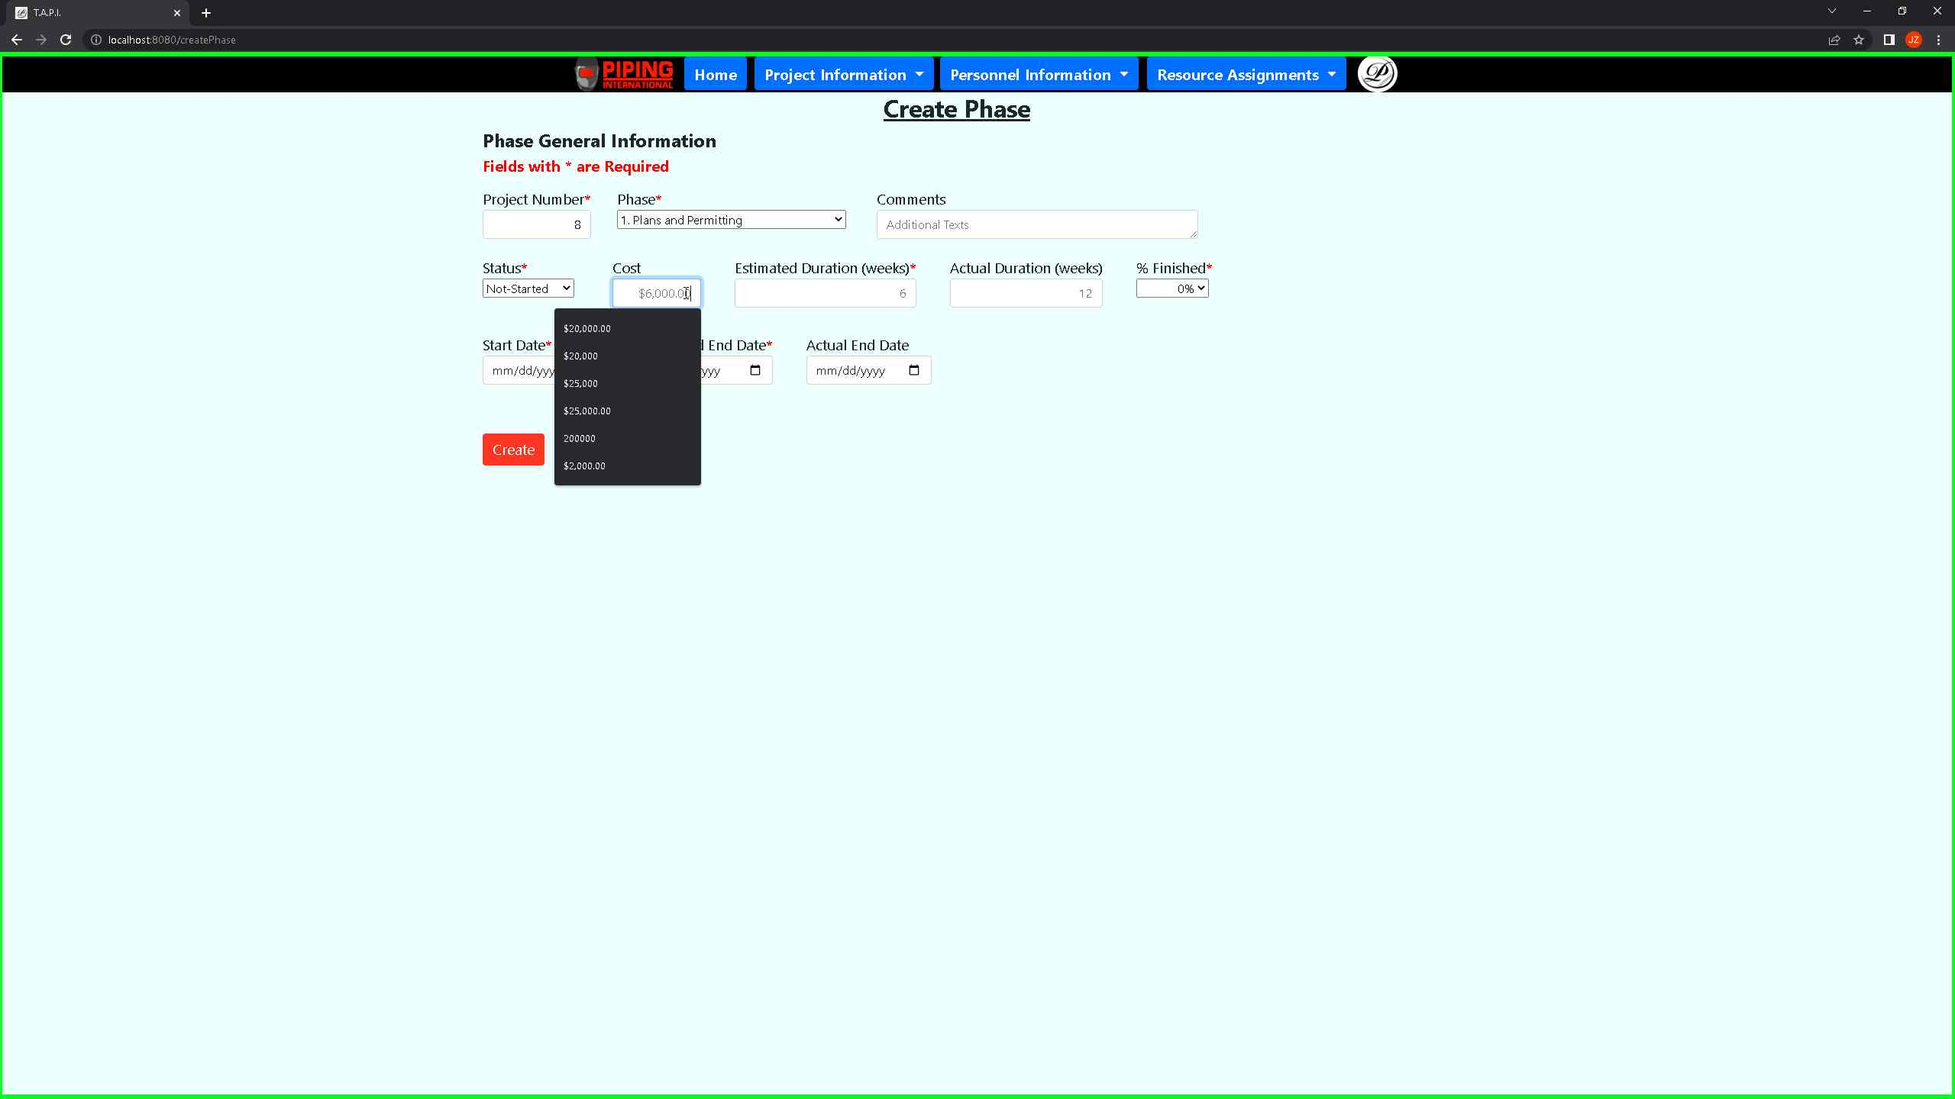 ***Screenshot 20: The above shows the user the process of filling out the create phase intake and how they must pass $100.00 or include the special character $ with the two decimal places.***

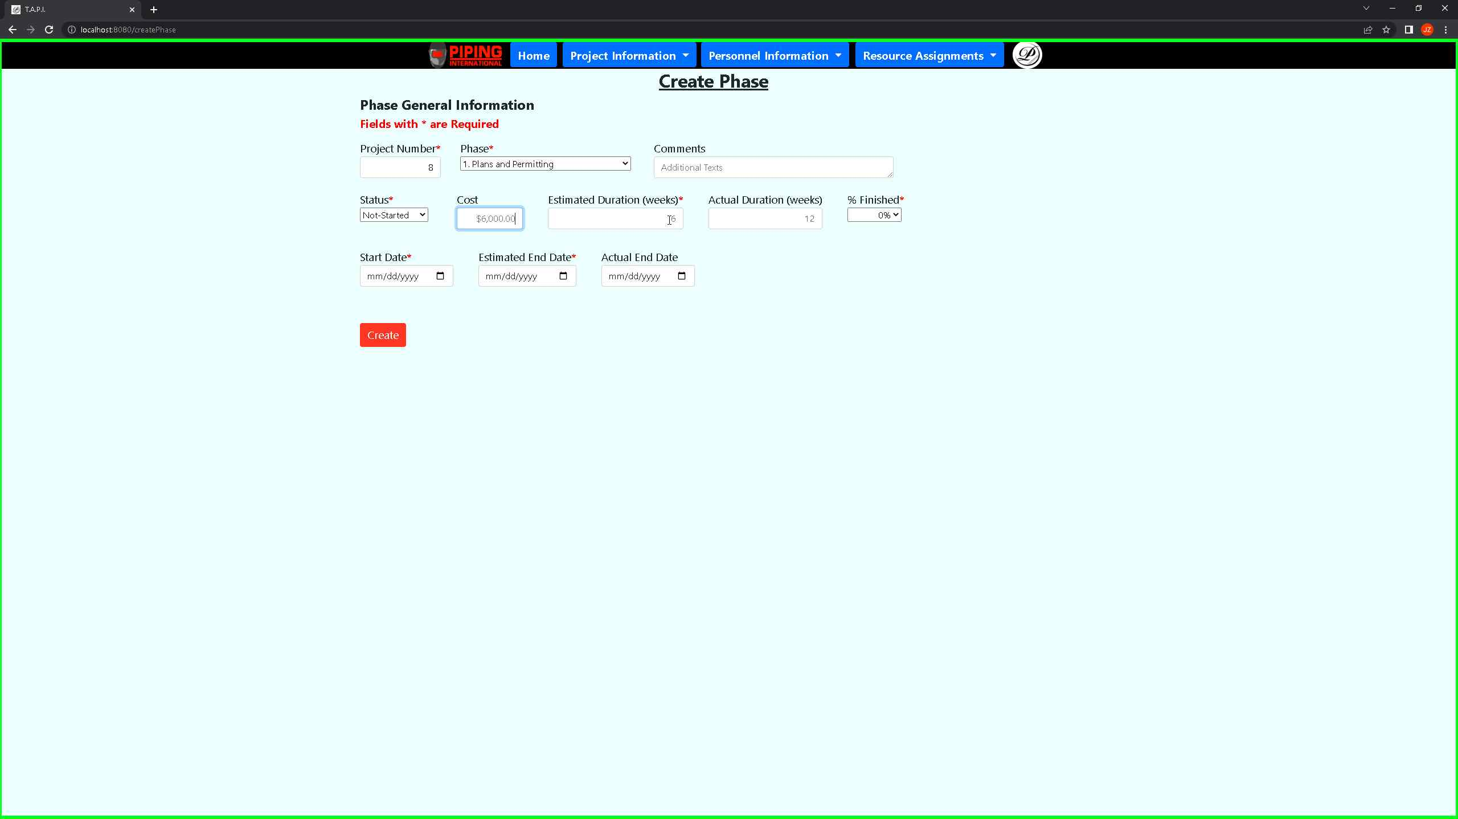 ***Screenshot 21: The above shows the user the process of filling out the create phase intake and how they must pass $100.00. They must include the special character $ with the two decimal places.***

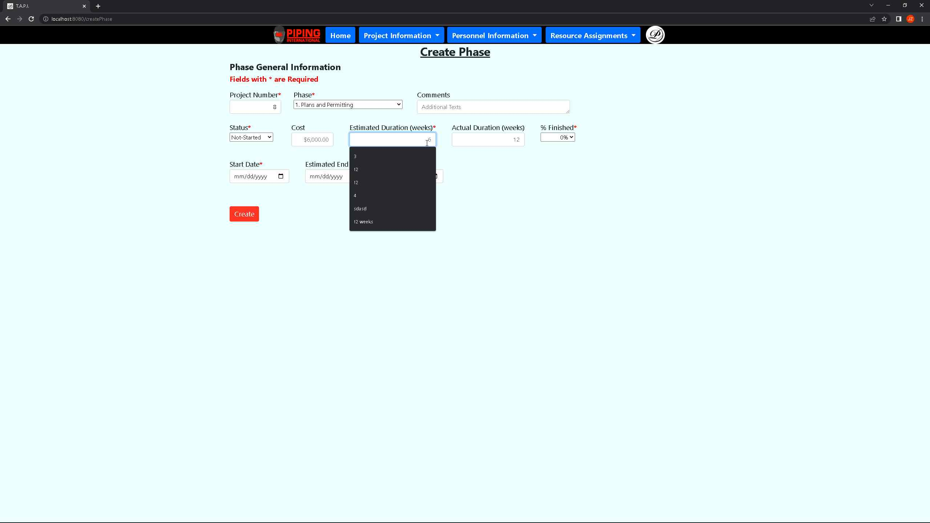 ***Screenshot 22: The above shows the user process of filling out the create phase intake and how the estimated duration can only pass a number value that represents several weeks.***

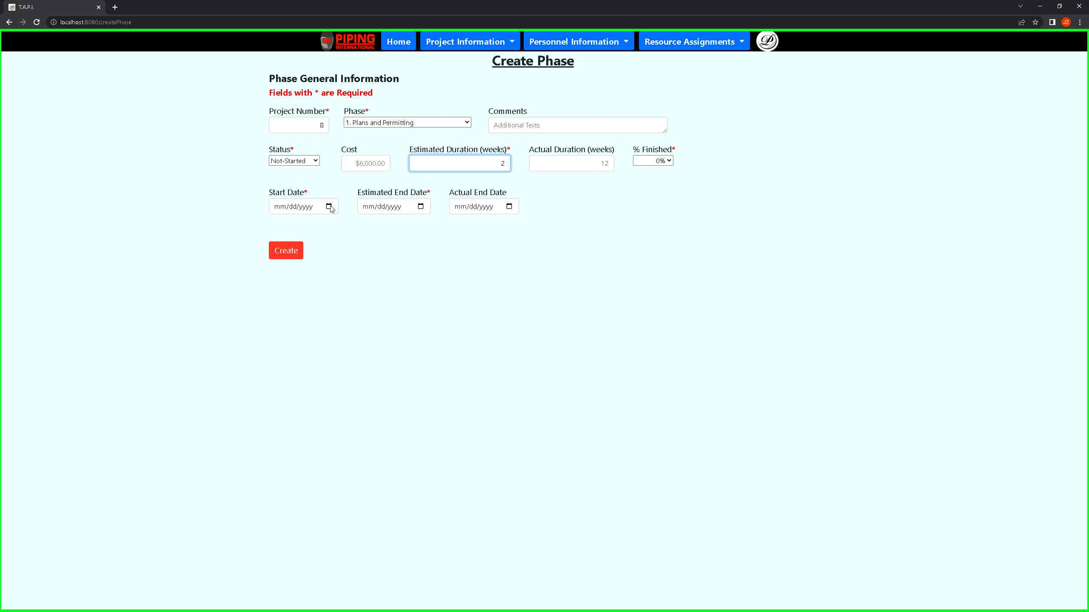 ***Screenshot 23: The above shows the user the process of filling out the create phase intake and user form. Must fill out all required fields with a red asterisk by their field name and user must input a start date.***

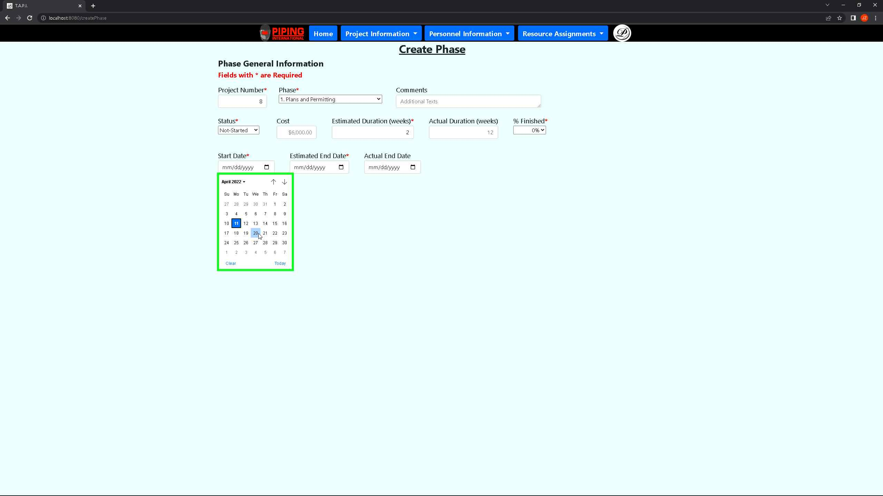 ***Screenshot 24: The above shows the user the process of filling out the create phase intake form showing that the calendar is fully functional.***

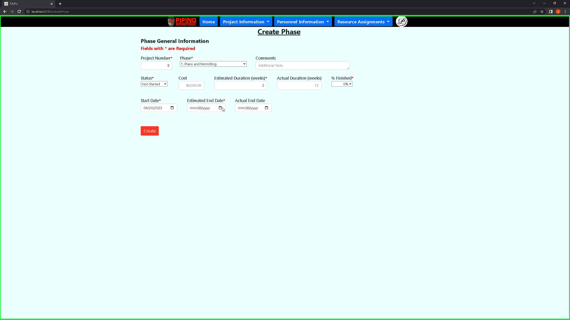 ***Screenshot 25: Showing that the user for the create phase intake form must fill out the estimated end date. Projects typically have a start date and an estimated end date.***

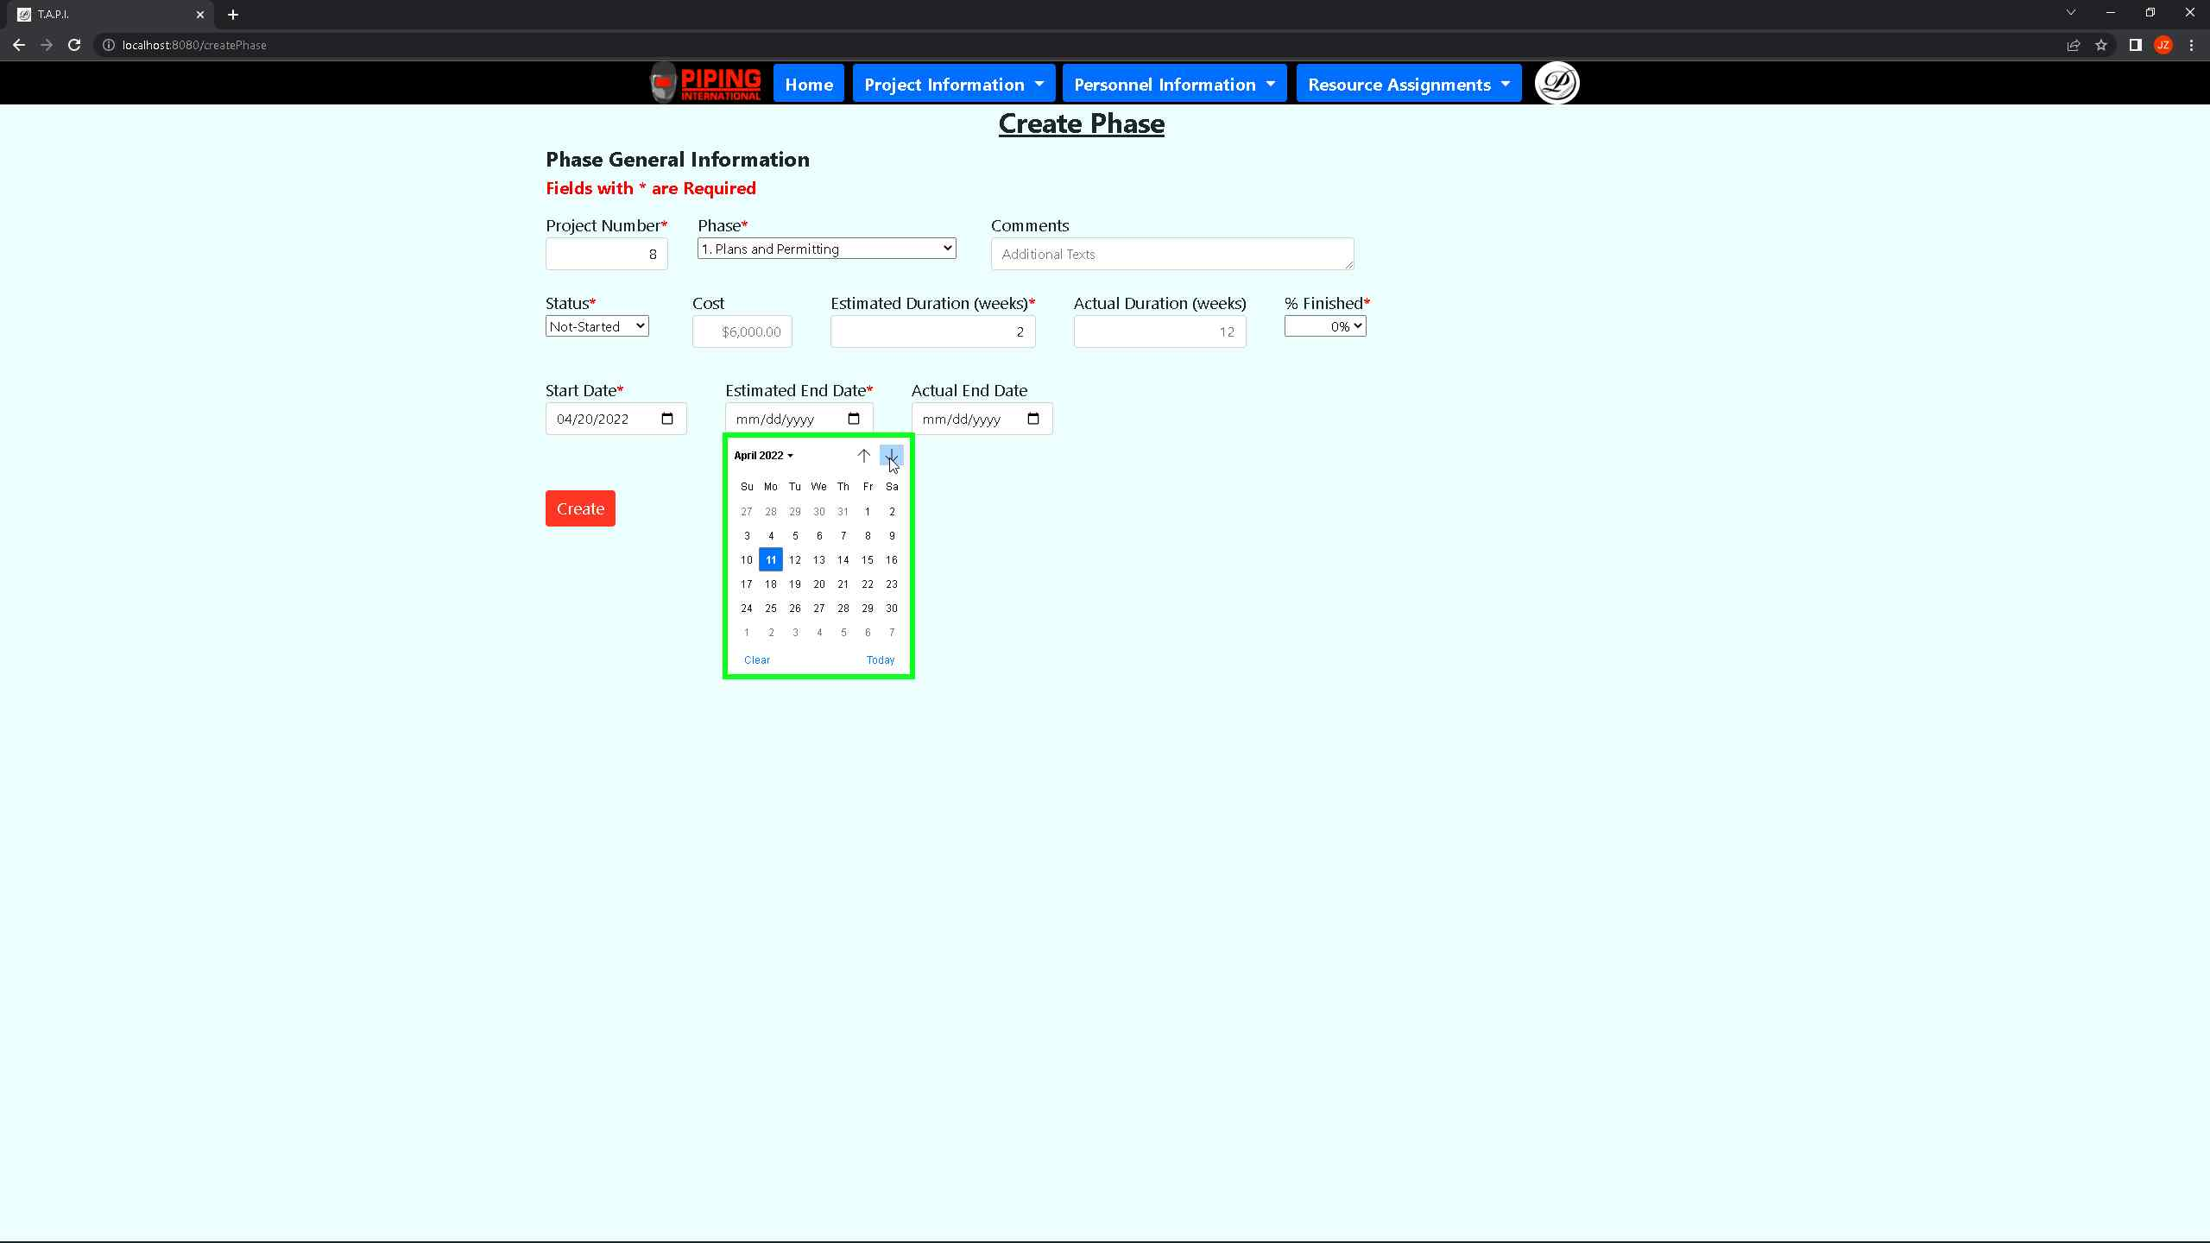 ***Screenshot 26: The above shows the user the process of filling out the create phase intake showing that the calendar is fully functional for the estimated end date field.***

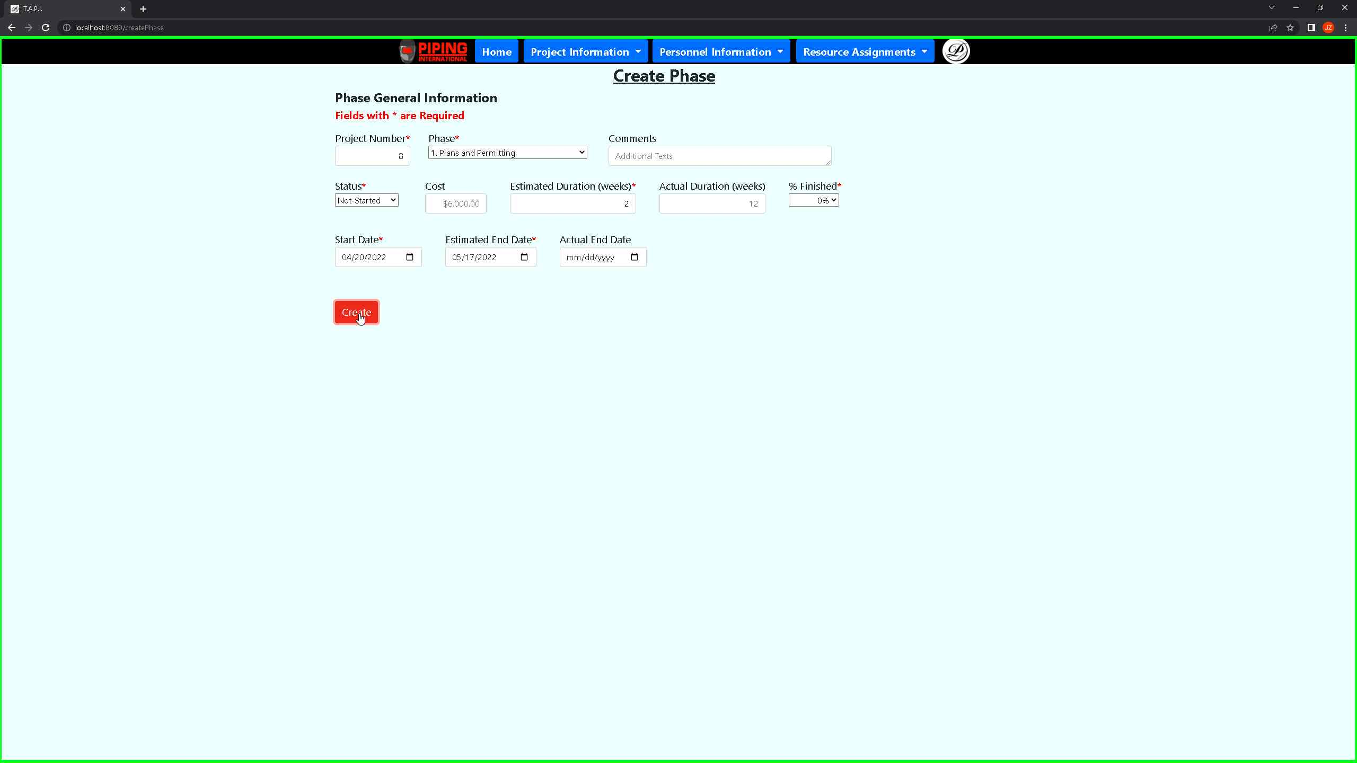

***Screenshot 27: The above shows the user the process of filling out the create phase intake showing that once the required fields are filled out, then the user clicks on the create button that will take them to the view phase page.***

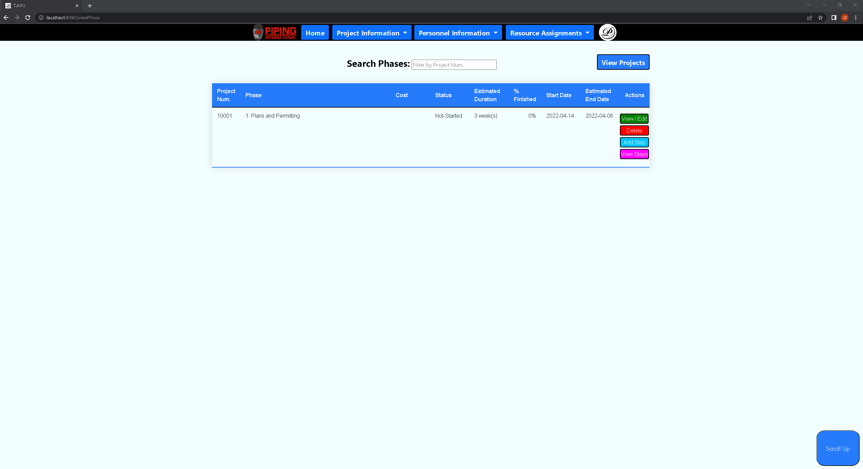 ***Screenshot 28: The above shows the view phase page that shows all phases that were created for a project in this view phase page. Users can filter through data by searching phases using the project num.***

*** Screenshot 29: The above shows that within the view phase page the user can search by project number in this case passed by the number 8 which shows project 8 phase info.***

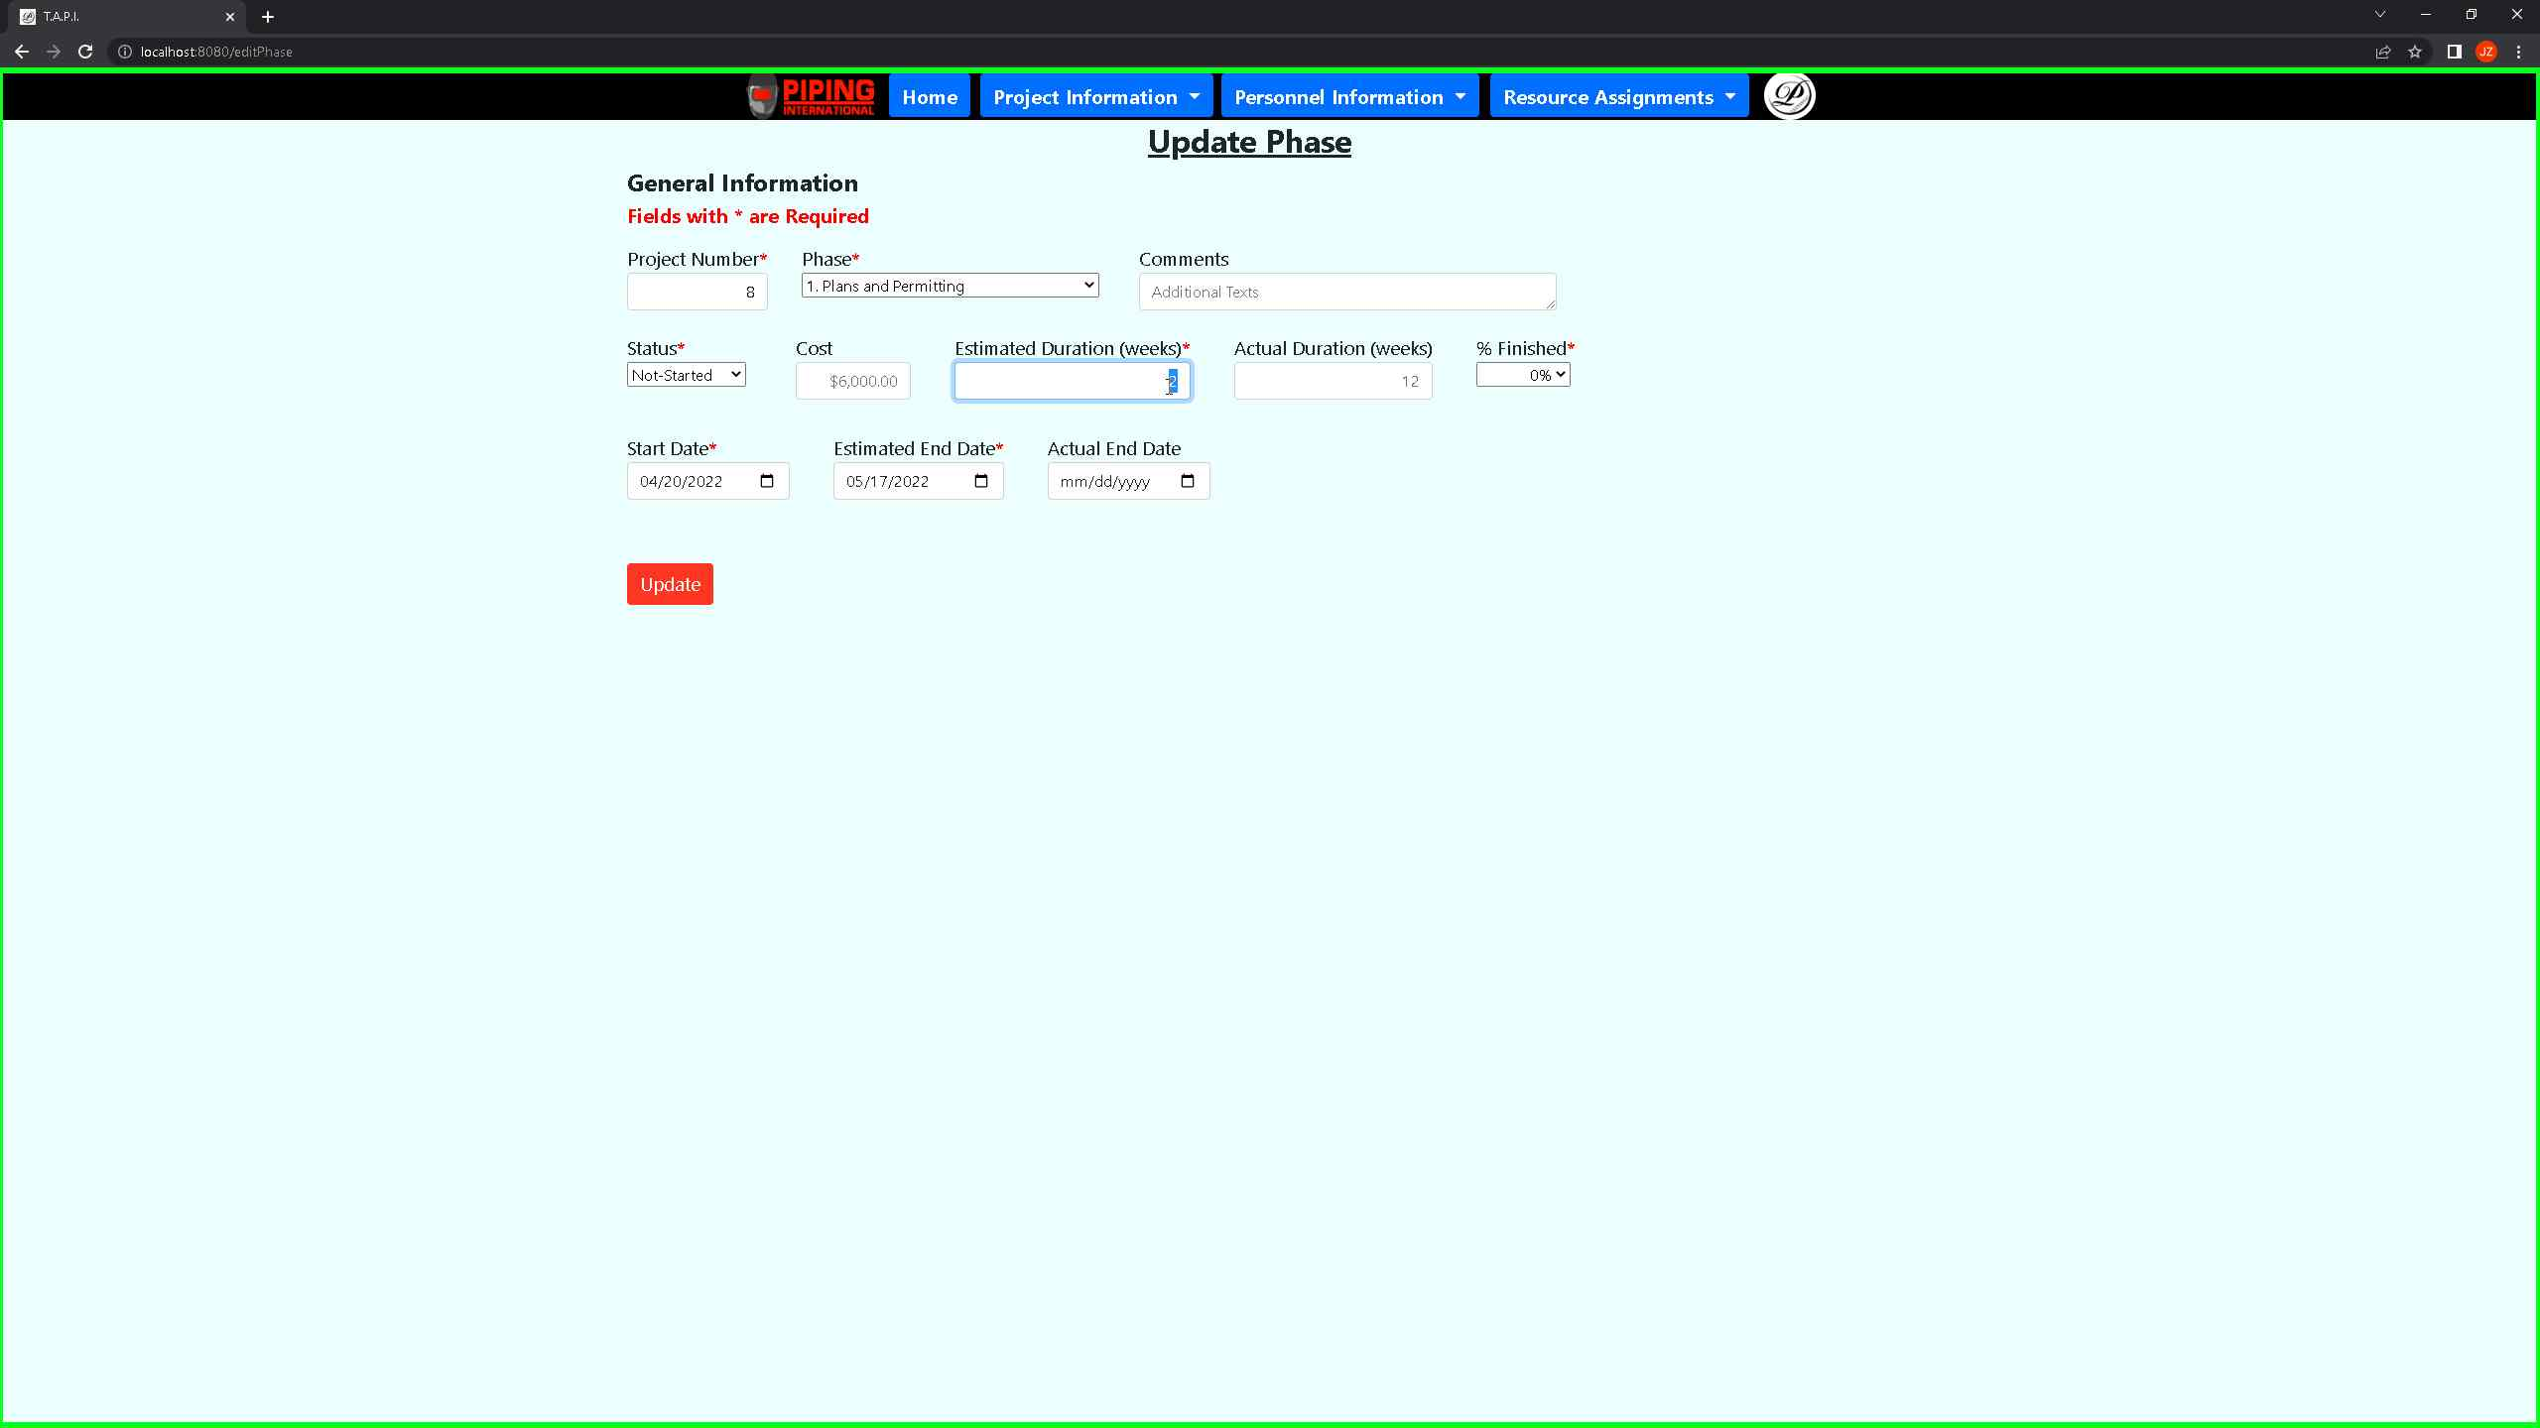 ***Screenshot 30: The above shows that a user from the view phase page can click on the view/edit button to modify or view data for an individual phase.***

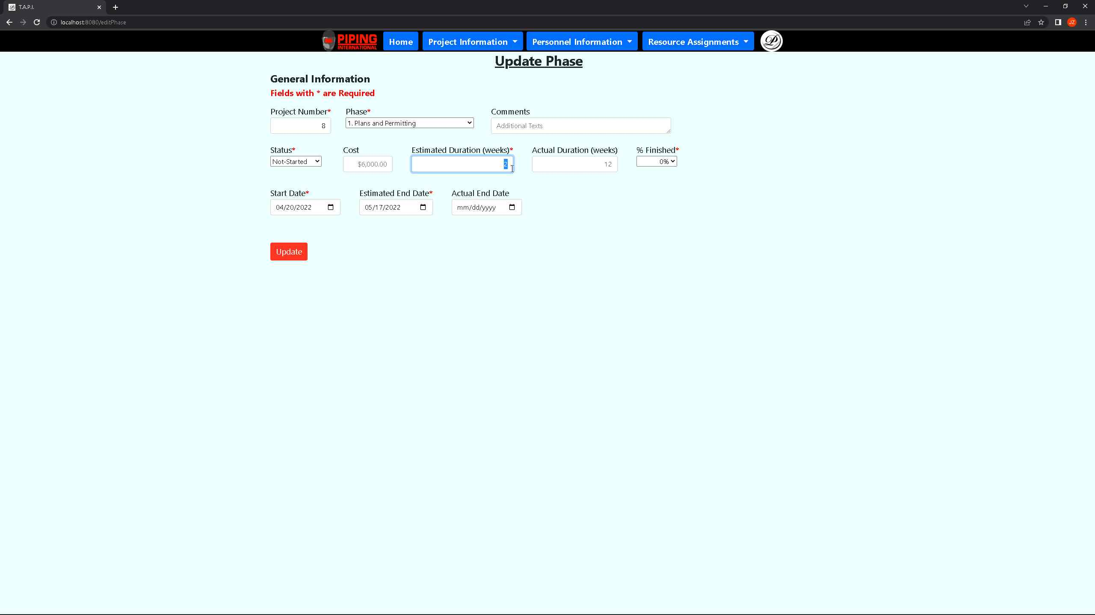 ***Screenshot 31: The above shows the user that in the update phase page, all fields can be updated in the estimated duration (weeks) and updated to a different number value.***

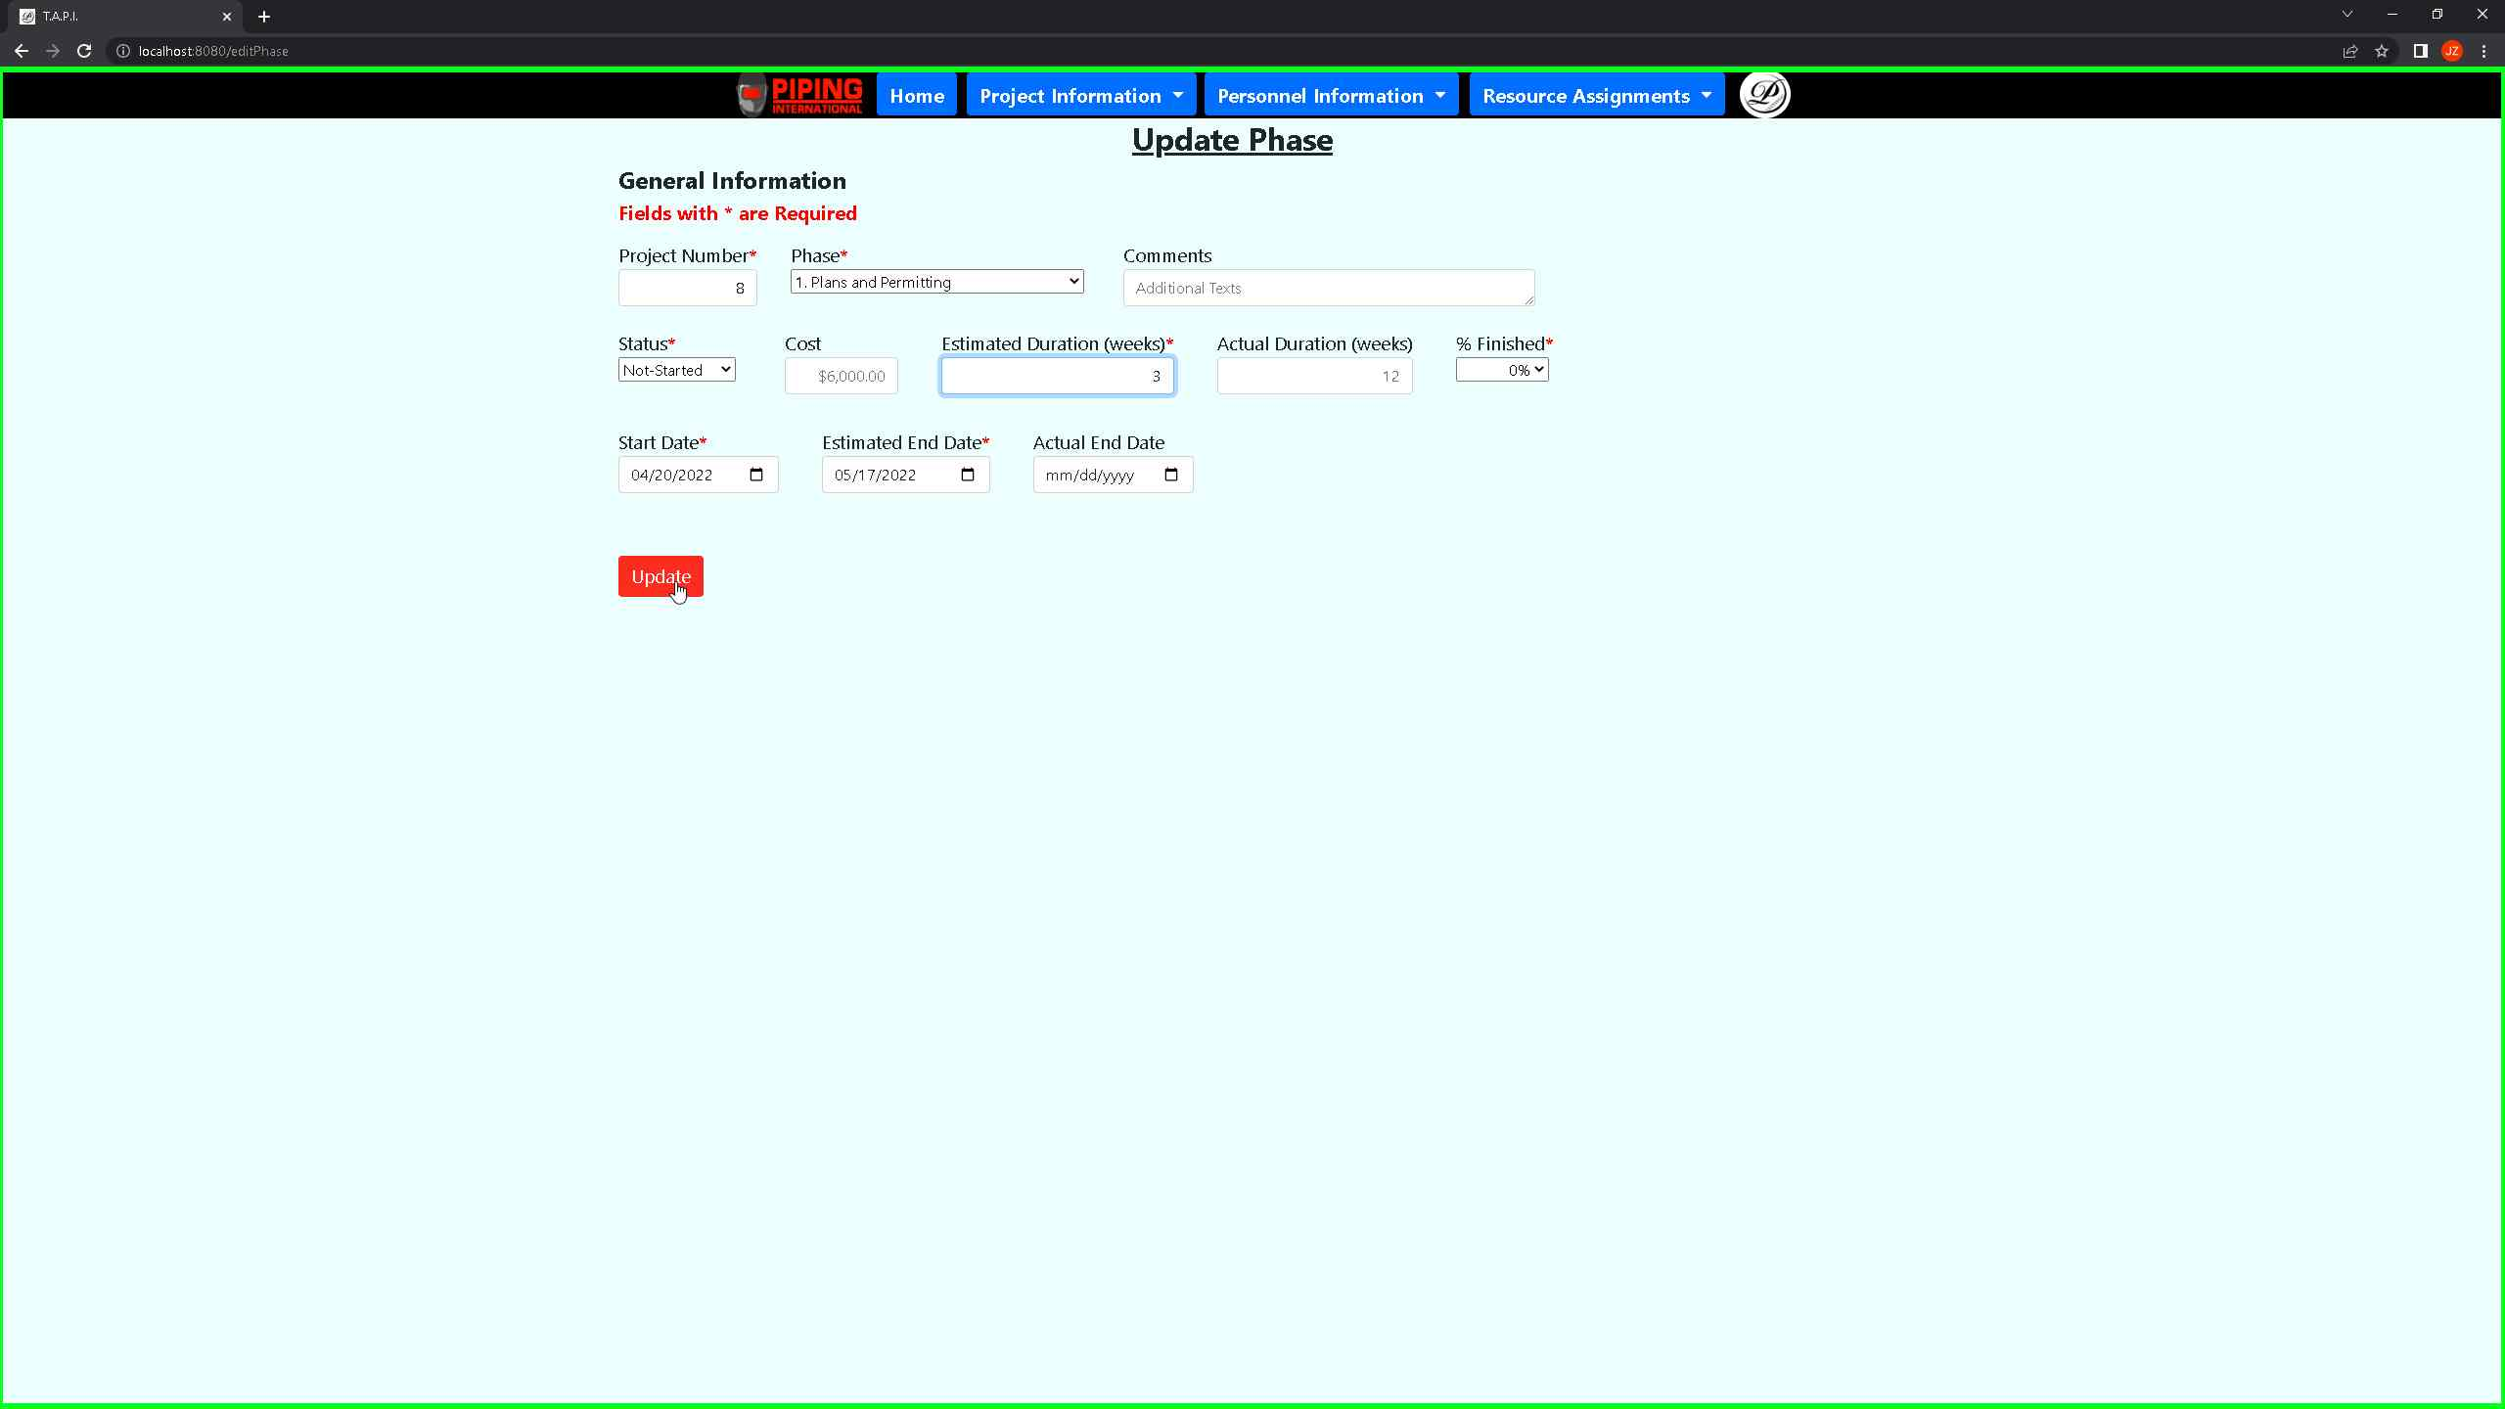 ***Screenshot 32: The above shows that once the user has updated the update phase page, they will click on the update button which will save the updates made and then take them back to the view phase page.***

*** Screenshot 33: The above shows that once the update has been made by the user, he will see the view phase’s page that includes all the phases highlighting the view/edit button that allows the user to update data for an individual phase record.***

*** Screenshot 34: The above shows the view phases page which the user can add by clicking on the “Add Step” button.***

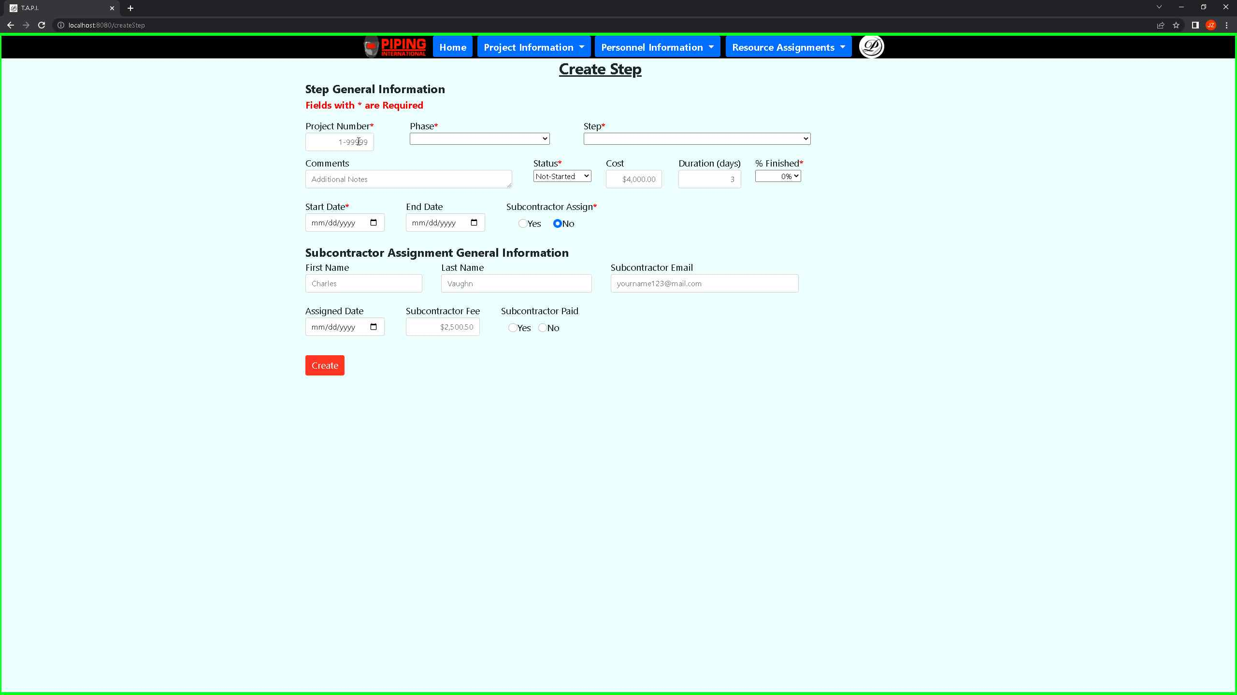

***Screenshot 35: The above shows the create step intake form which the user will have to fill out all the required fields with a red asterisk.***

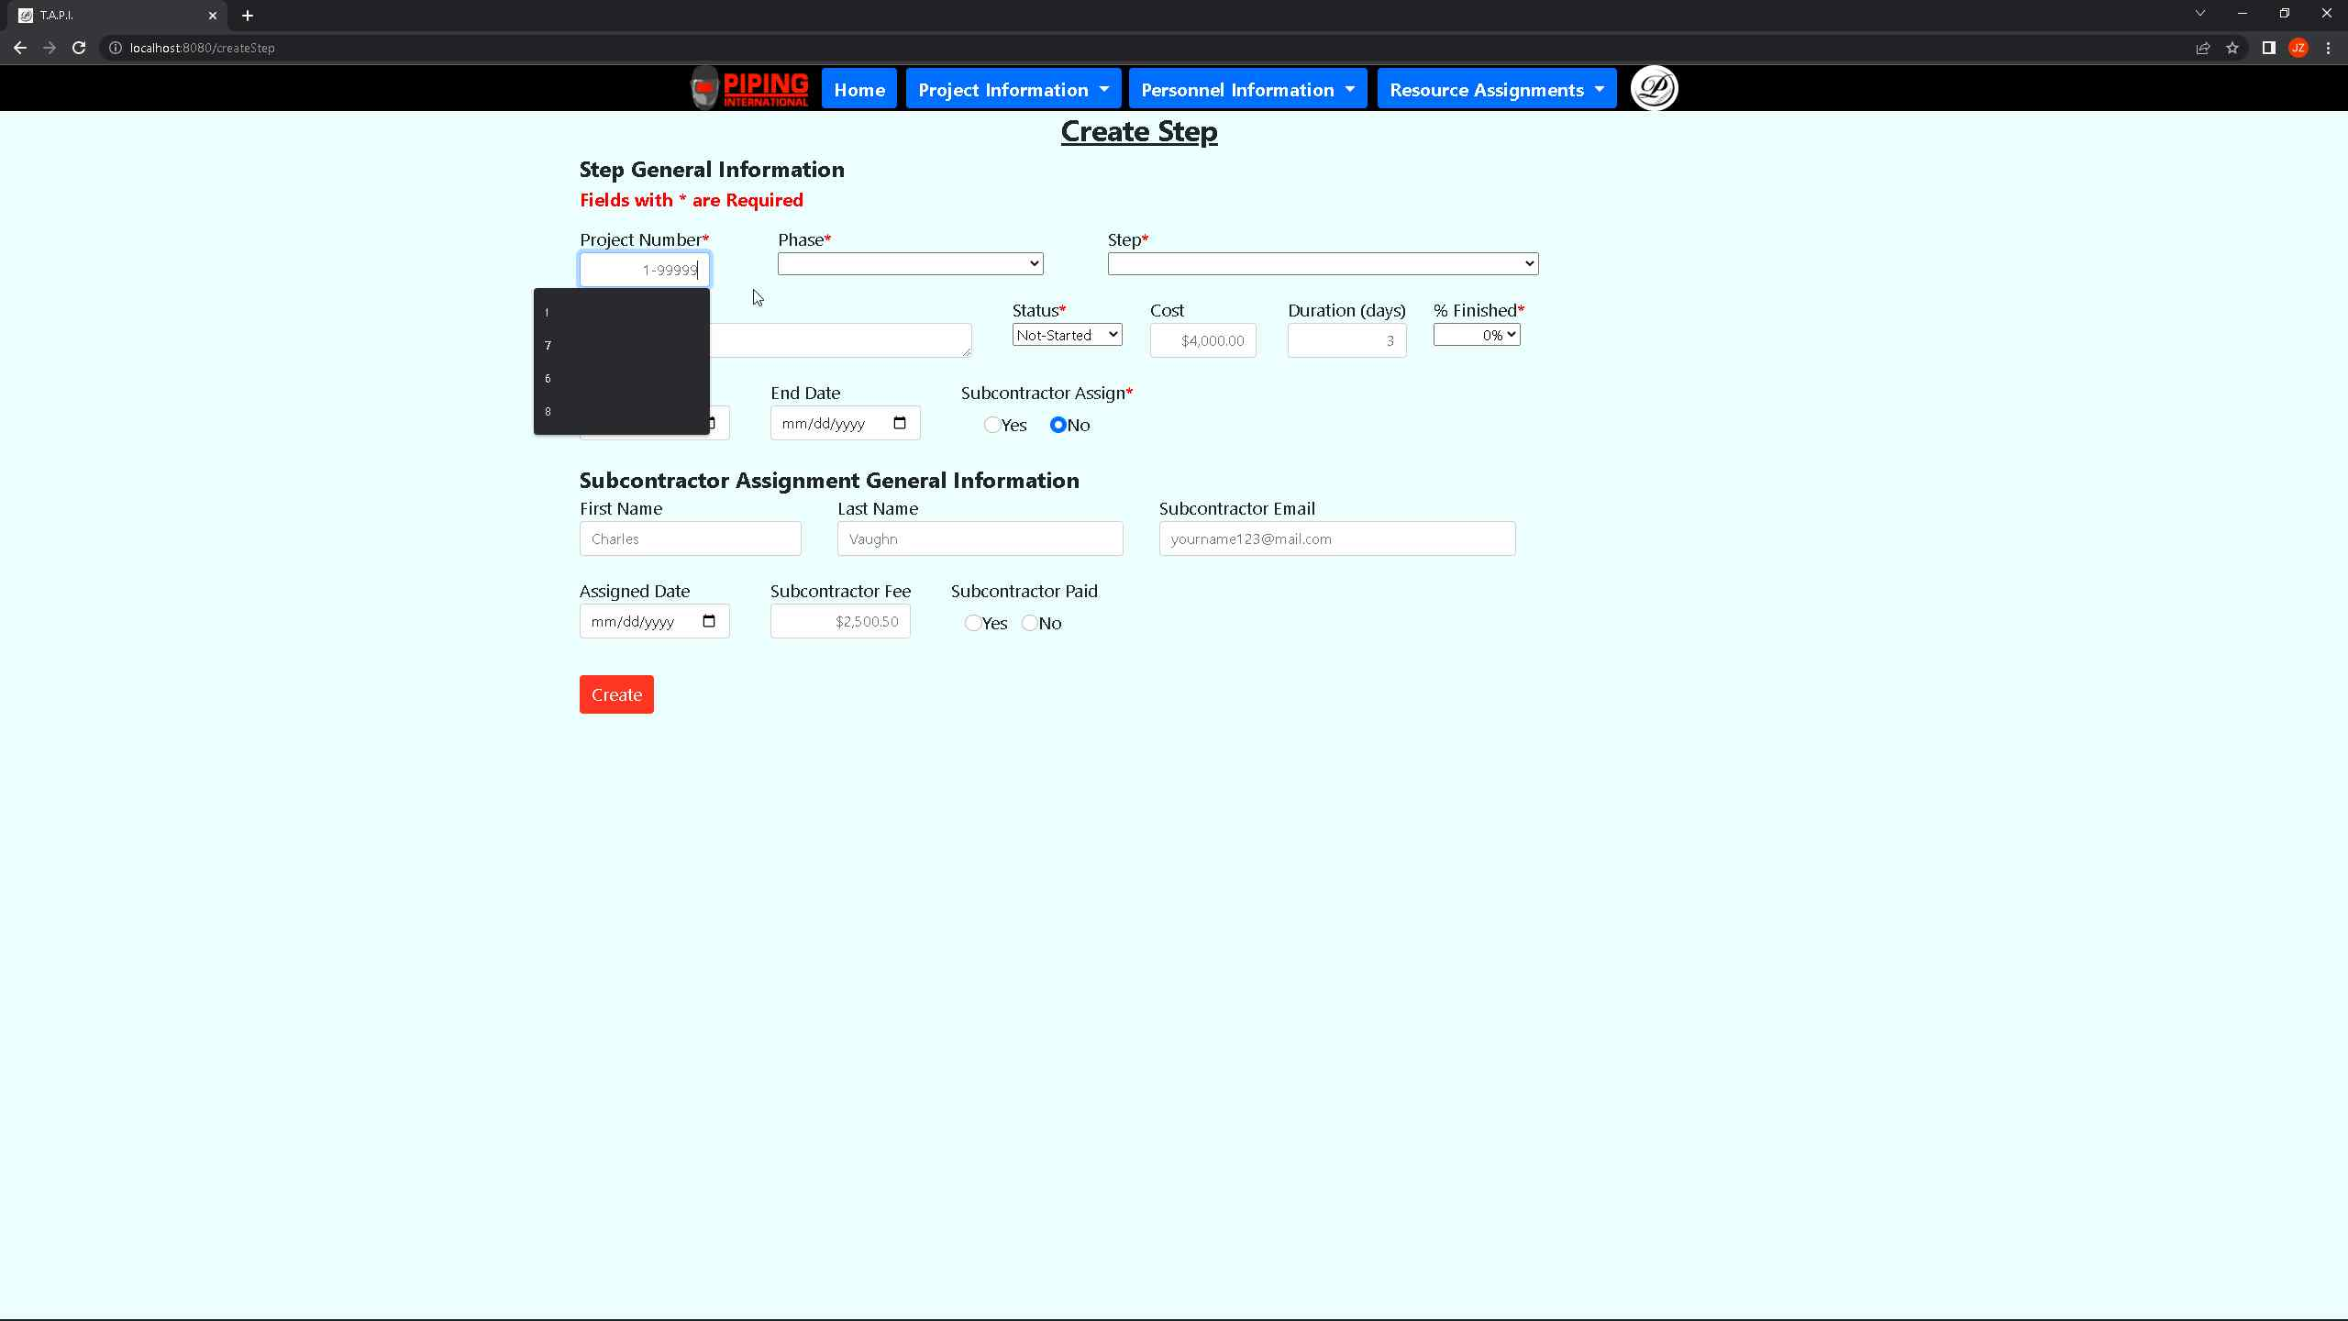 ***Screenshot 36: The above shows the create step intake form which the user must pass for the project number and the phase which links a phase to a step.***

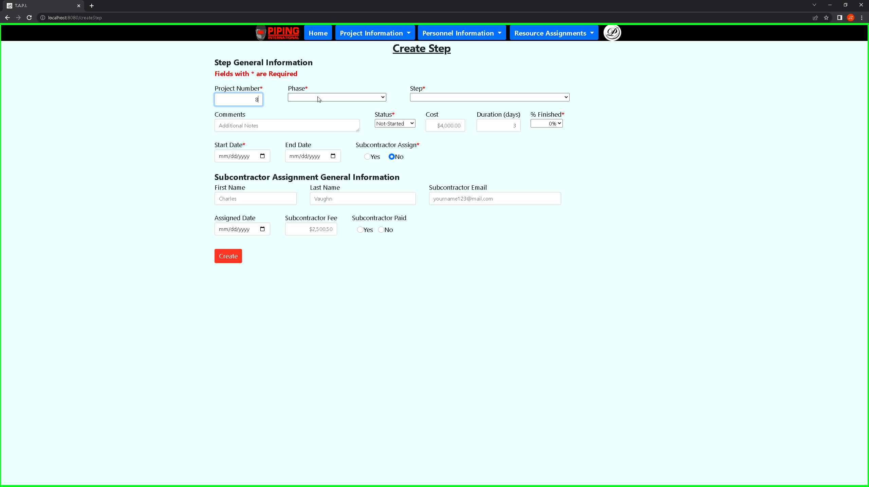 ***Screenshot 37: The above shows the create step intake form which the user must pass for the phase and step and follow the format based on the example for the input values.***

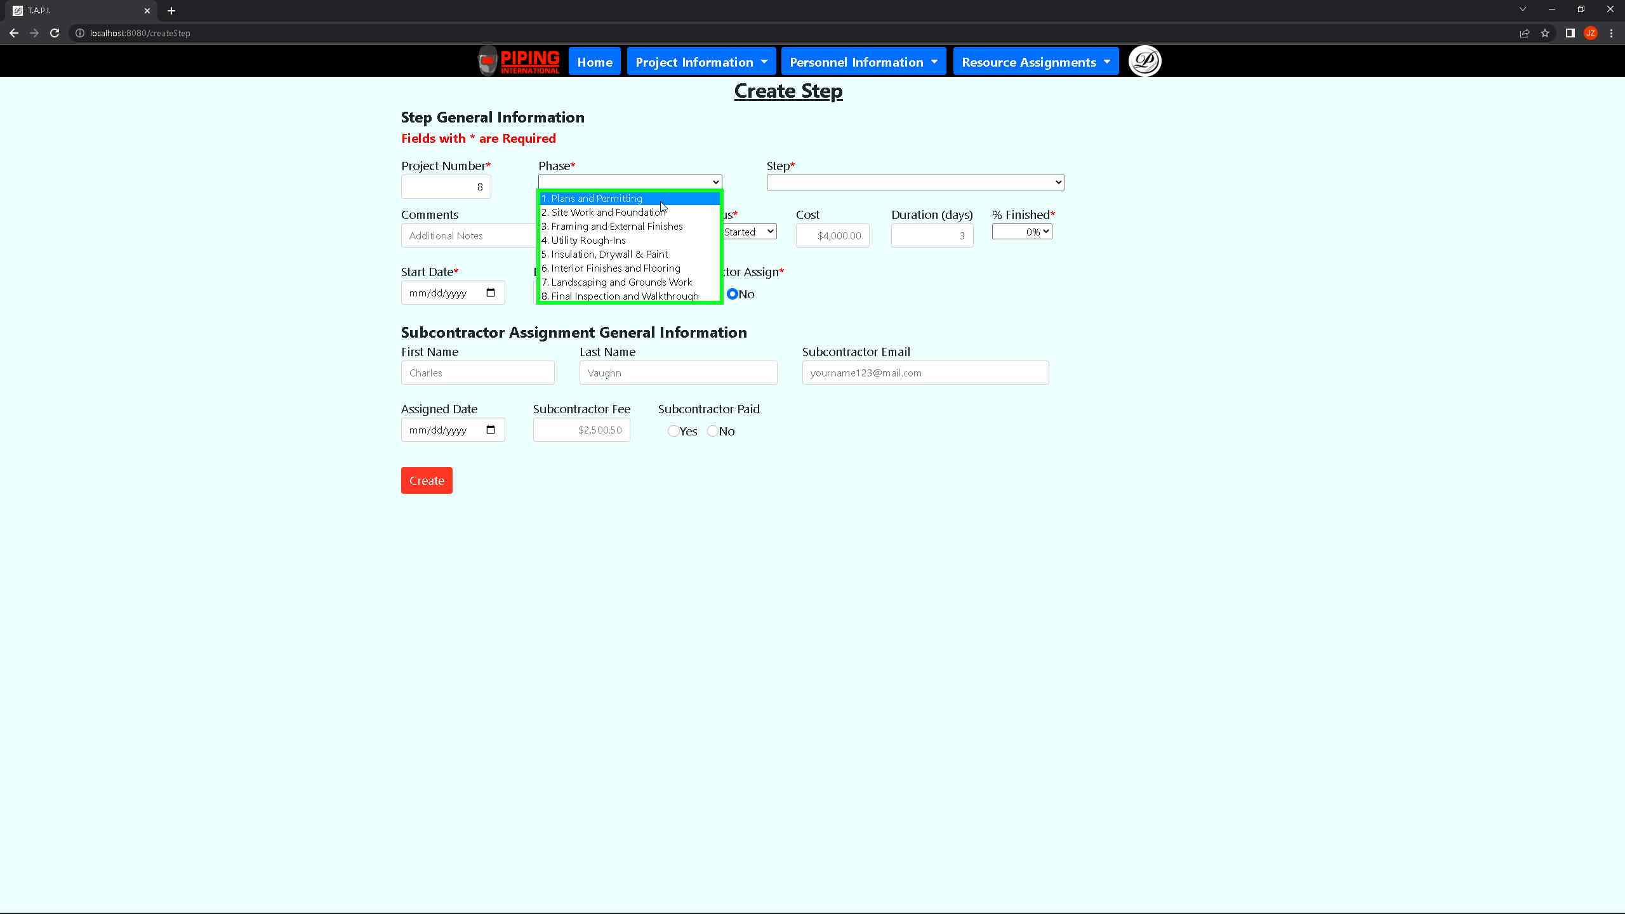 ***Screenshot 38: The above shows the create step intake form which the user selects from one out of eight phases which can be applied to a project.***

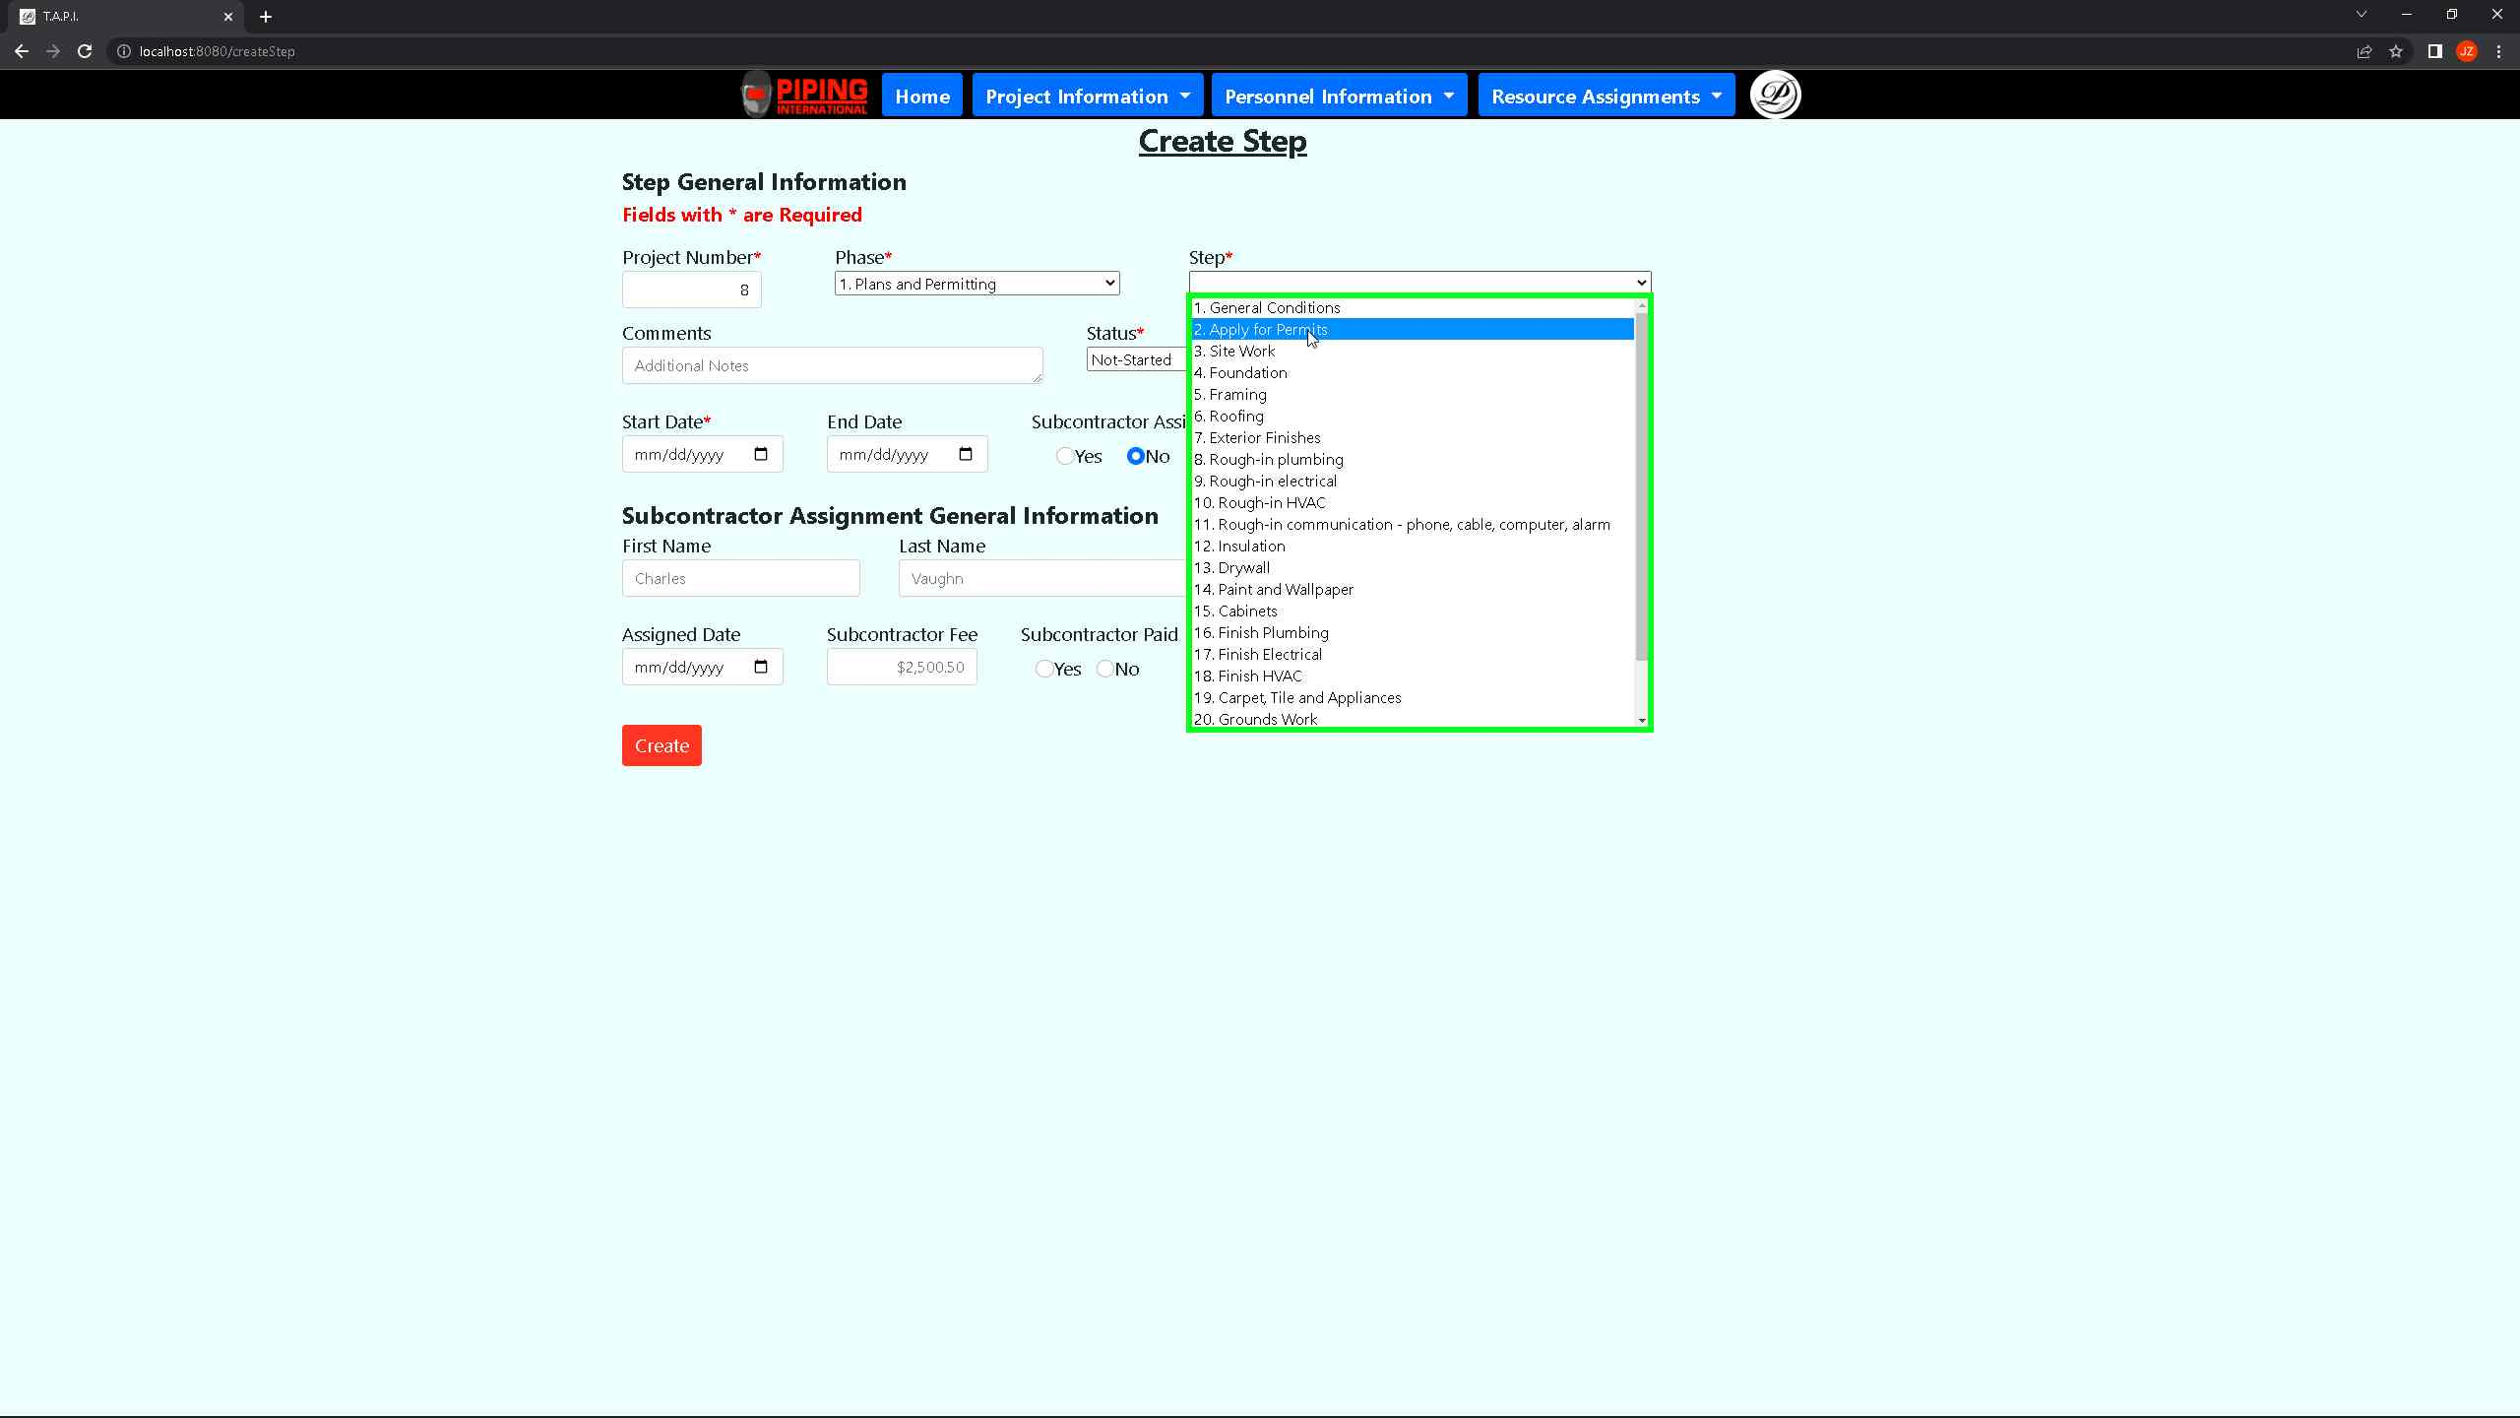 ***Screenshot 39: The above shows the create step intake form which the user selects from a predefined number of steps that can be applied to a phase for a project.***

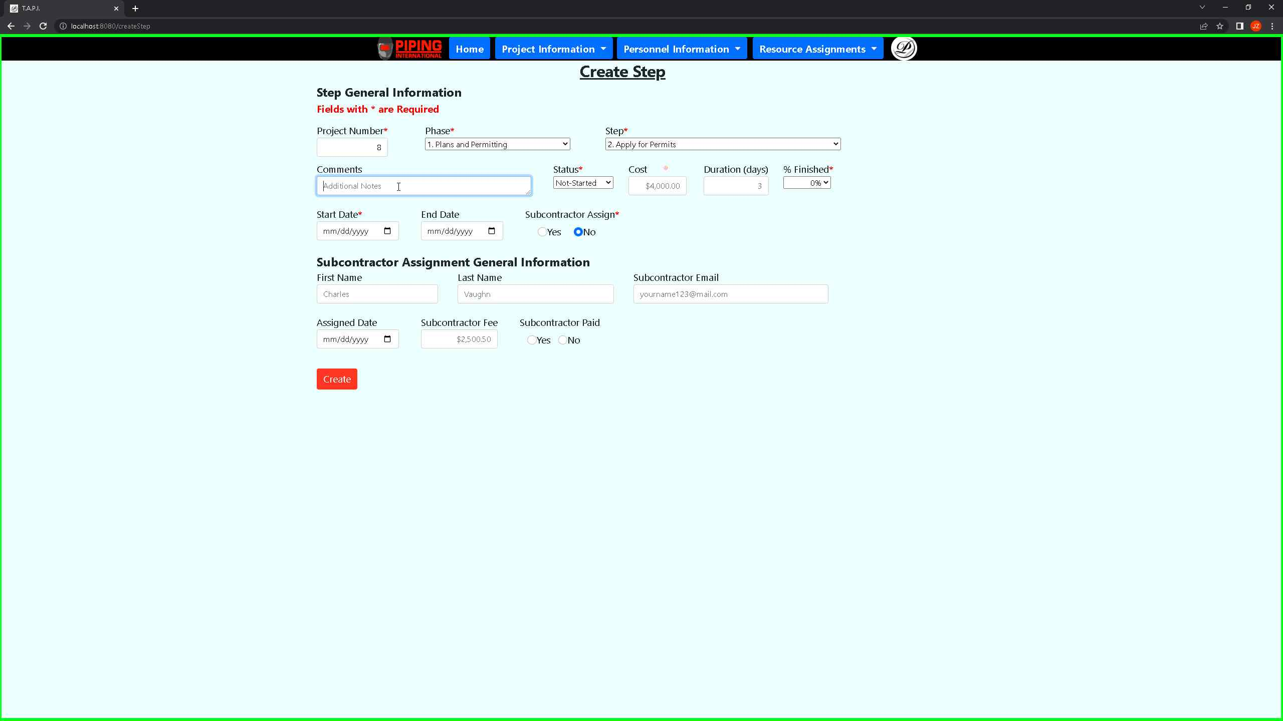 ***Screenshot 40: The above shows the create step intake form which the user can provide comments for and additional information that can benefit the user as well.***

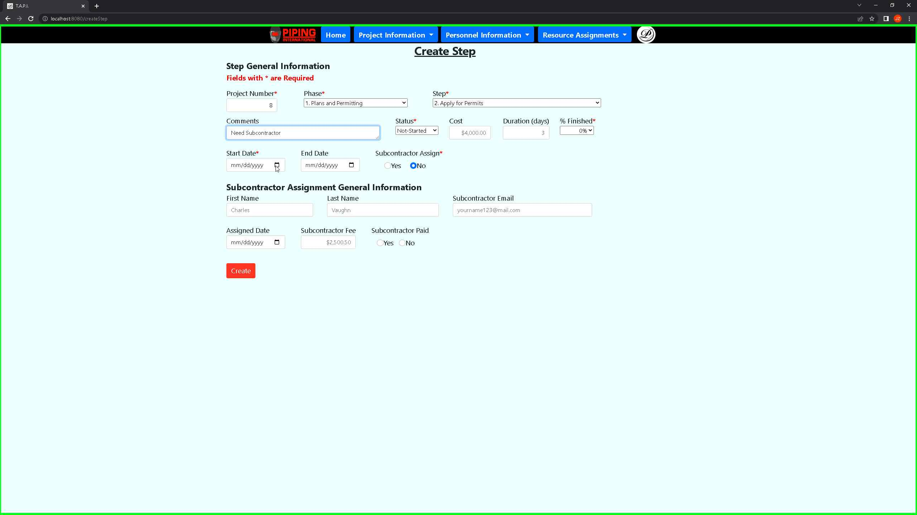 ***Screenshot 41: The above shows the create step intake which the user can link back to a subcontractor by filling out the subcontractor email which must match the one provided in the subcontractor intake form.***

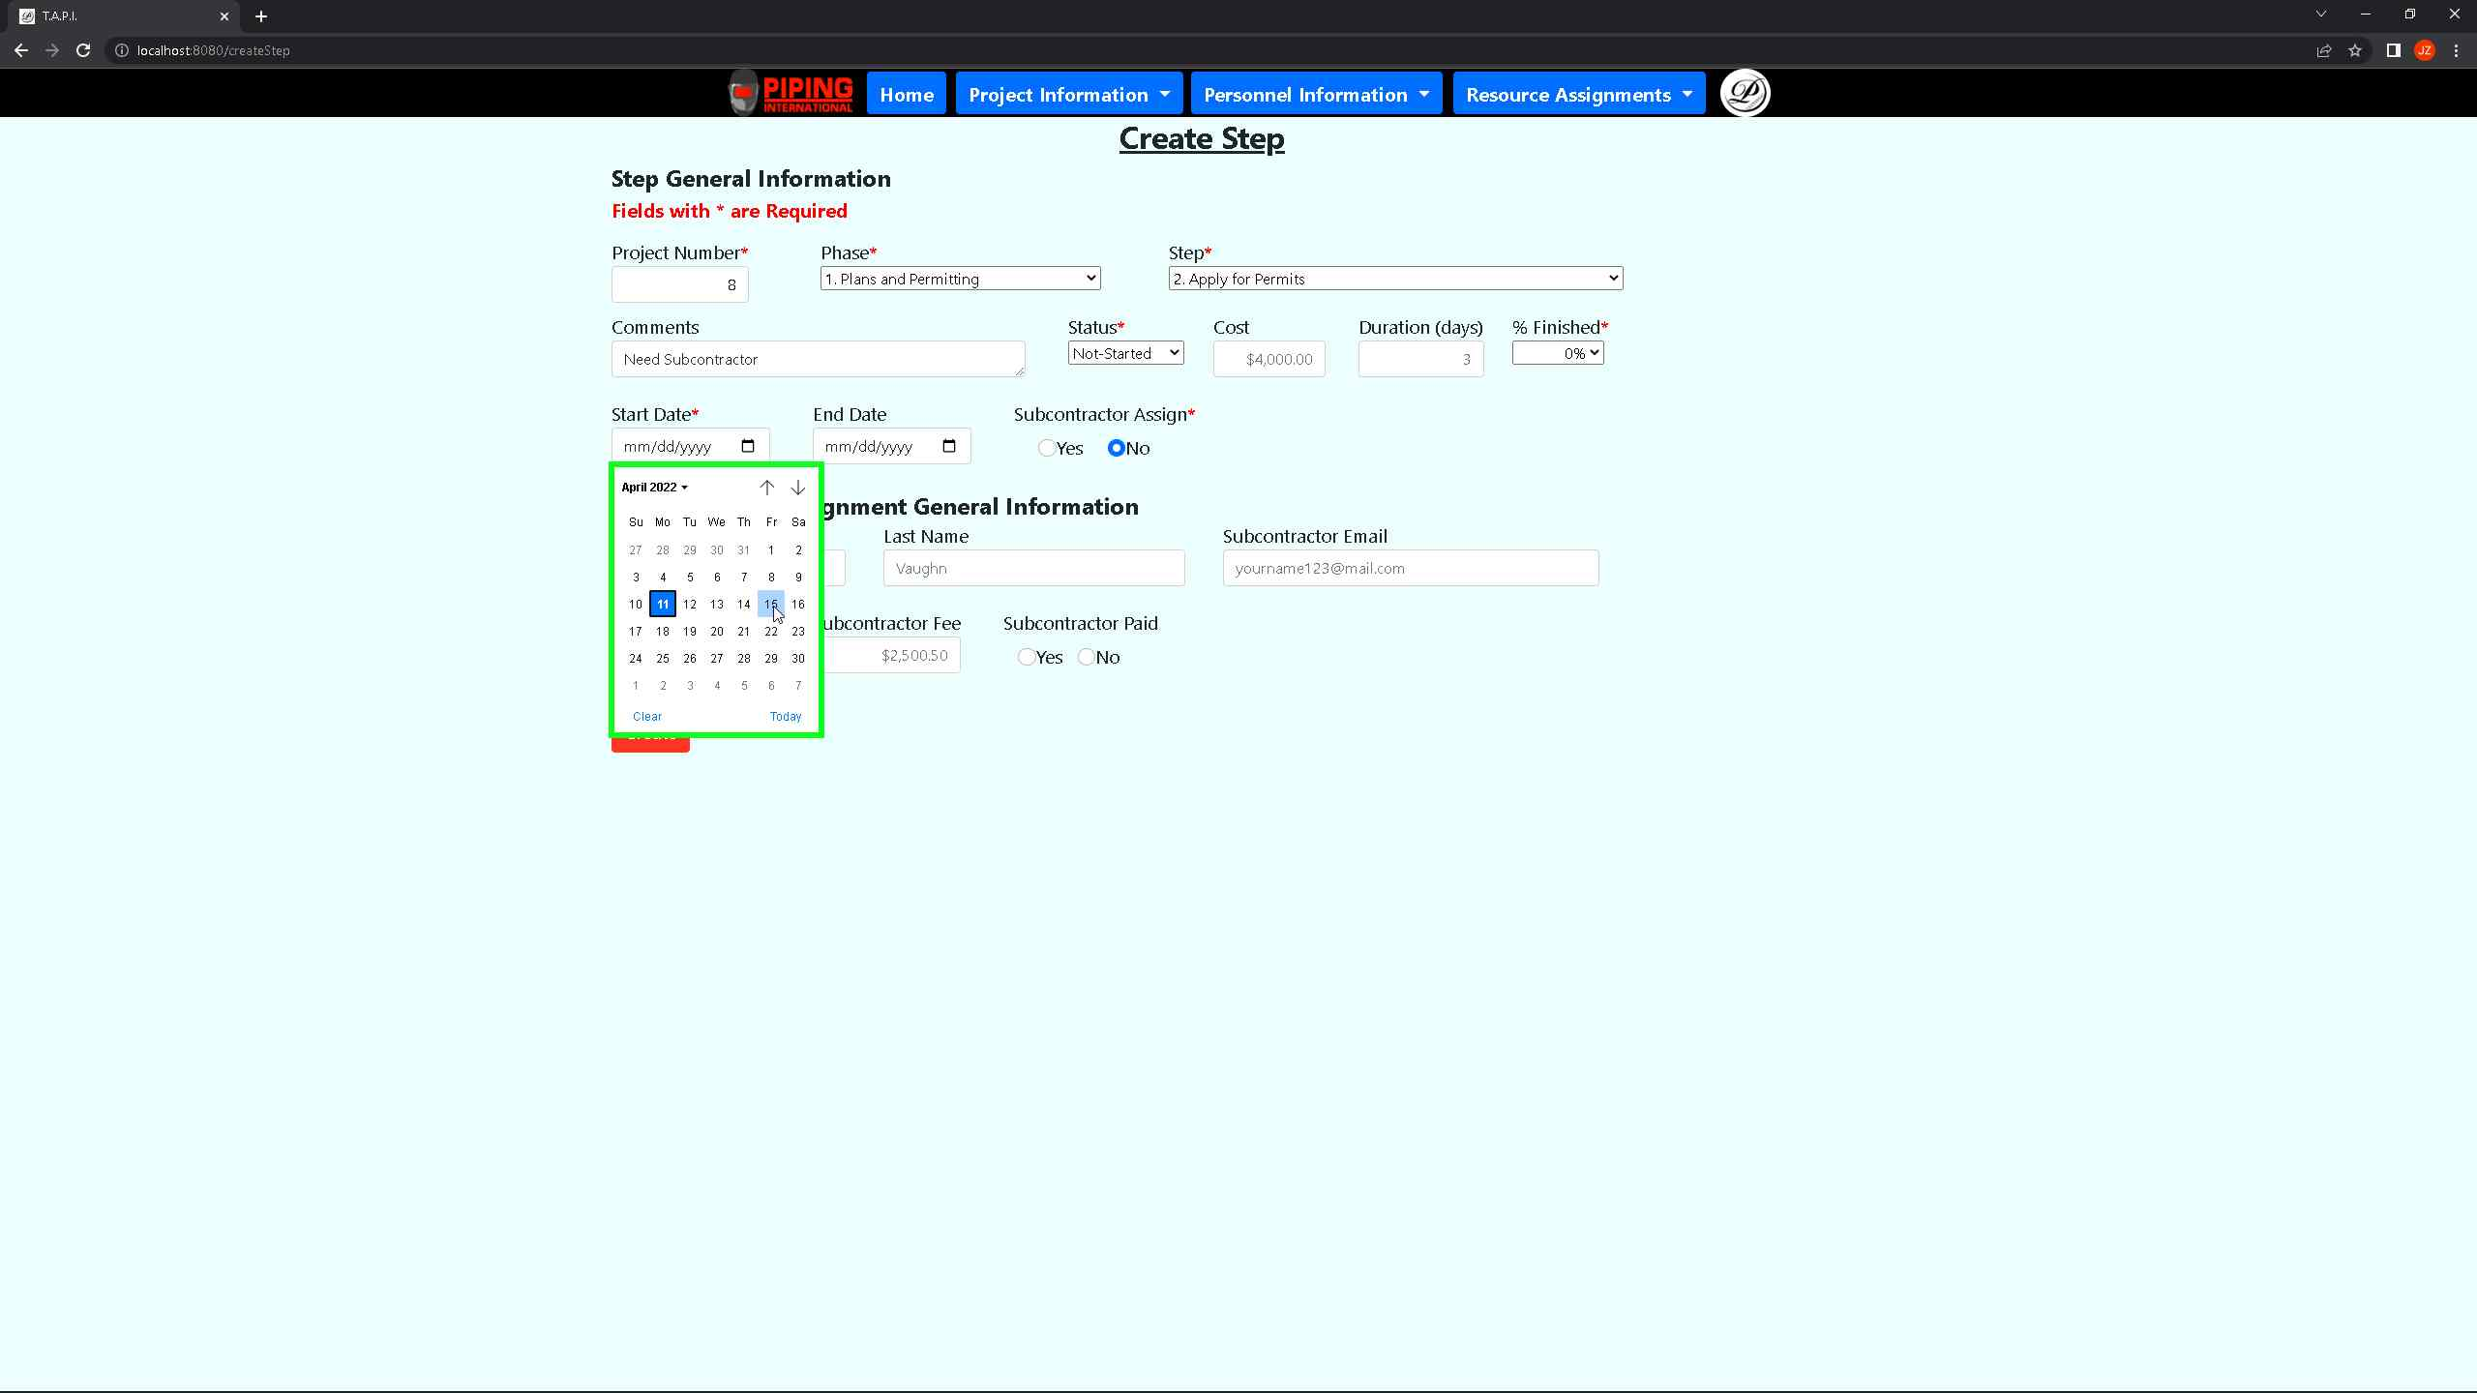 ***Screenshot 42: The above shows the create step intake which the user must pass for the start date of the step where there is no tracking or precedence when a start date is selected. It does not update on its own and the user will have to manually update it.***

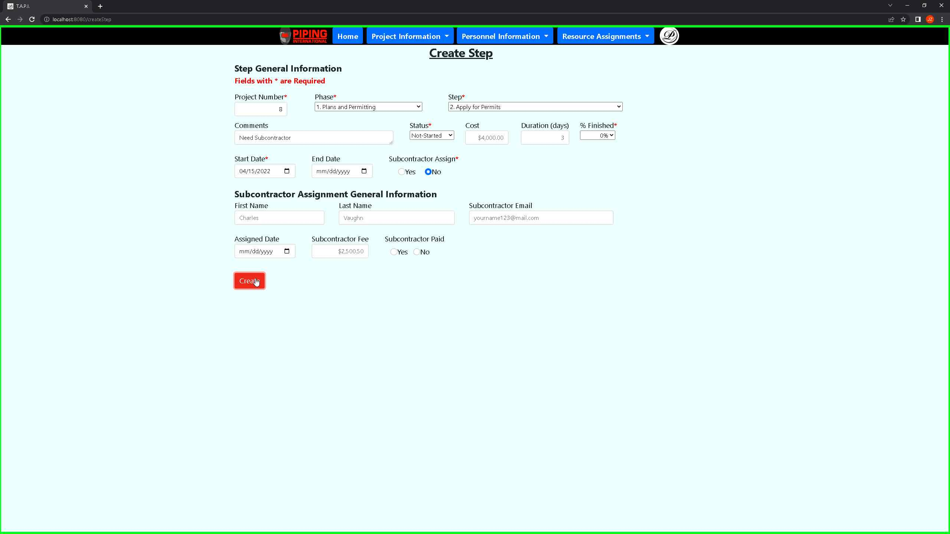 ***Screenshot 43: The above shows the create step intake which the user must pass for the start date of the step where there is no tracking or precedence when a start date is selected. It does not update on its own so the user will have to manually update it.***

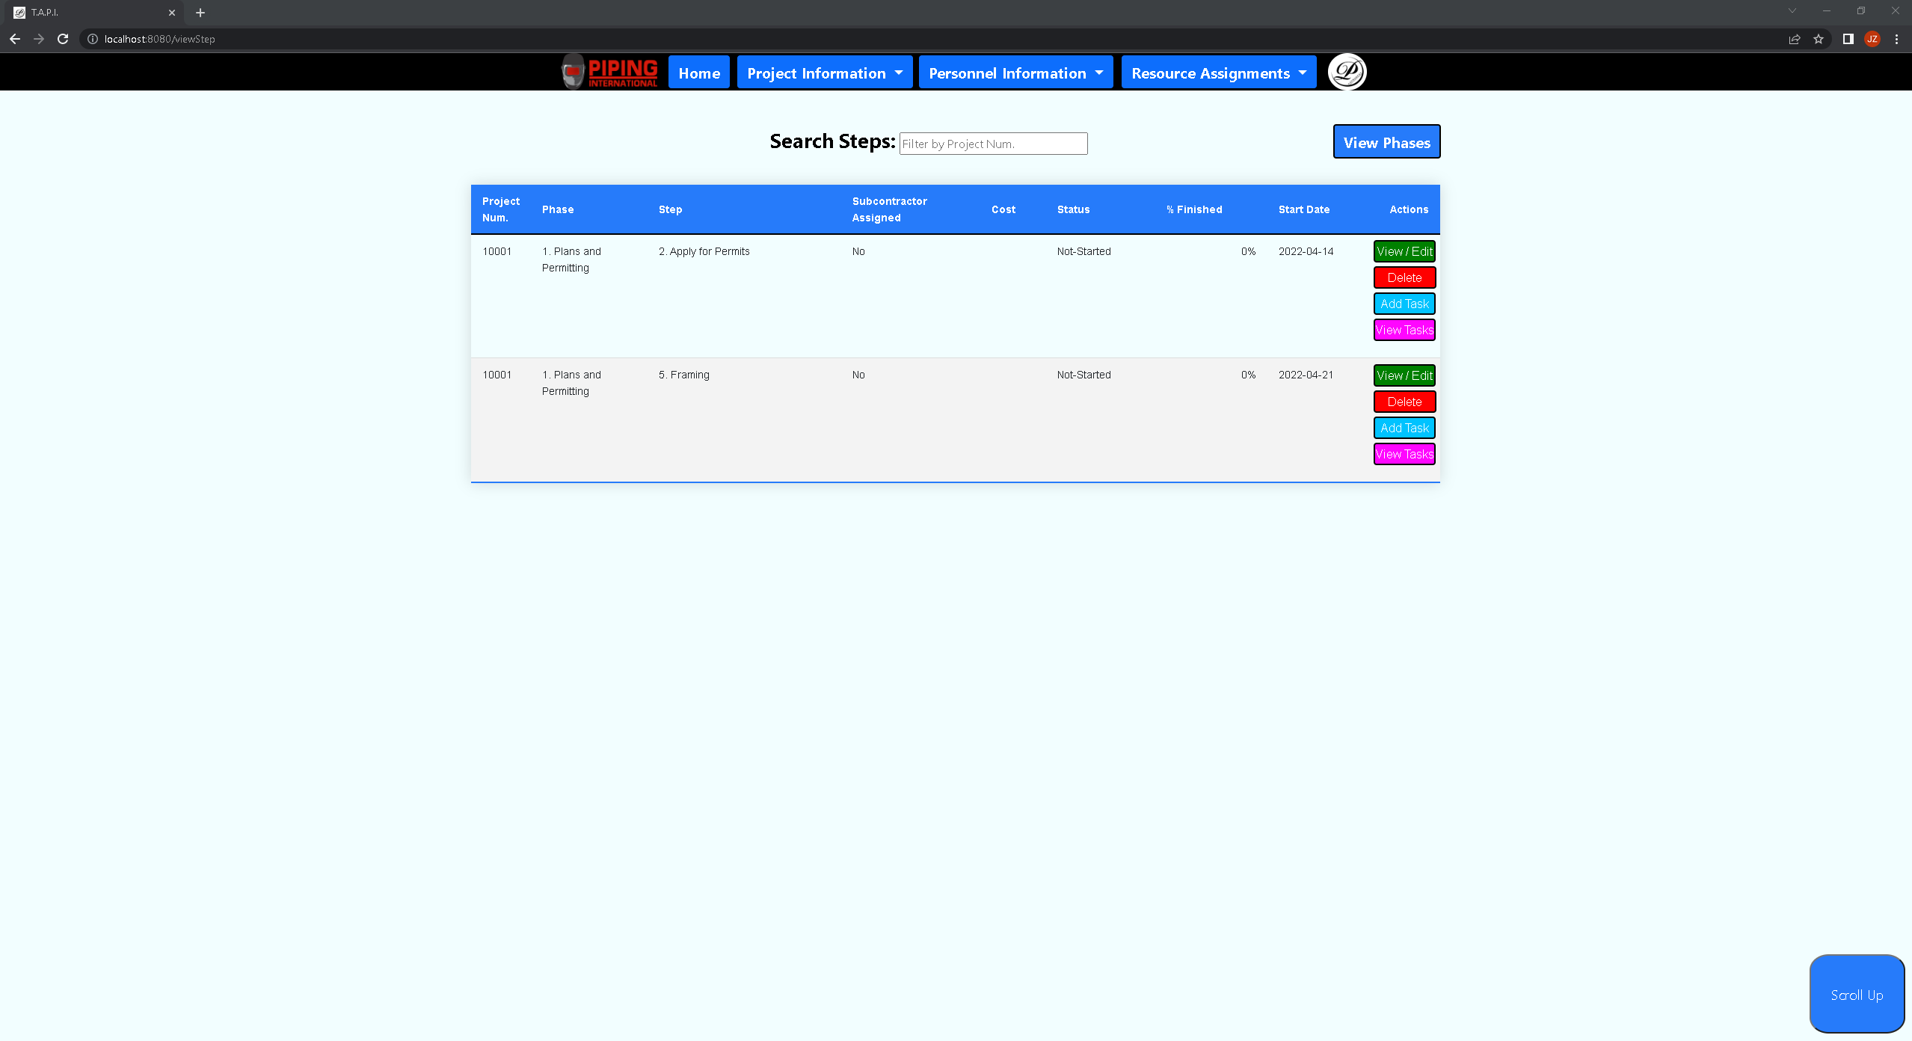 ***Screenshot 44: The above shows that once the user successfully creates a step, he will be taken to the view steps page that shows cases for all the steps present and their respective columns that list unique info for a step.***

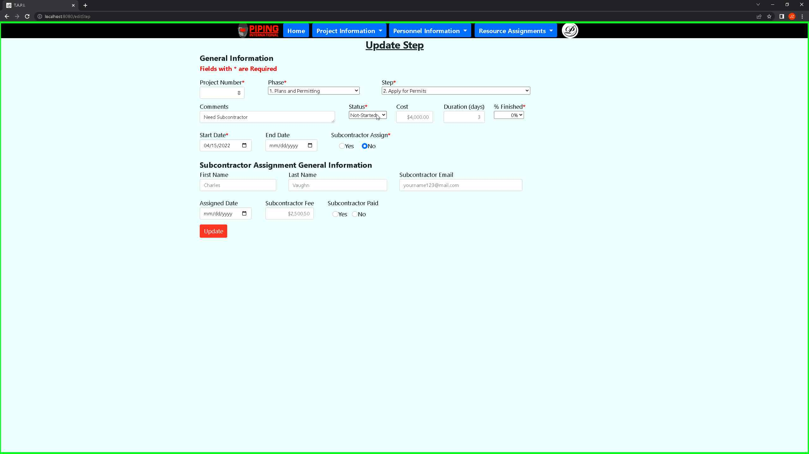 ***Screenshot 45: The above shows that once the user is in the view step, he can click on the view/edit button which lets him update one row of data that pertains to a step.***

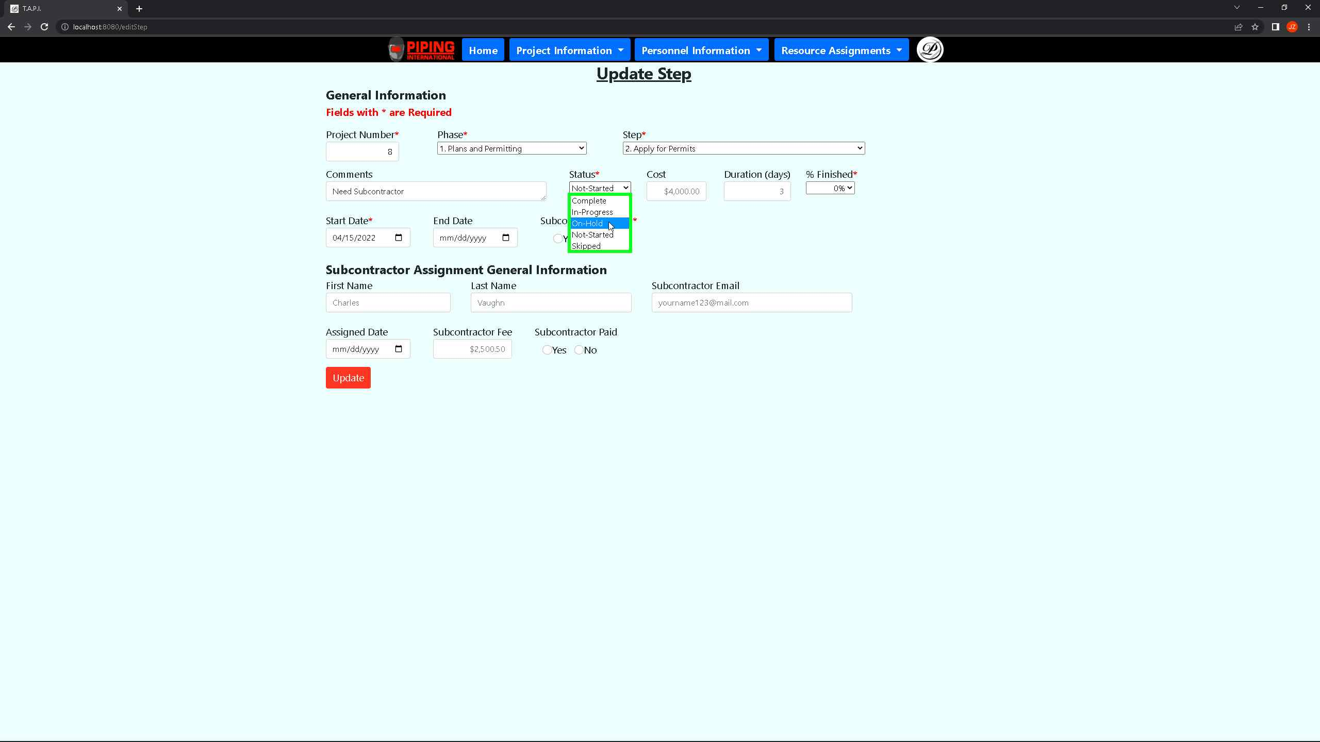 ***Screenshot 46: The above shows the update step page which the user can update for any field once it is present in this case, showing an update for the status.***

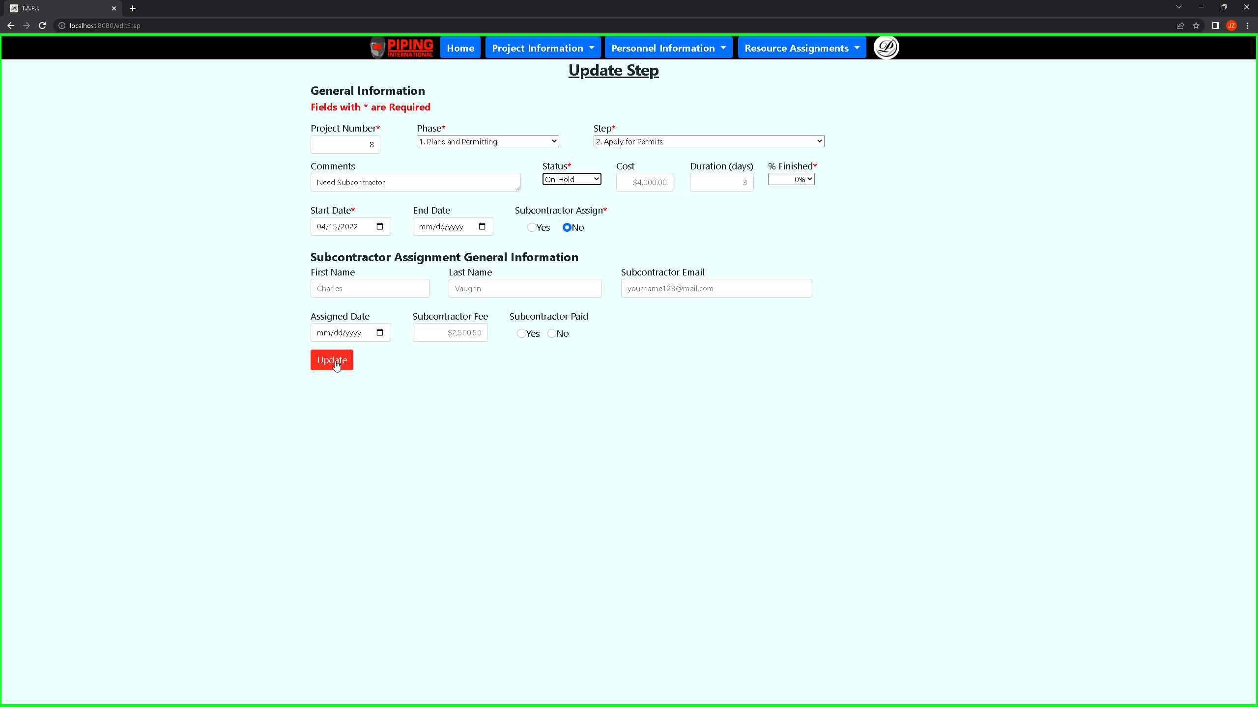 ***Screenshot 47: The above shows the update step page which the user can use once he is done with edits clicks on the update button. This will then take him back to the view steps page.***

*** Screenshot 48: The above shows that the user within the view steps can filter through records of data based on the project num.***

*** Screenshot 49: The above shows that the user within the view steps can delete one step by clicking on the delete button which will produce a popup about whether he wants to delete the row.***

*** Screenshot 50: The above shows that the user within the view steps can go back to the phases by clicking on the view phases that will take the user back to the view phase’s page.***

*** Screenshot 51: The above shows that within the view steps page the user can click on the add task button that will take him to the create task intake form.***

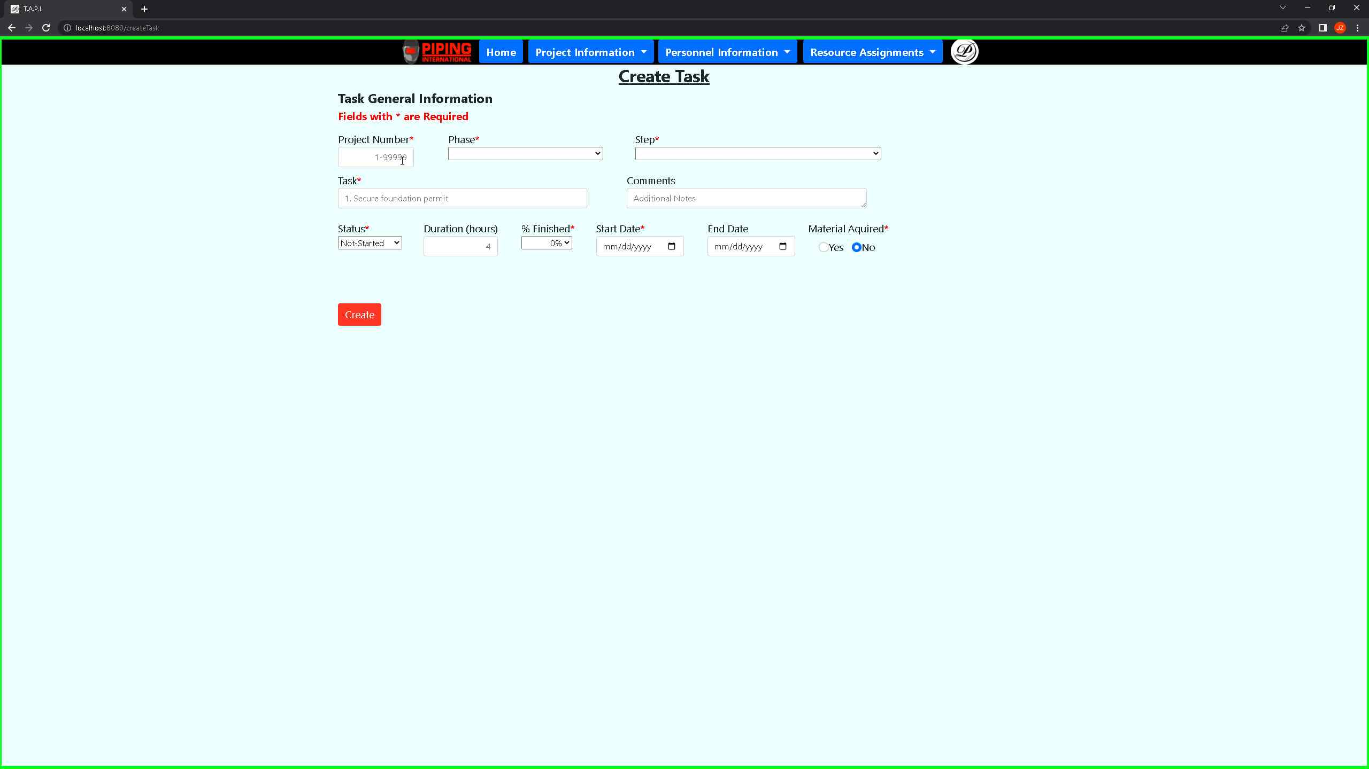 ***Screenshot 52: The above shows the create task intake form which the user is required to fill out all the required fields with red asterisk.***

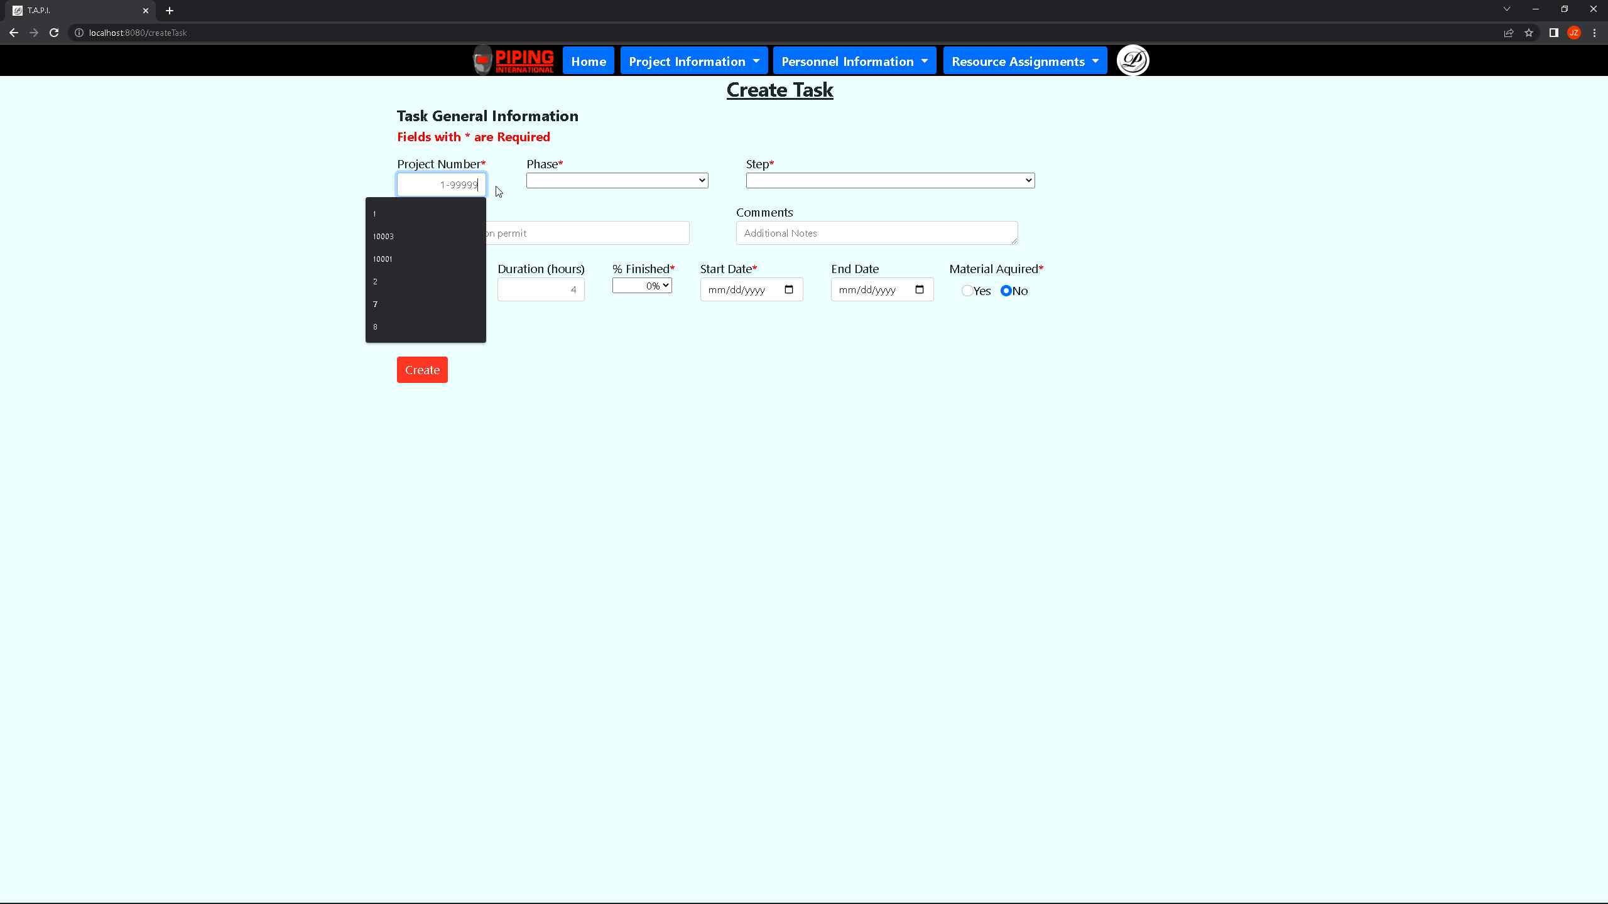 ***Screenshot 53: The above shows the create task intake form which the user must pass the phase, step, and project num as that helps link that to the project number. Also, the step is what links back to task base on that step value ensuring that a step can have assigned tasks to it.***

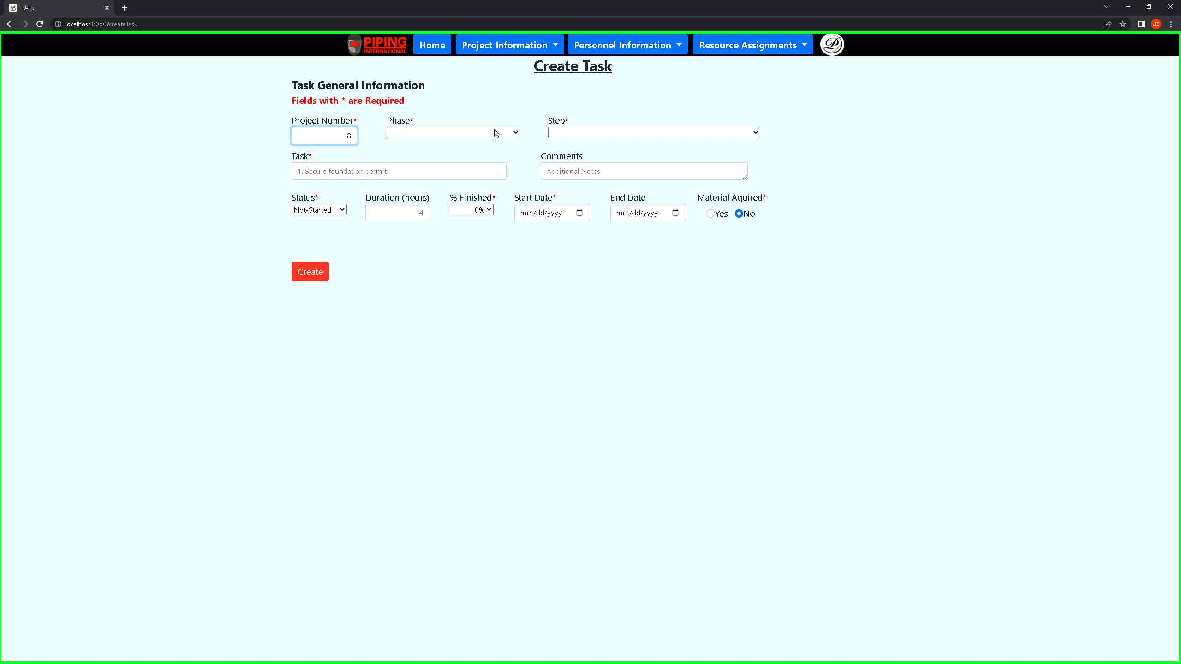 ***Screenshot 54: The above shows the create task intake form is that the user will be presented an intake form that some values are defaulted to make it quicker for the user to create a task.***

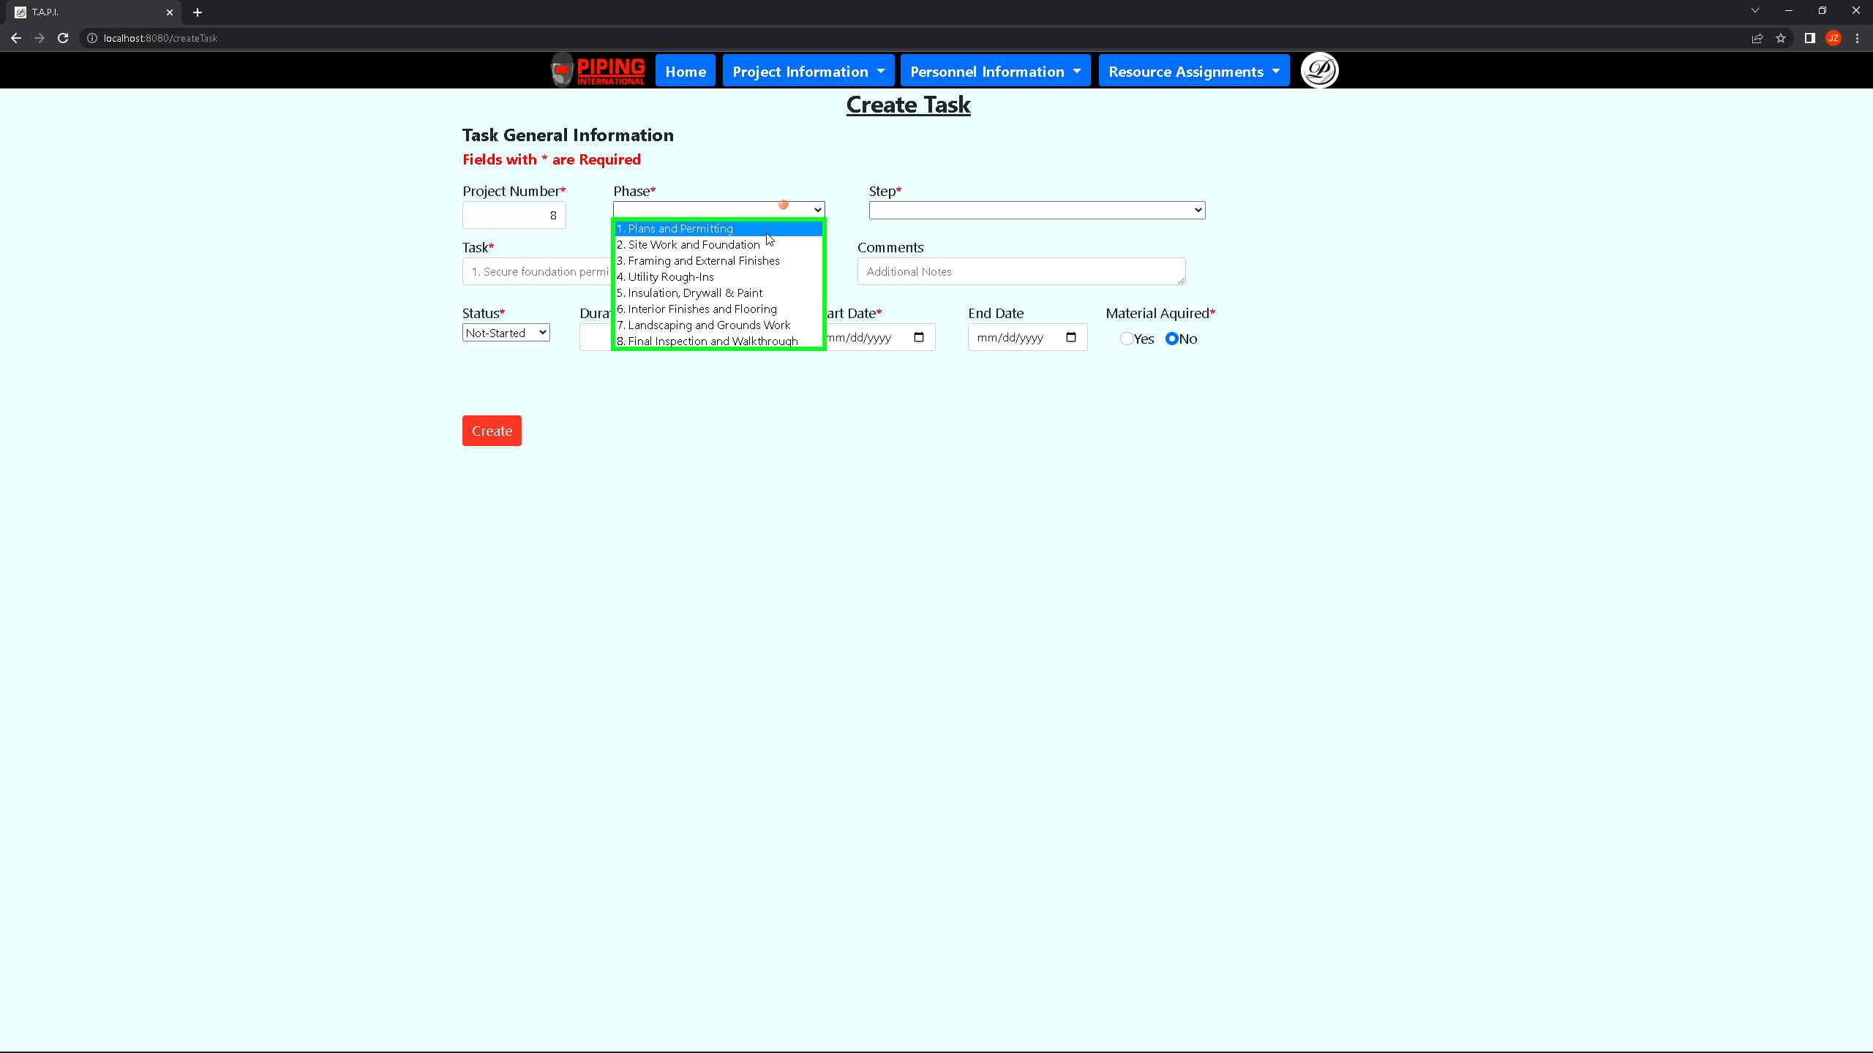 ***Screenshot 55: The above shows the user the create task intake form which the user will see the same predefined phase info that will also be the case for the step.***

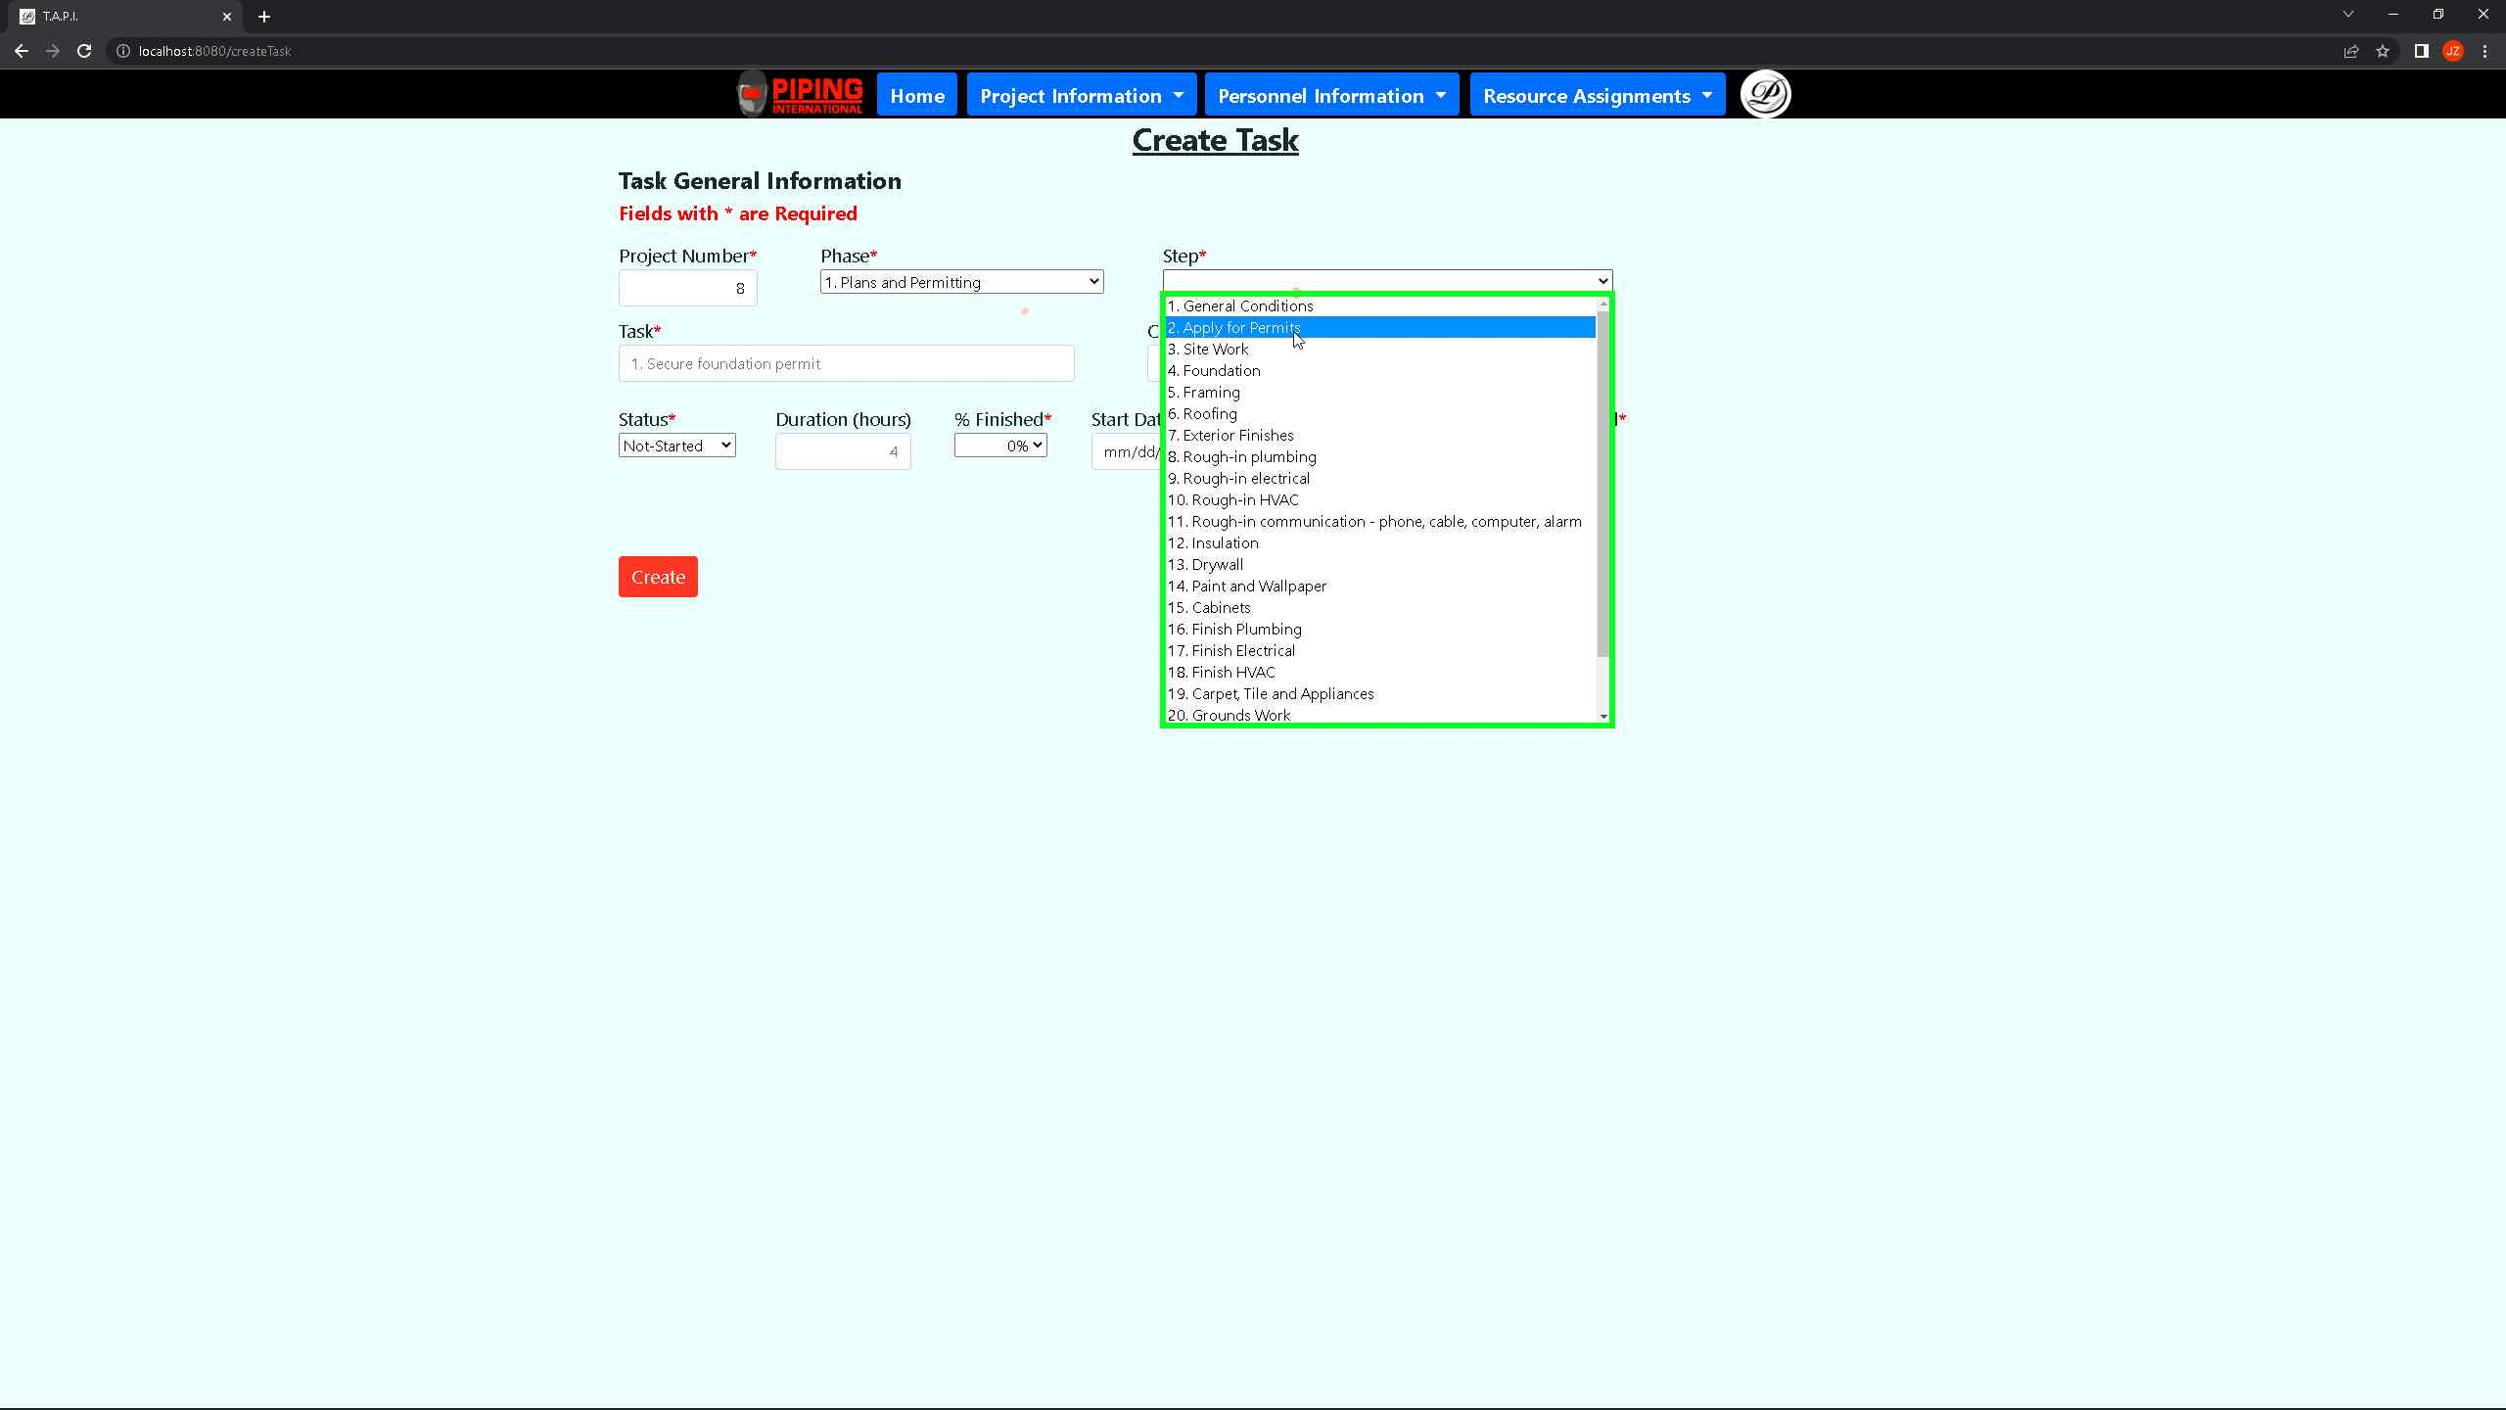***Screenshot 56: You must make sure to pick the phase and step fields according to what the task is intended for from the previous tables***

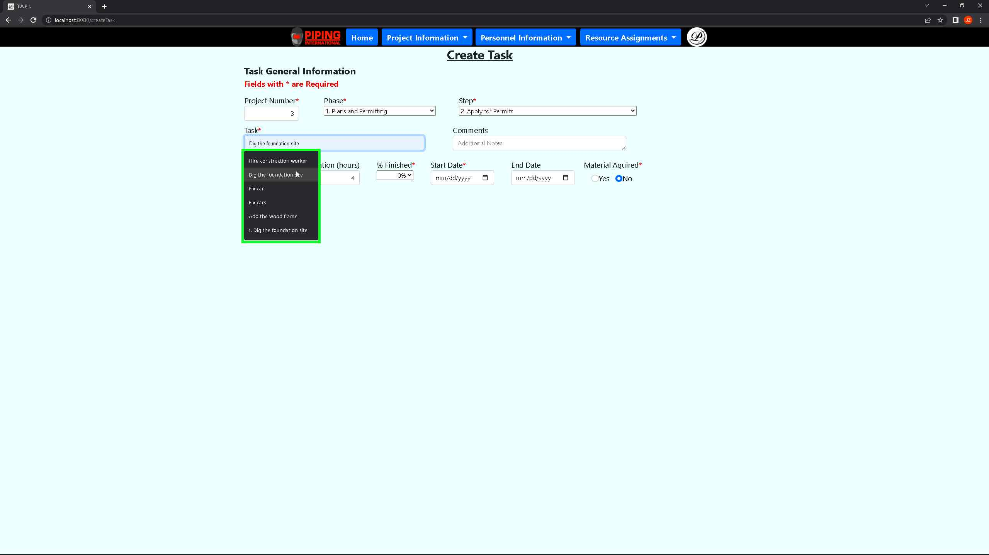 ***Screenshot 57: The task can be anything and since it is dependent on the kind of job required to do in the project.***

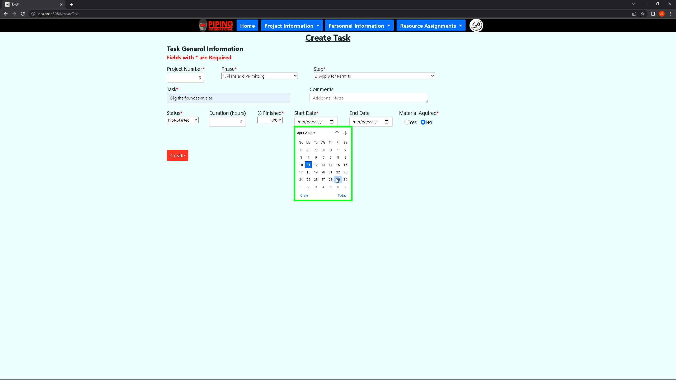 ***Screenshot 58: Choose Start date for task to include the beginning of this task. If it has not been started yet, then it must be 0% finished. If it is completed, then it is 100% and the start date will have to be in the past.***

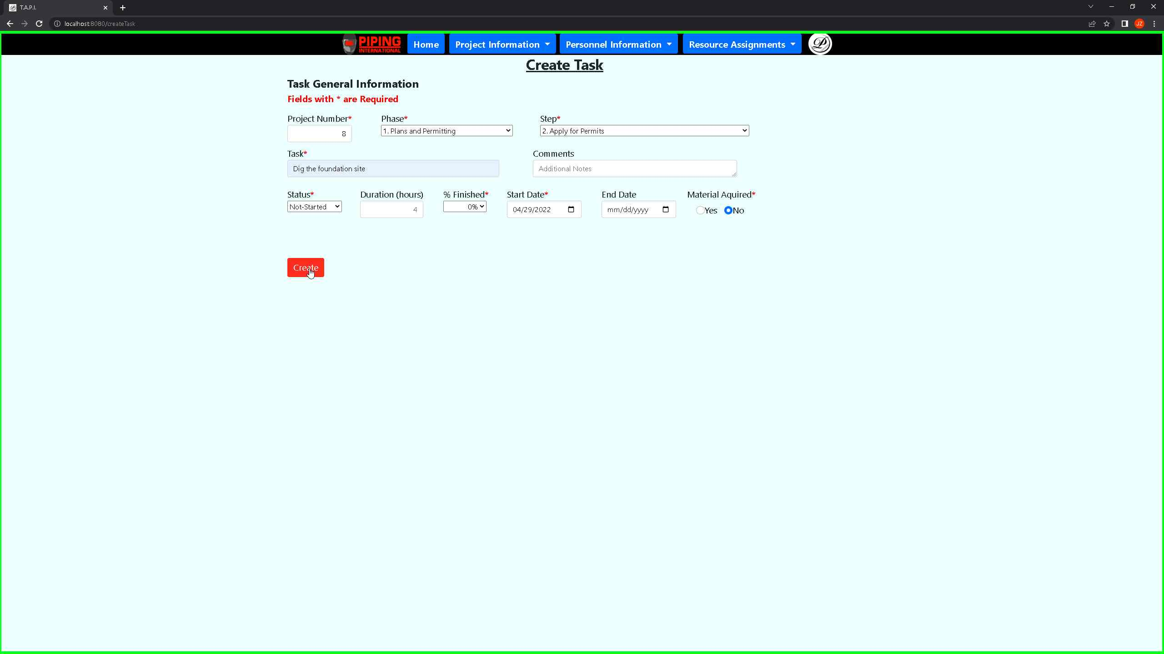 ***Screenshot 59: Once all required fields are typed, you may press the create button to generate a new record in the task table***

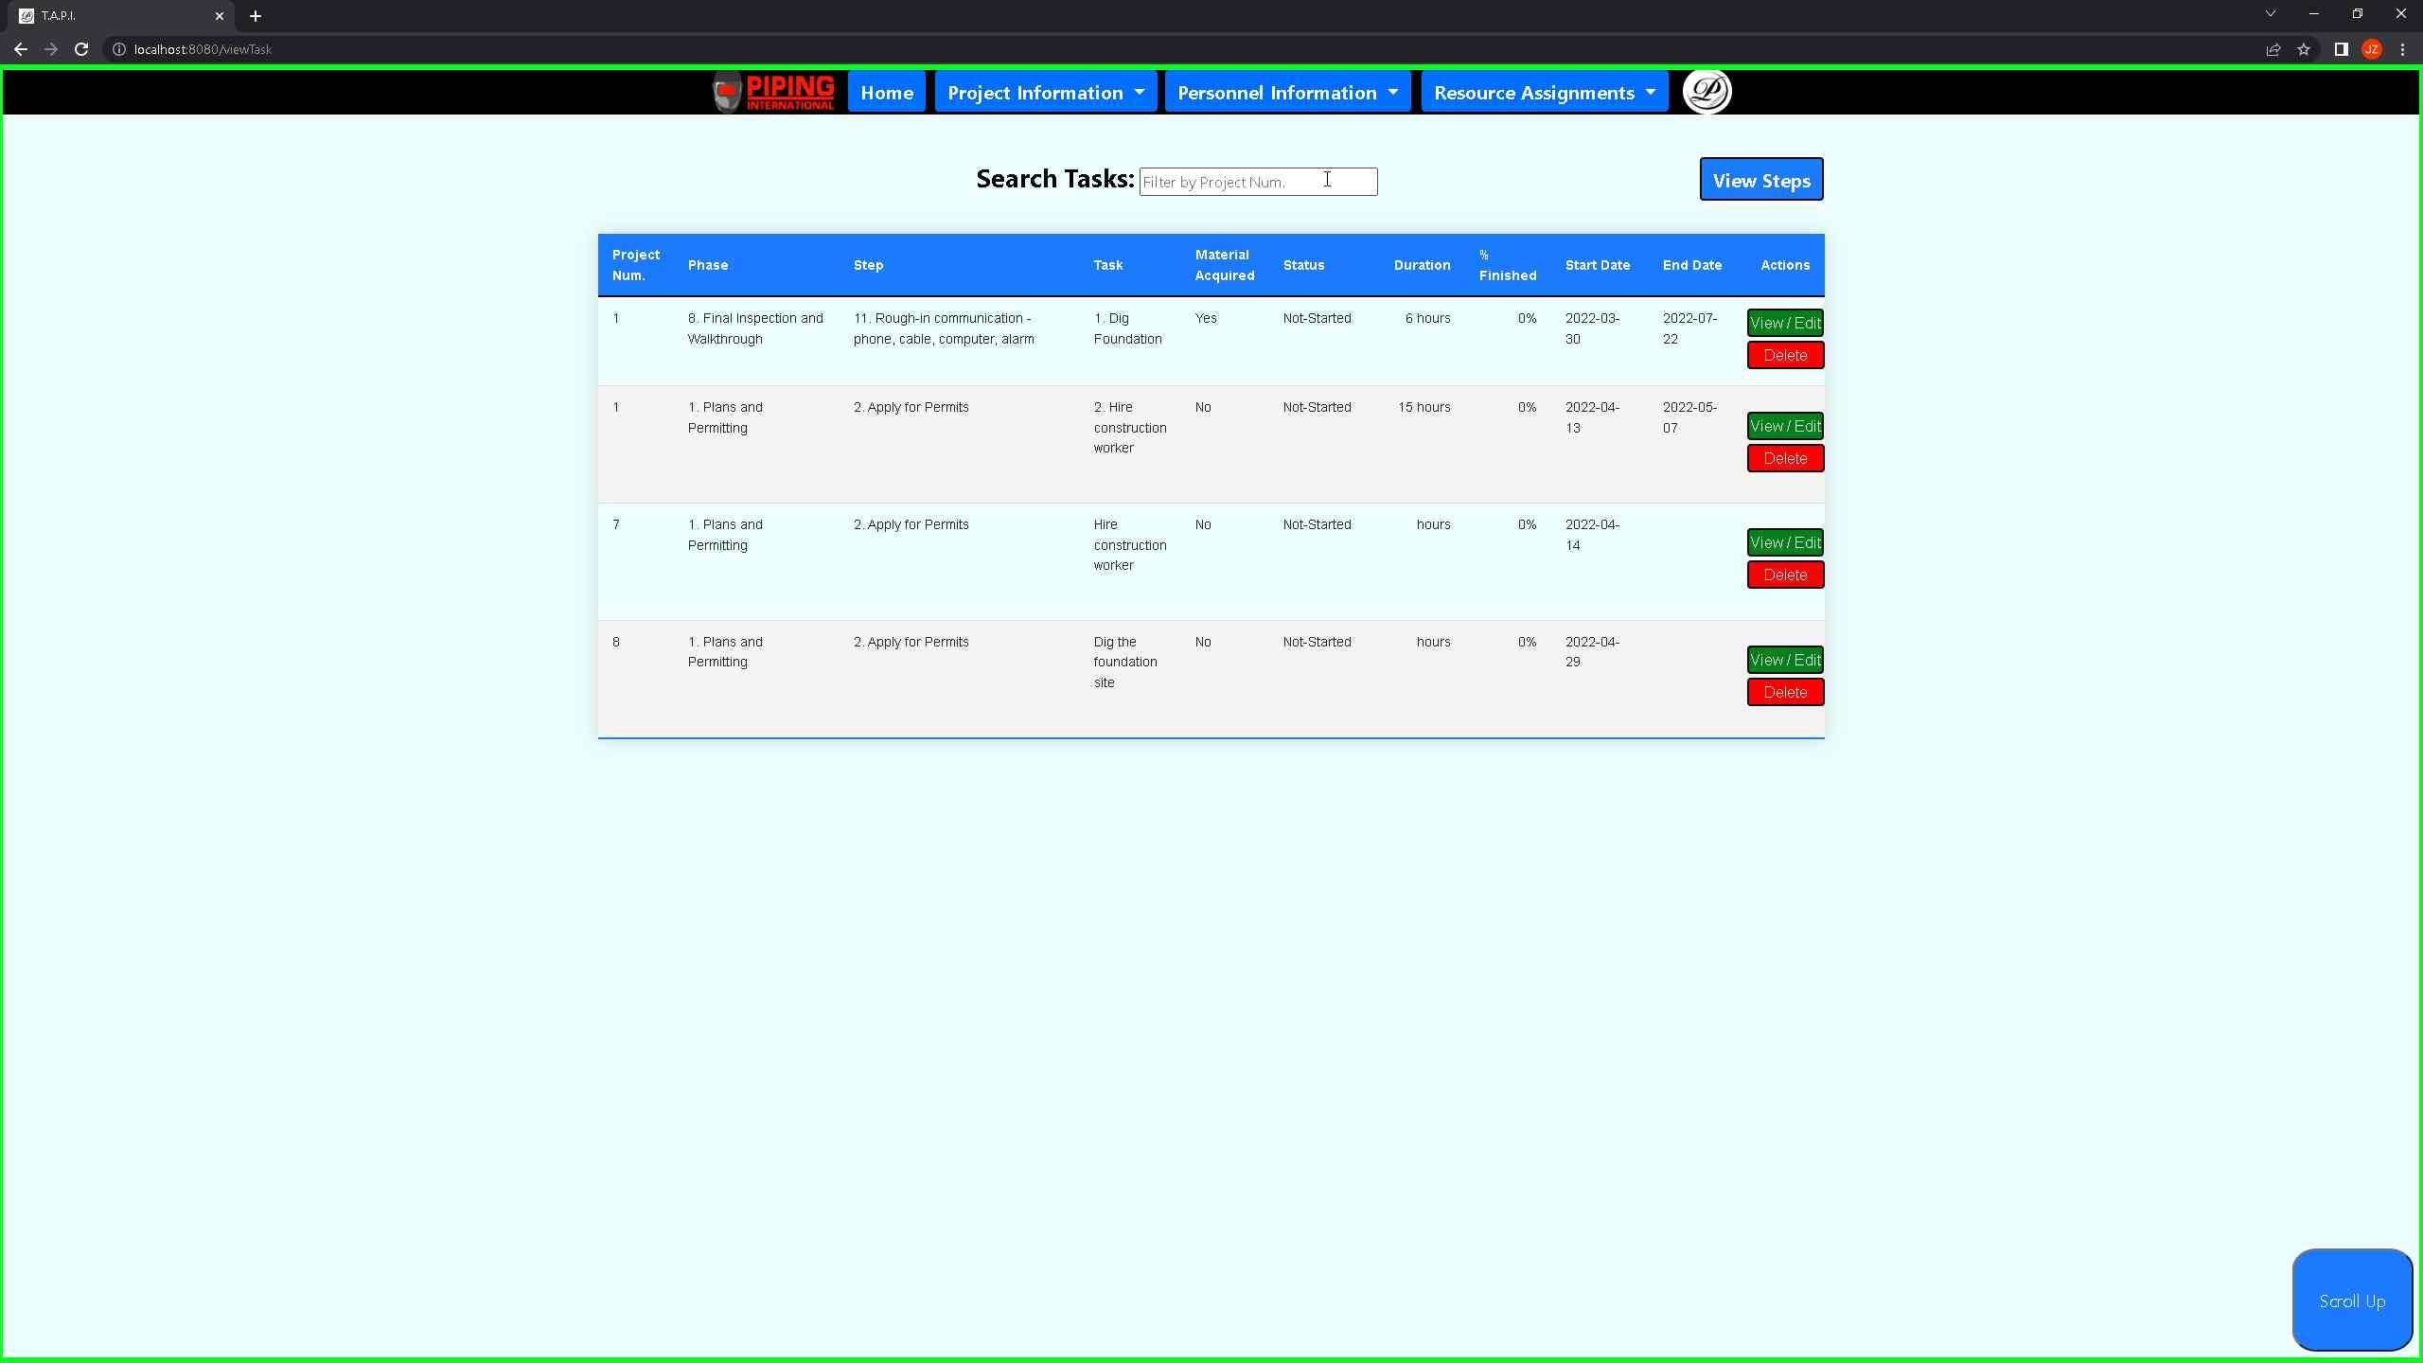 ***Screenshot 60: You will return to the task table once the task is generated with the new record shown above***

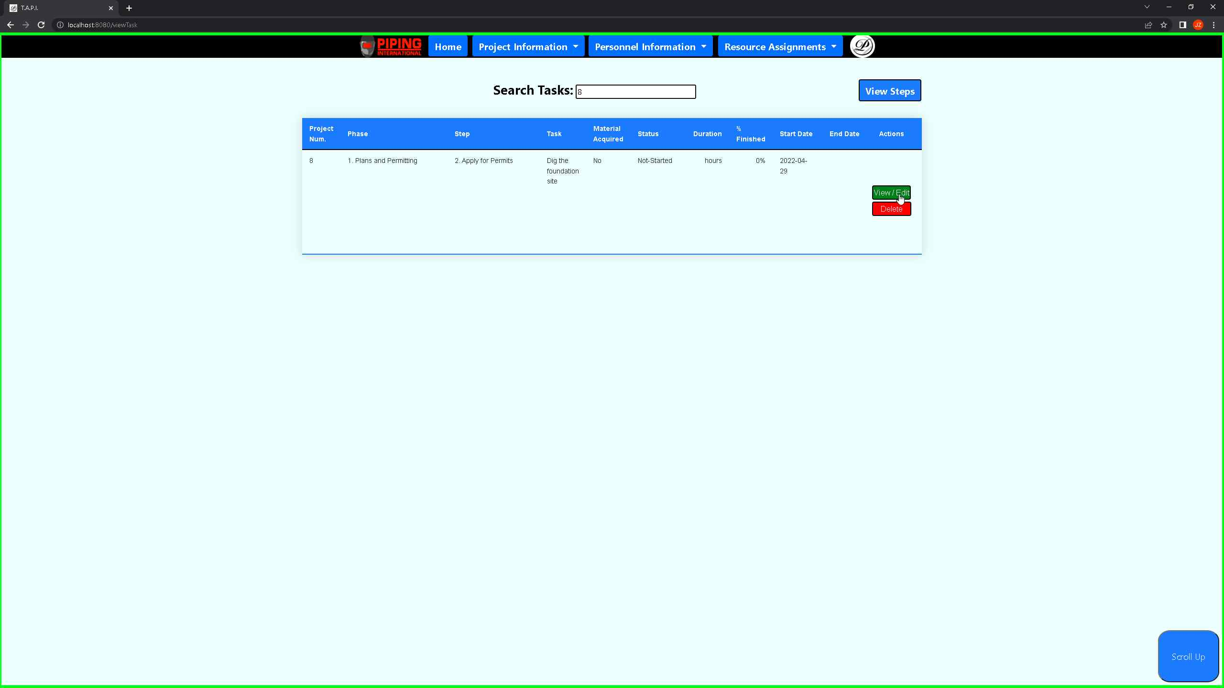 ***Screenshot 61: You can search for a task by using the search function. This searches by project number.***

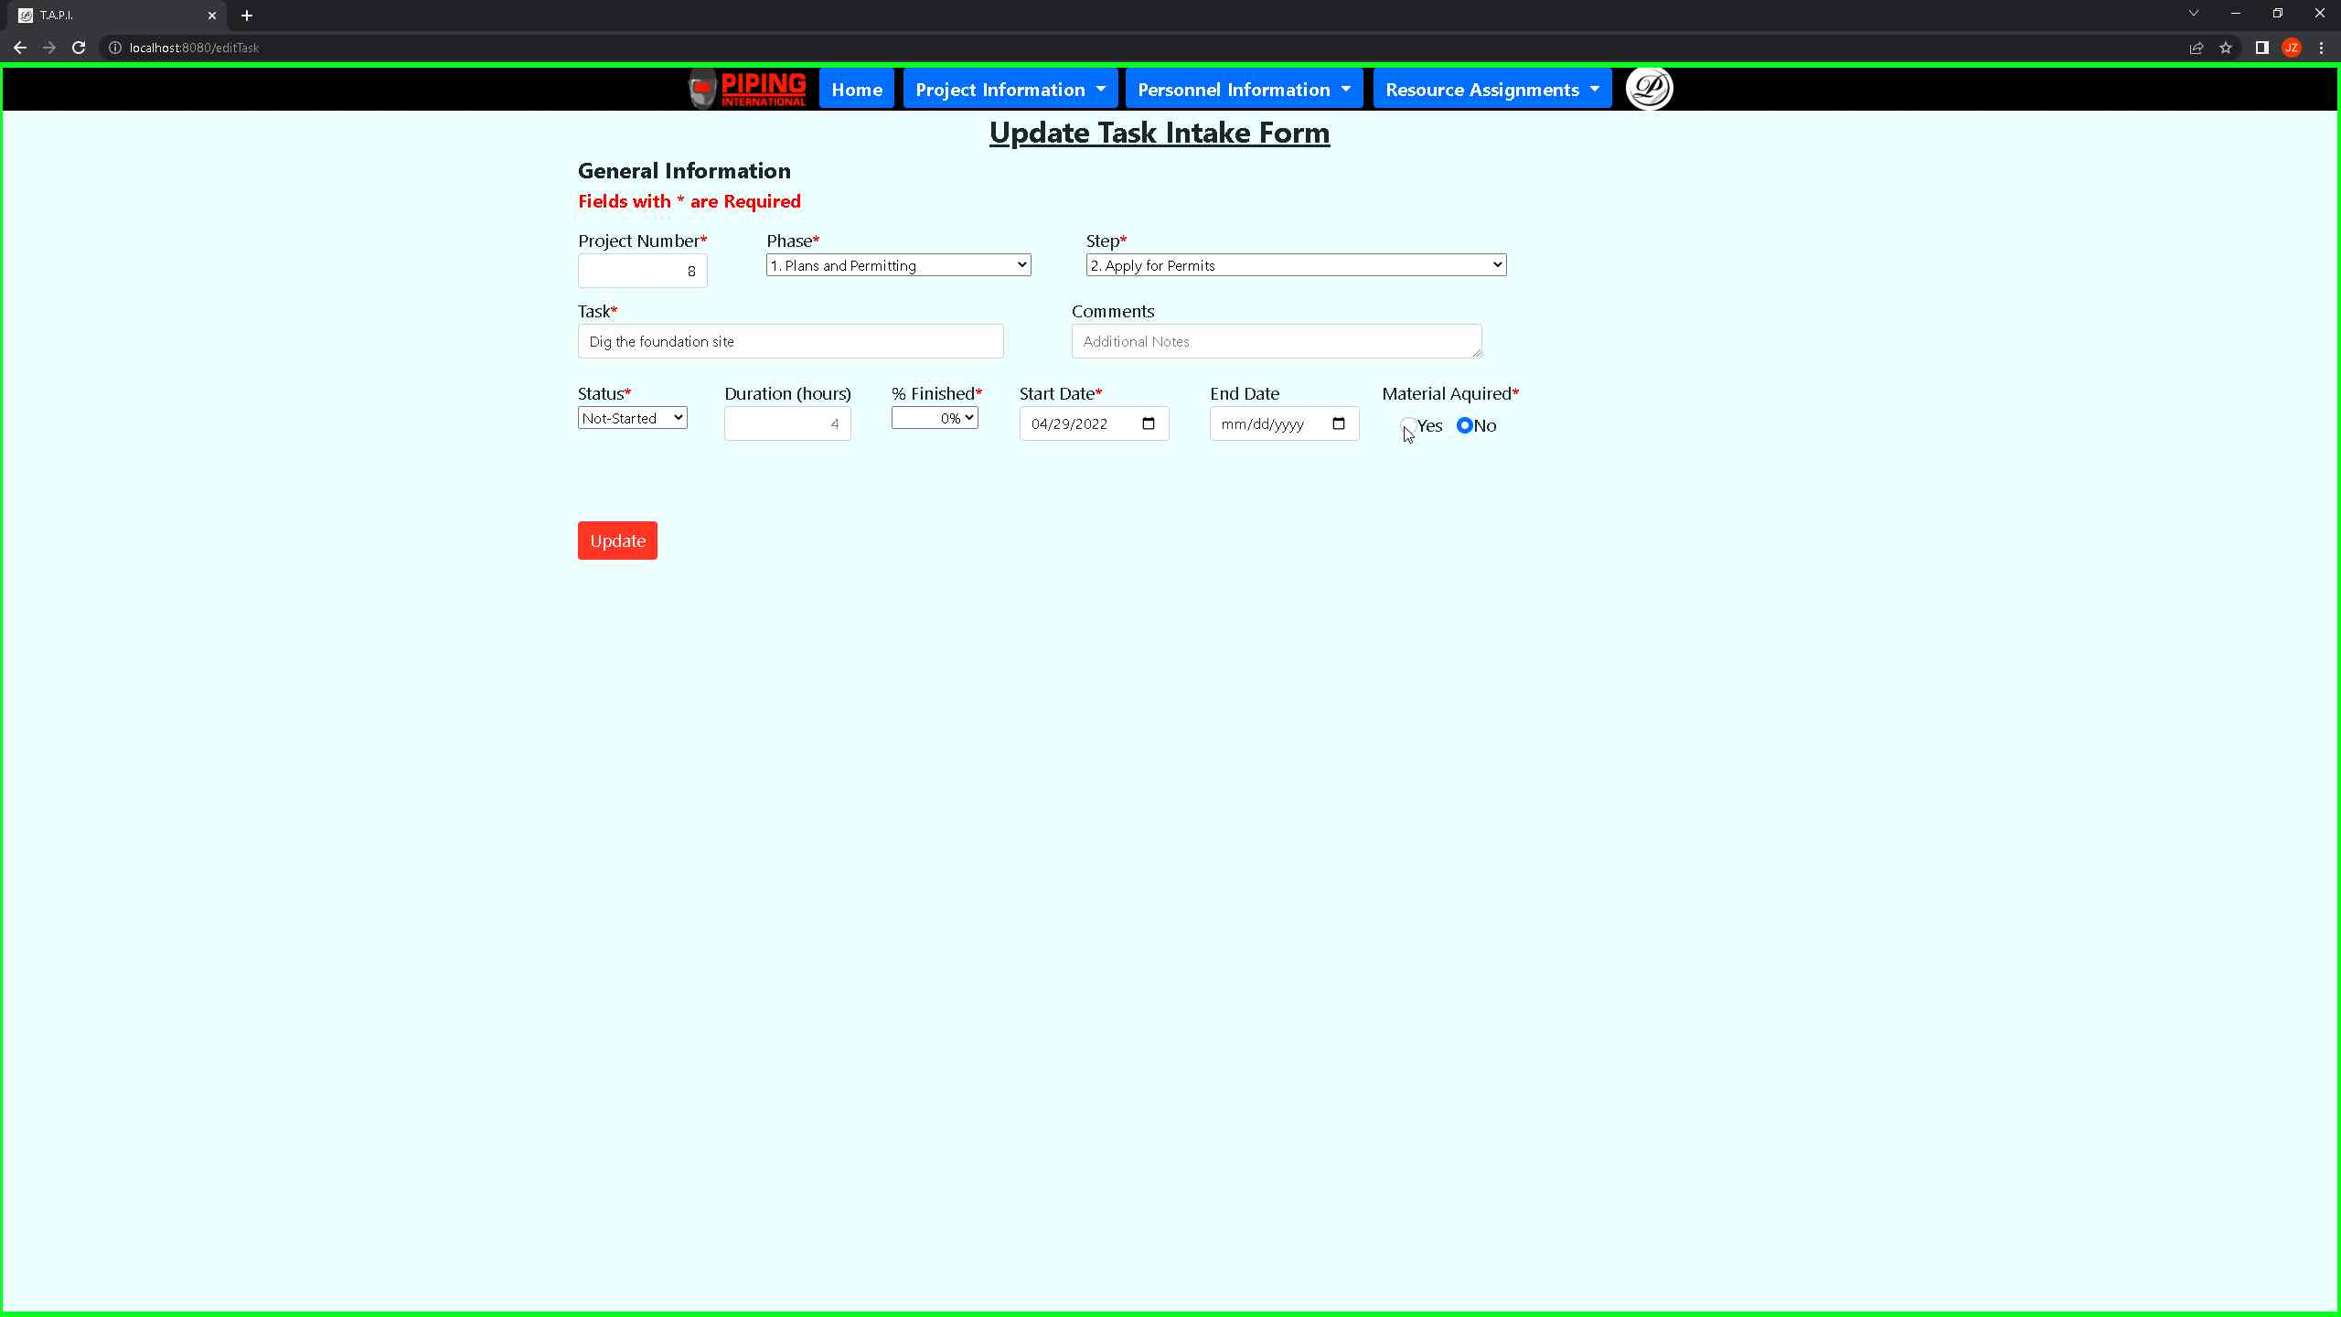 ***Screenshot 62: If you would like to update a record, you can press on the view/edit button of any record to change its existing values.***

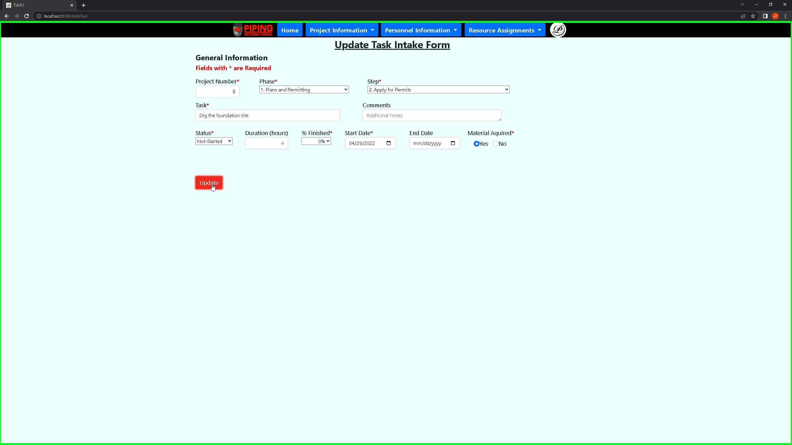 ***Screenshot 63: Once you are satisfied with your changes, you can press on the update button to update the field***

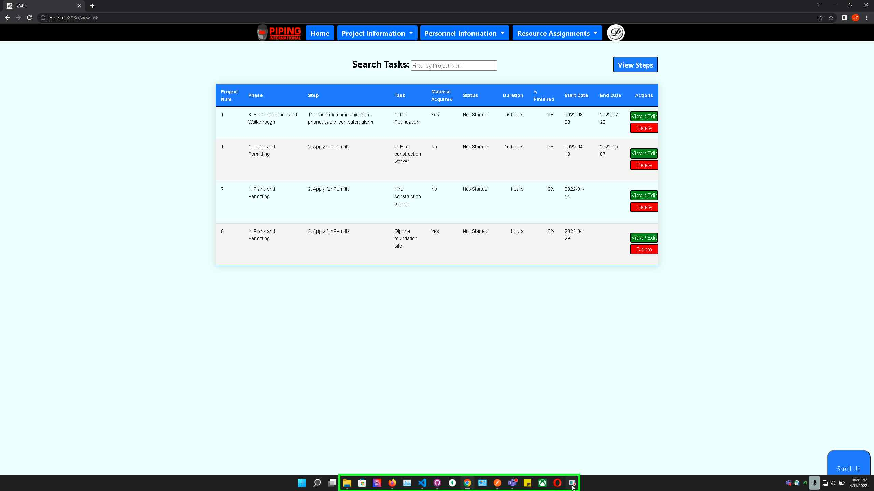 ***Screenshot 64: This will once again return you to the task table where you can see your changes.***

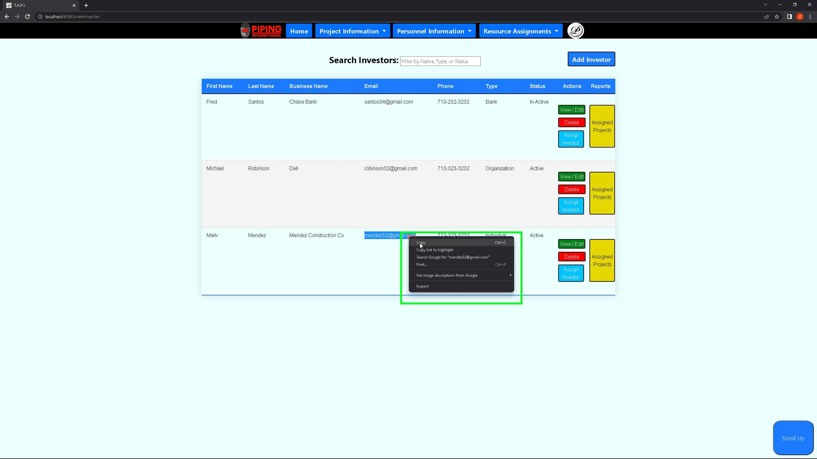***Screenshot 65: If you would like to assign an investor, subcontractor, or employee to a project, you will need to remember the email address associated with them to link their record with the project.***

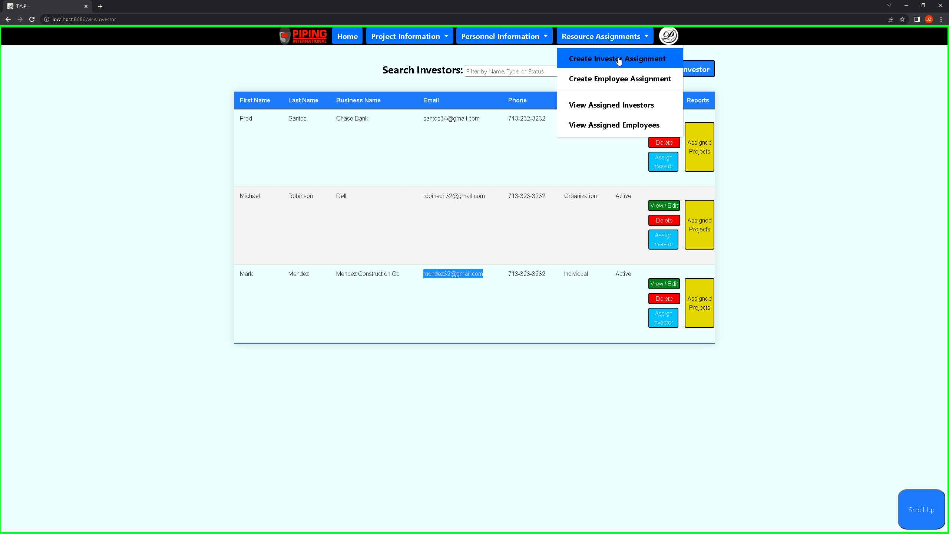 ***Screenshot 66: If you would like to assign an investor a project, you can press on this to create investor assignment, where you will be redirected to an intake form.***

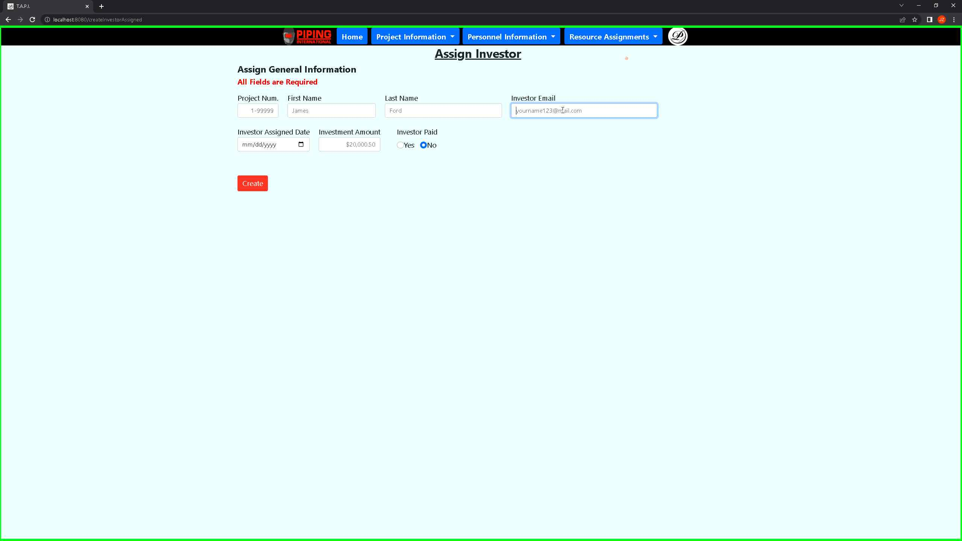 ***Screenshot 67: When assigning an investor, you will have to use the investor email, name, and project number to identify what the investor is from the investors table.***

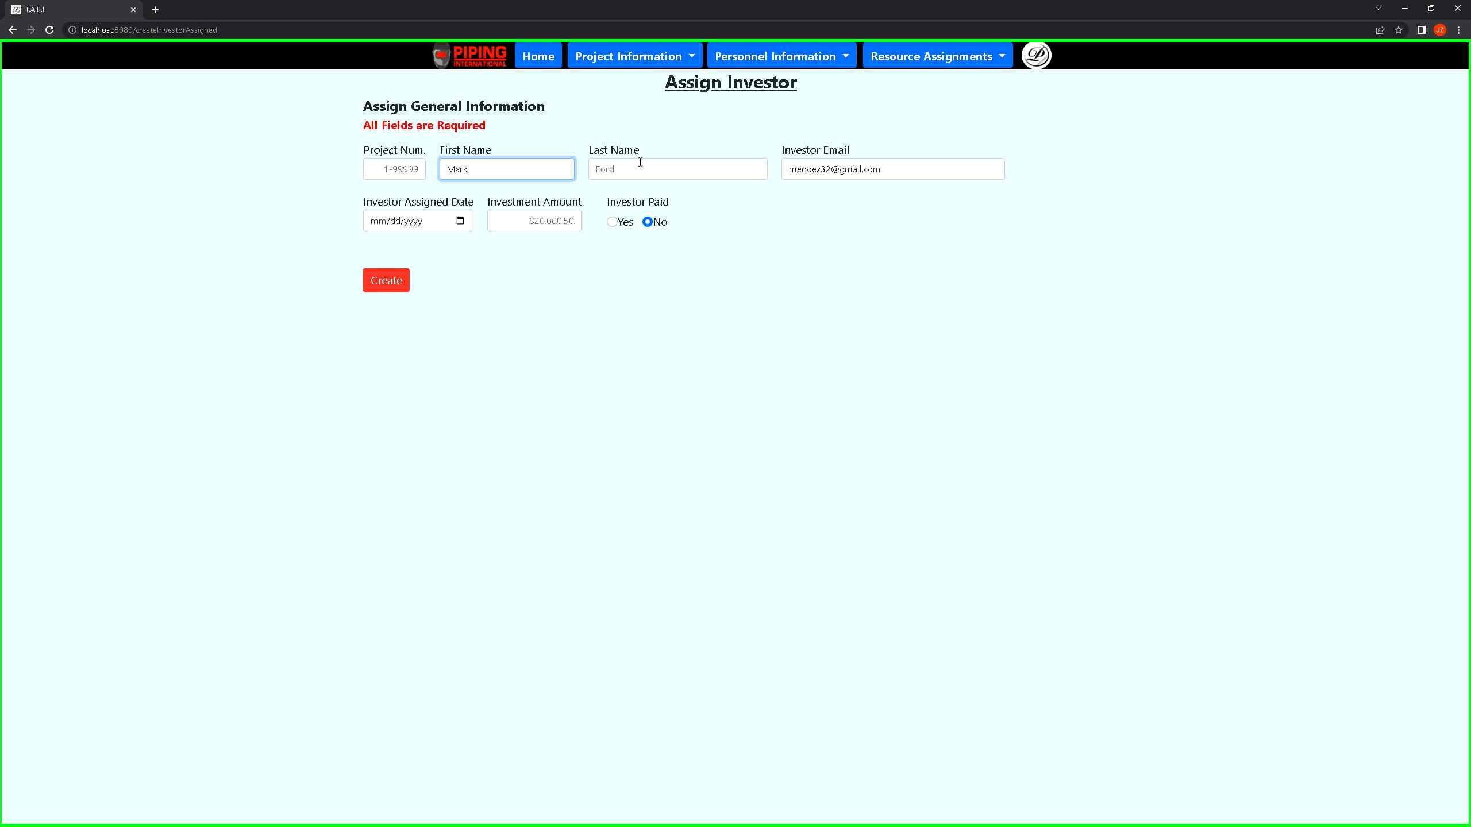***Screenshot 68: Please make sure to add the name and project number for the investor to identify this person to the project itself***

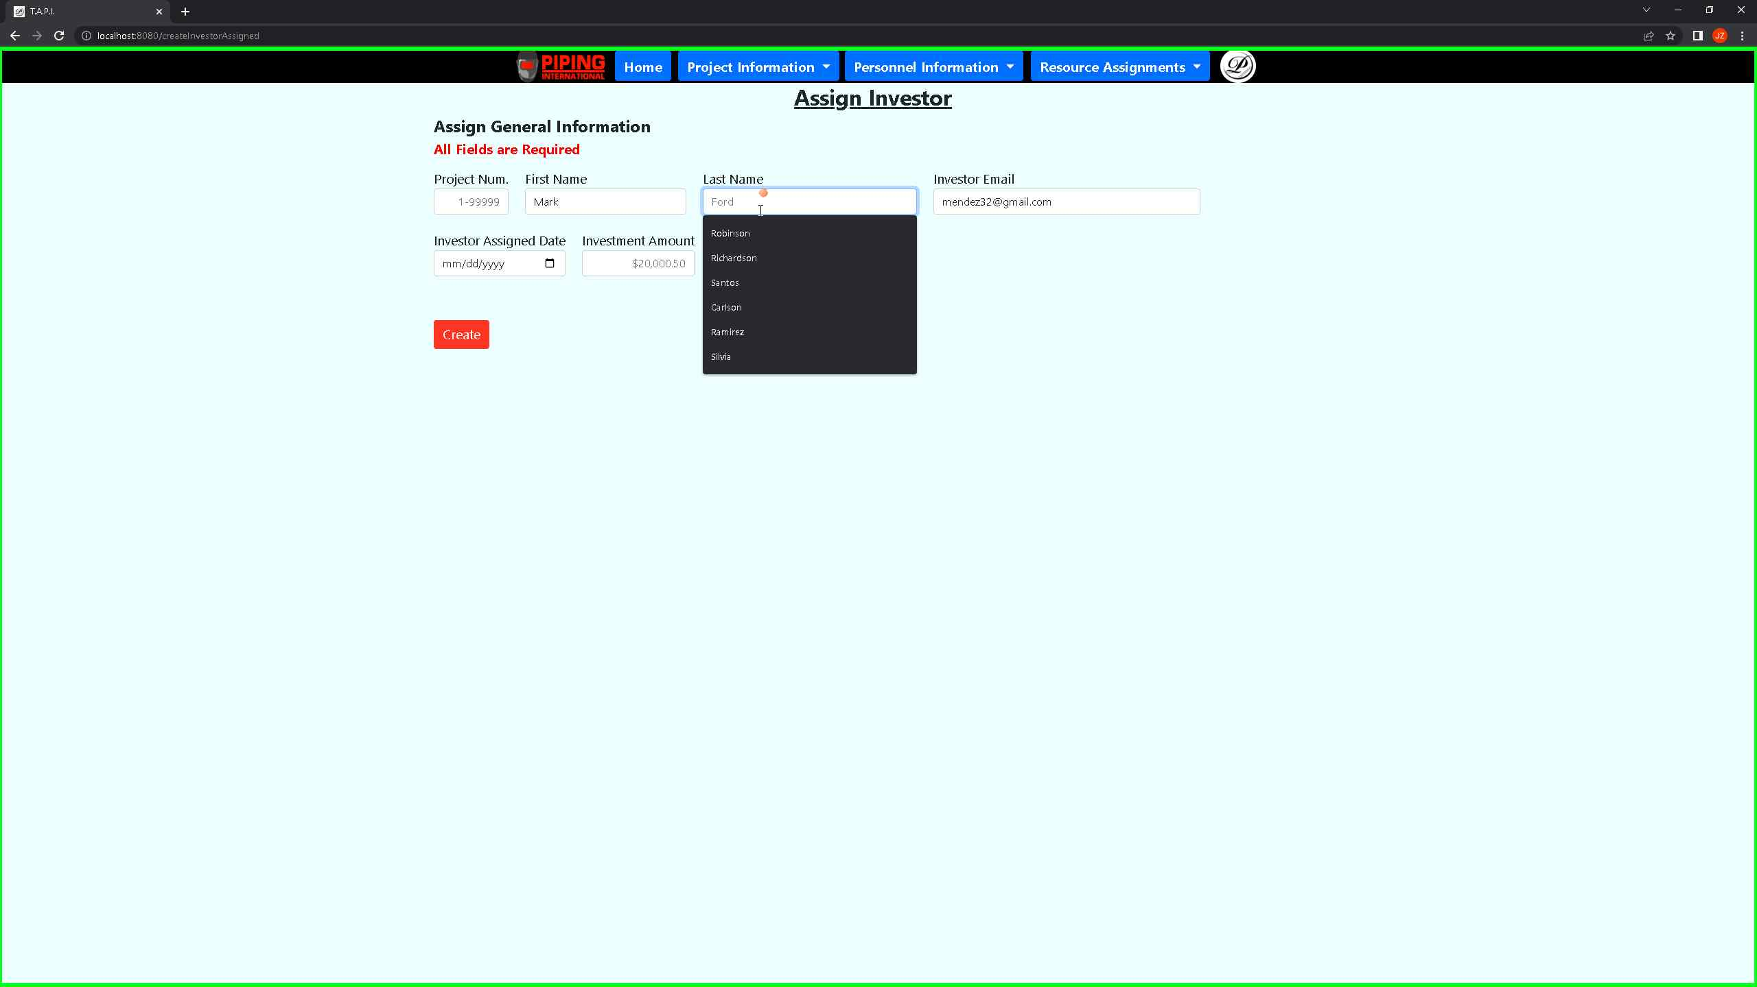 ***Screenshot 69: The last name is optional but will be included in the search field when filtering in the table view.***

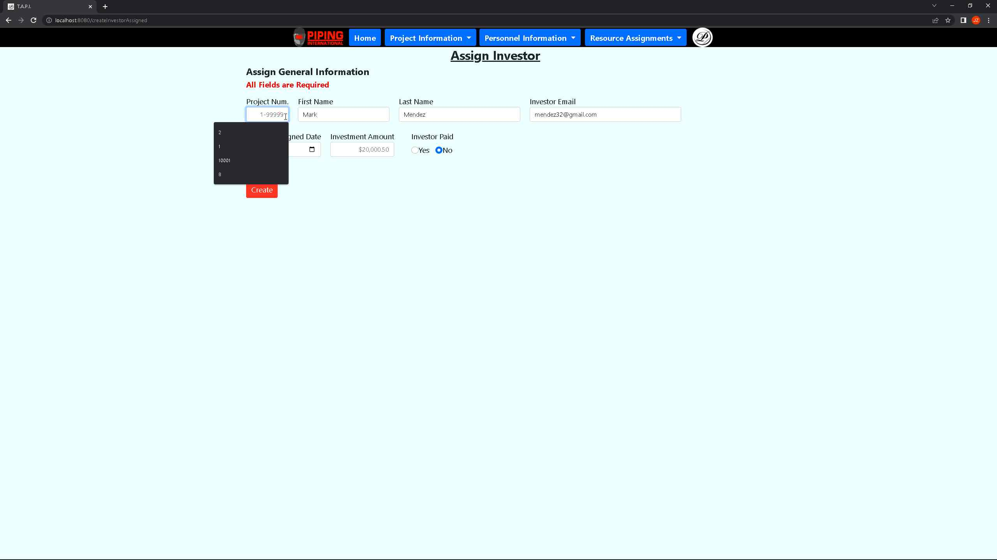 ***Screenshot 70: The project number is necessary to ensure that the reports are linked between the project and the investor***

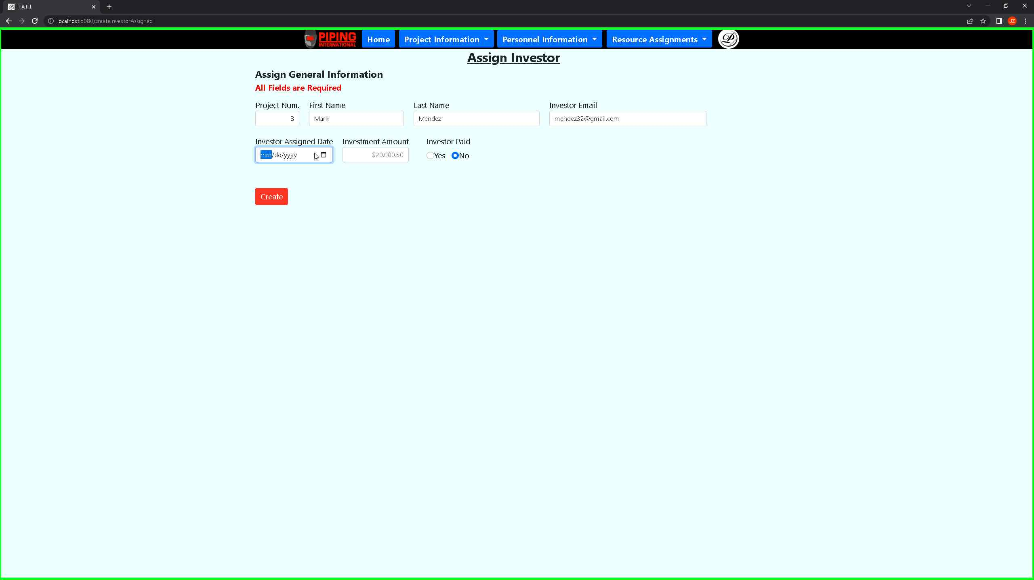***Screenshot 71: It is important that you add the assignment date for this investor to show when they were assigned to the project.***

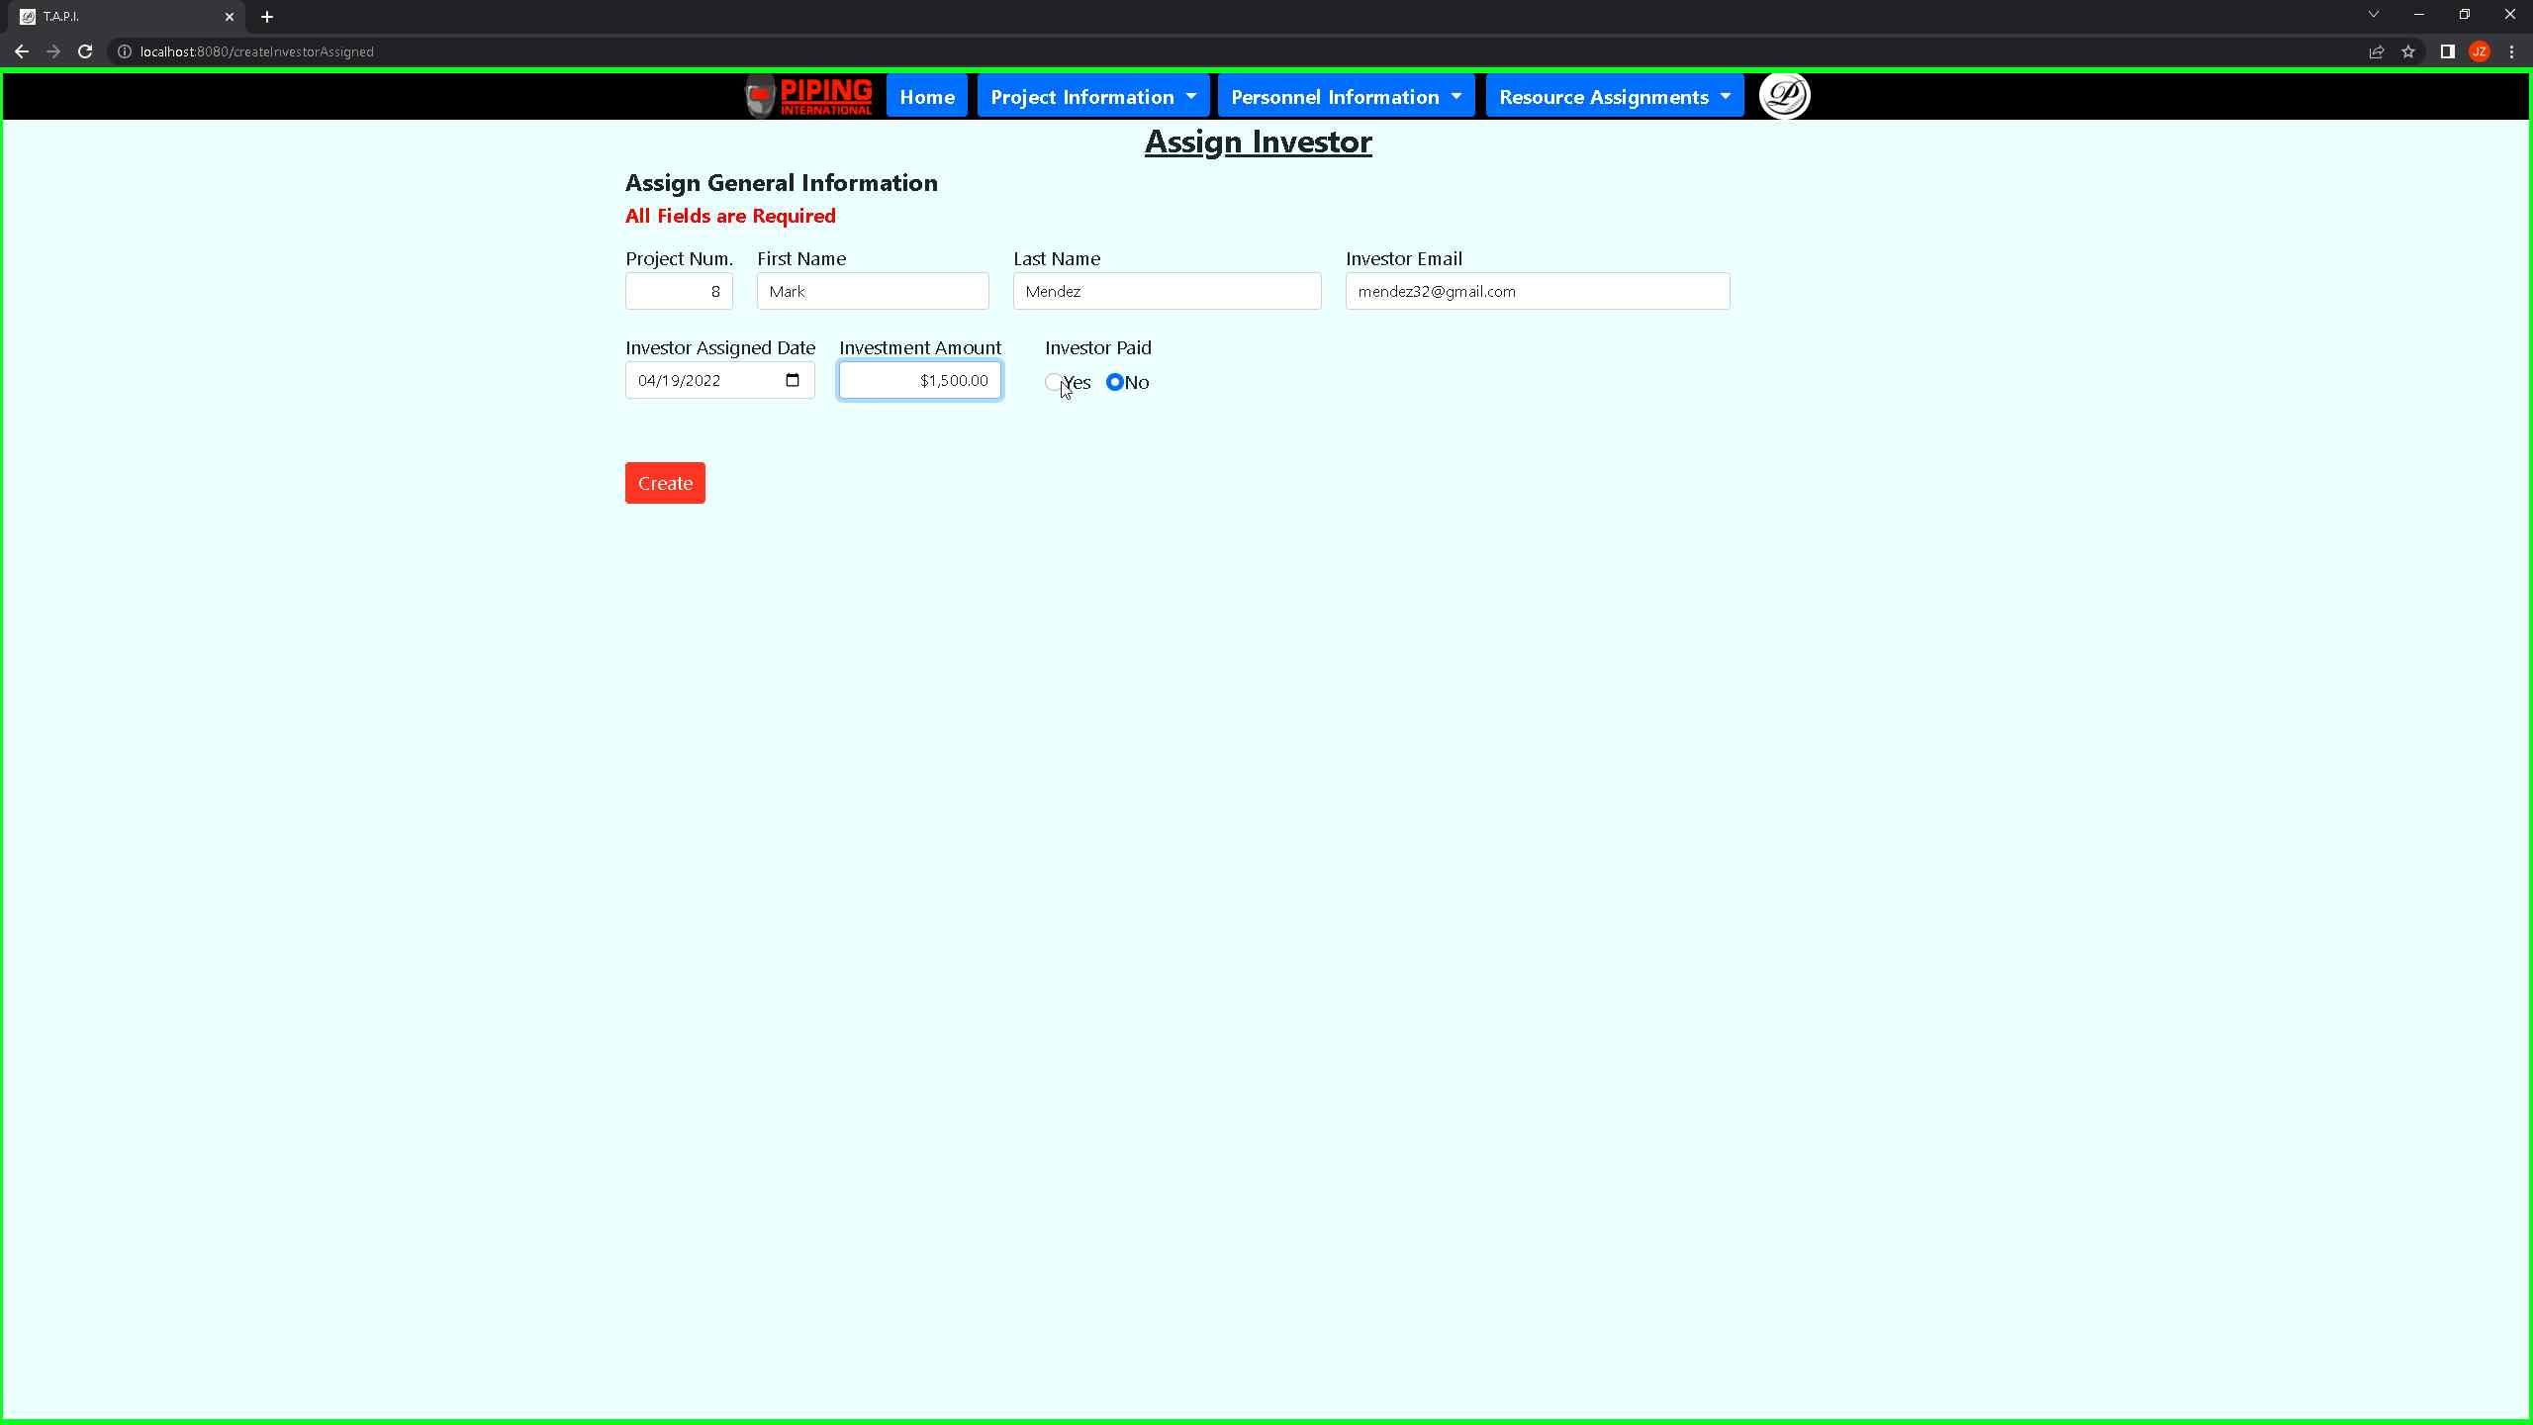***Screenshot 72: You can only pick the investor paid radio buttons if an investor amount is displayed***.

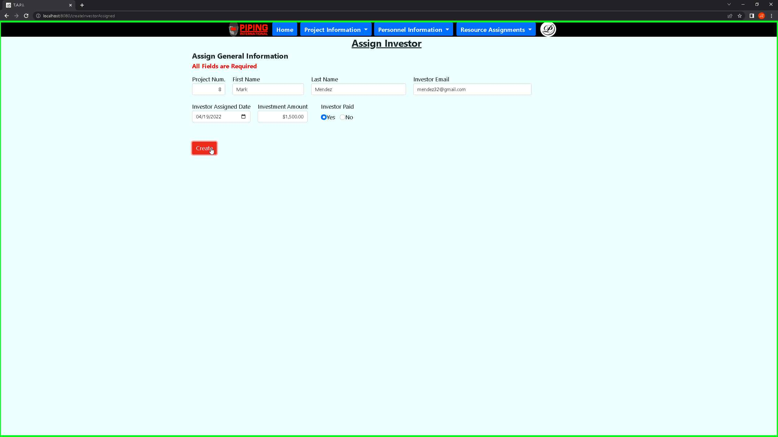 ***Screenshot 73: Once you are satisfied with your changes, you can proceed back to the assigned investors report view.***

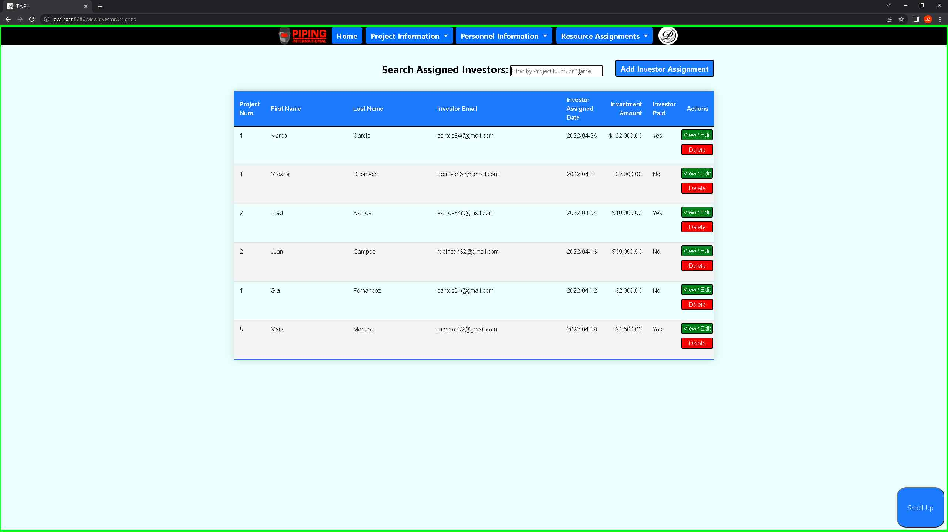***Screenshot 74: You can see your changes from the report above.***

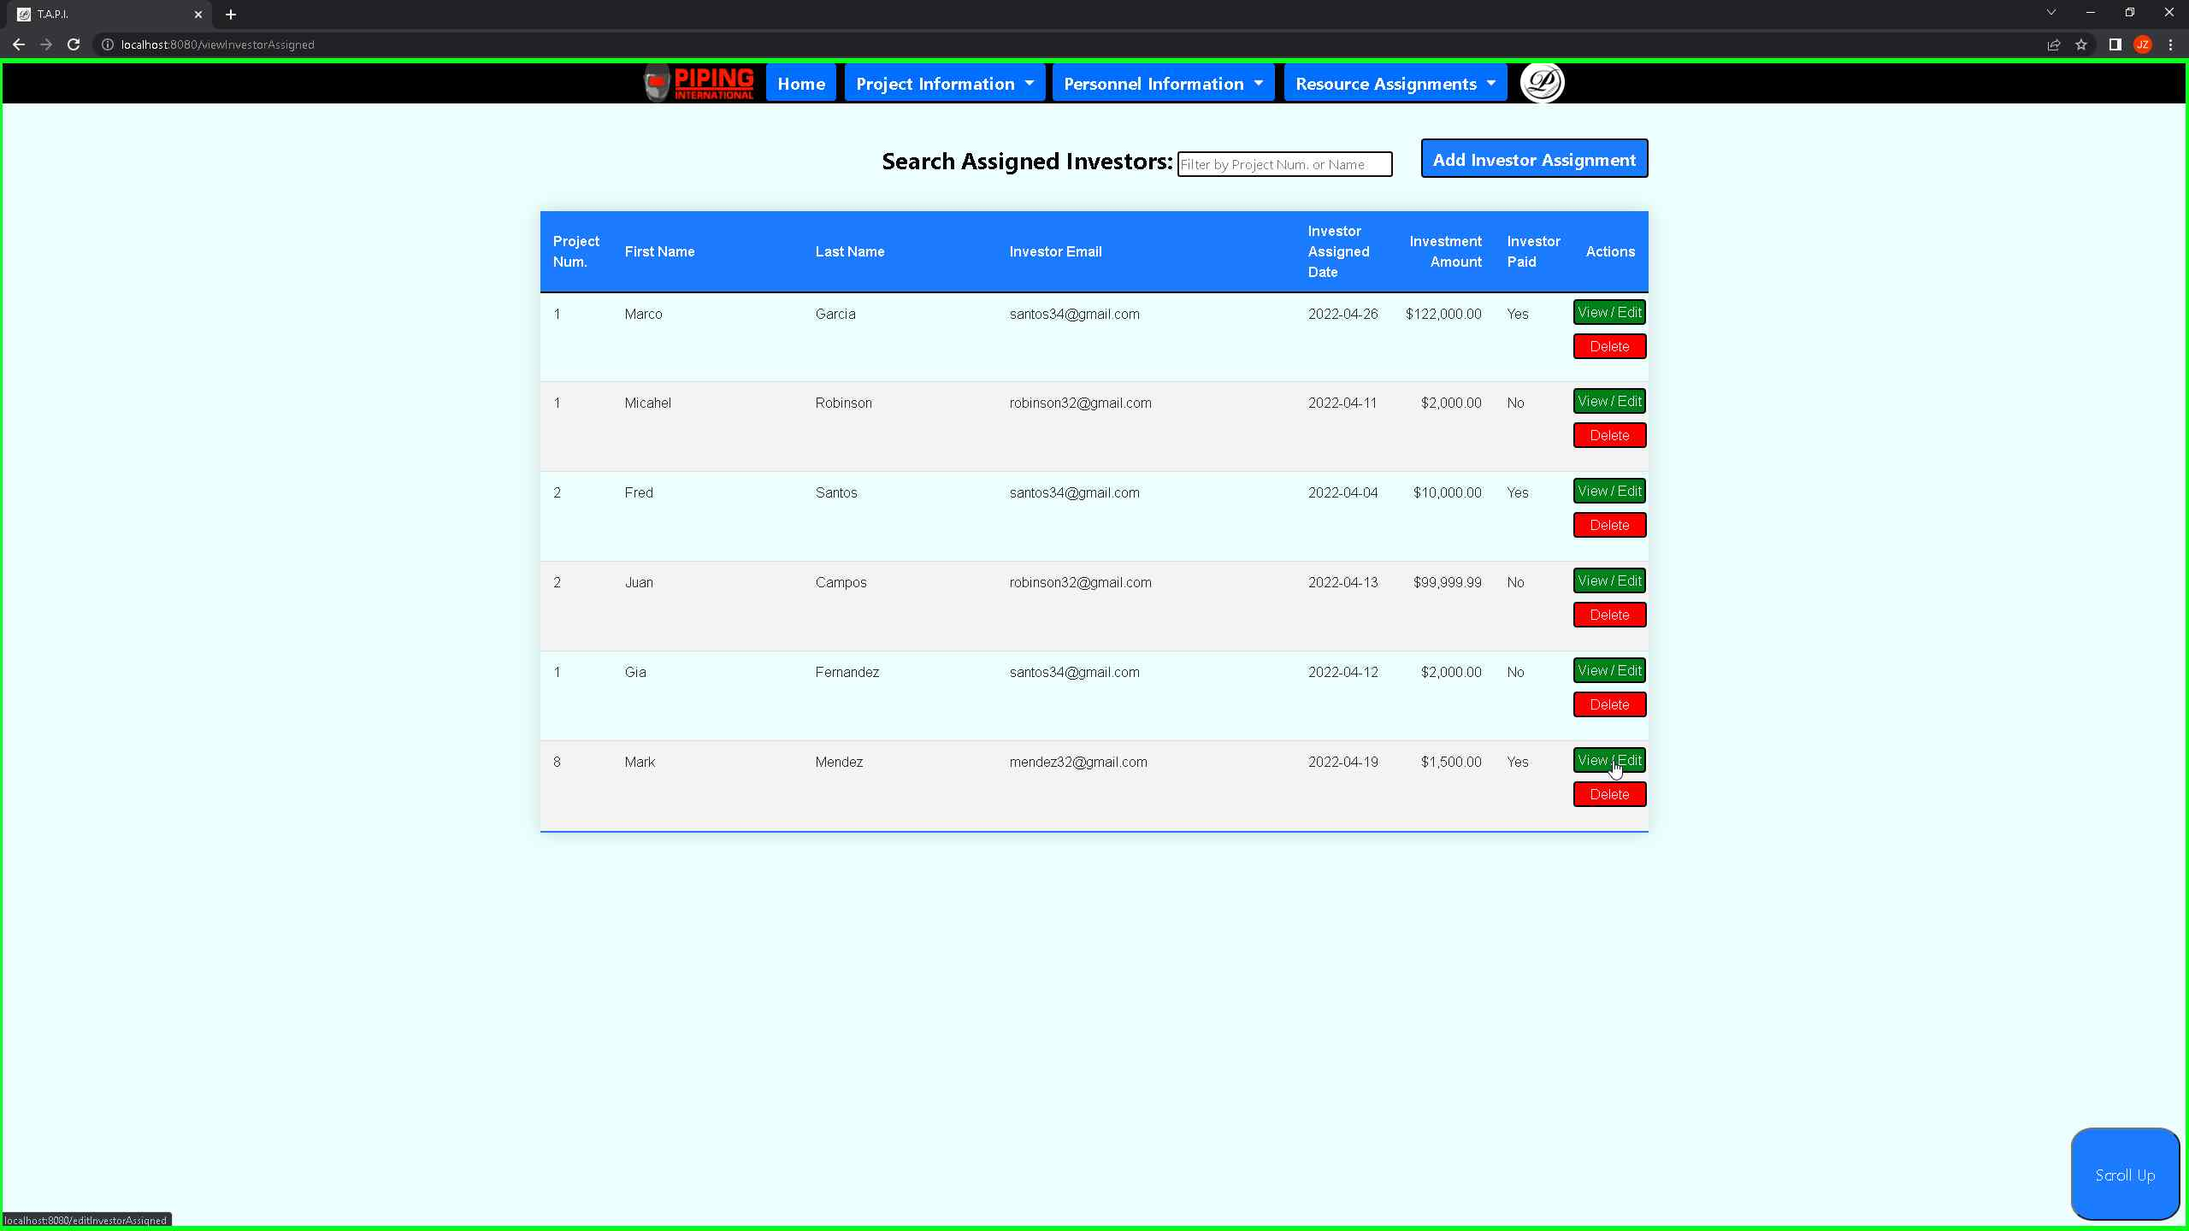 ***Screenshot 75: If you would like to view/edit any of the records, you can press on the view/edit button on any of the records.***

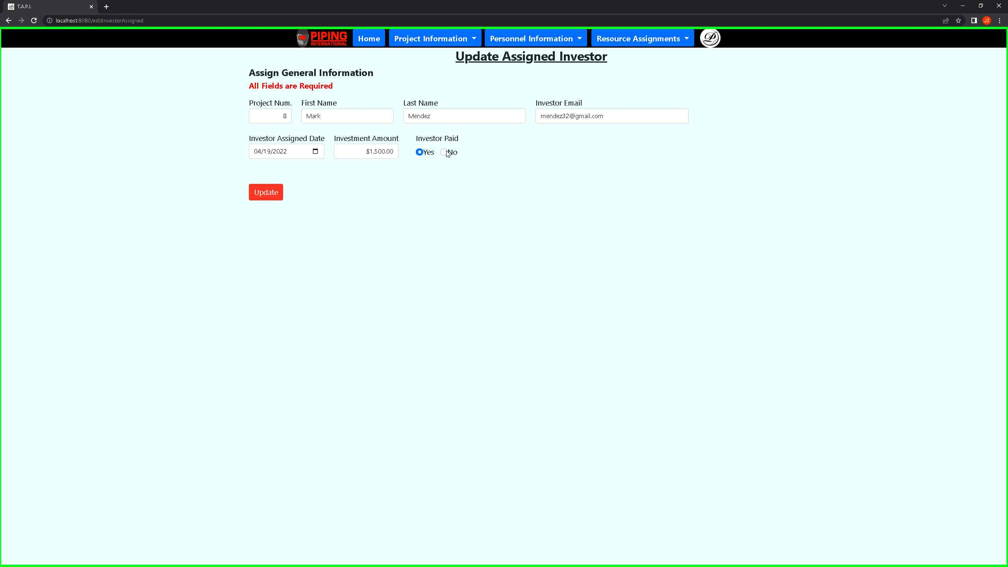 ***Screenshot 76: This will take you back to the intake form where you can then change your data.***

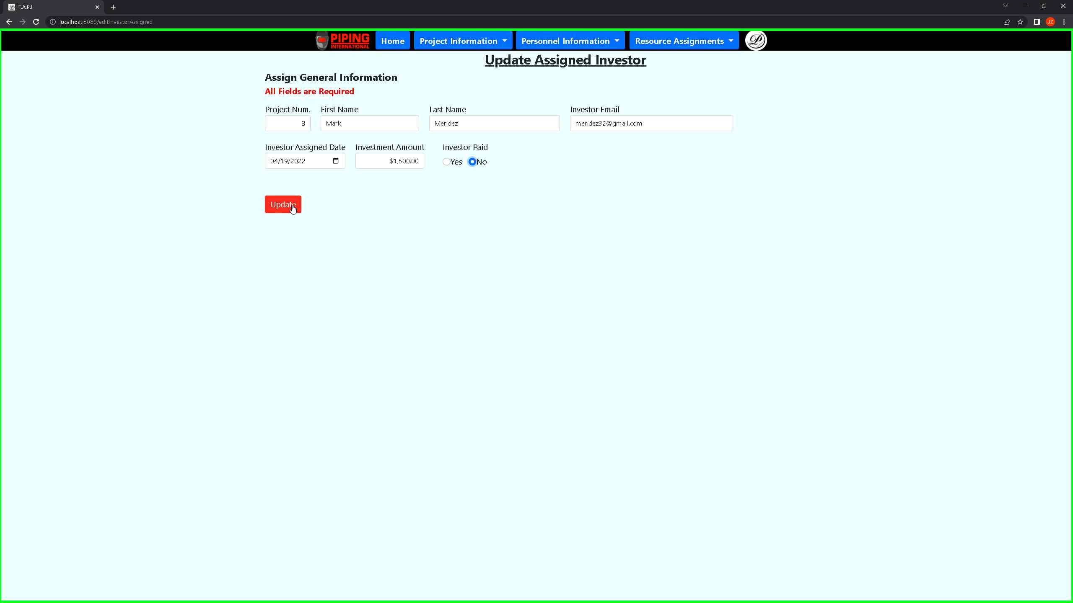 ***Screenshot 77: Once you are satisfied with the changes, you can proceed to the report table again.***

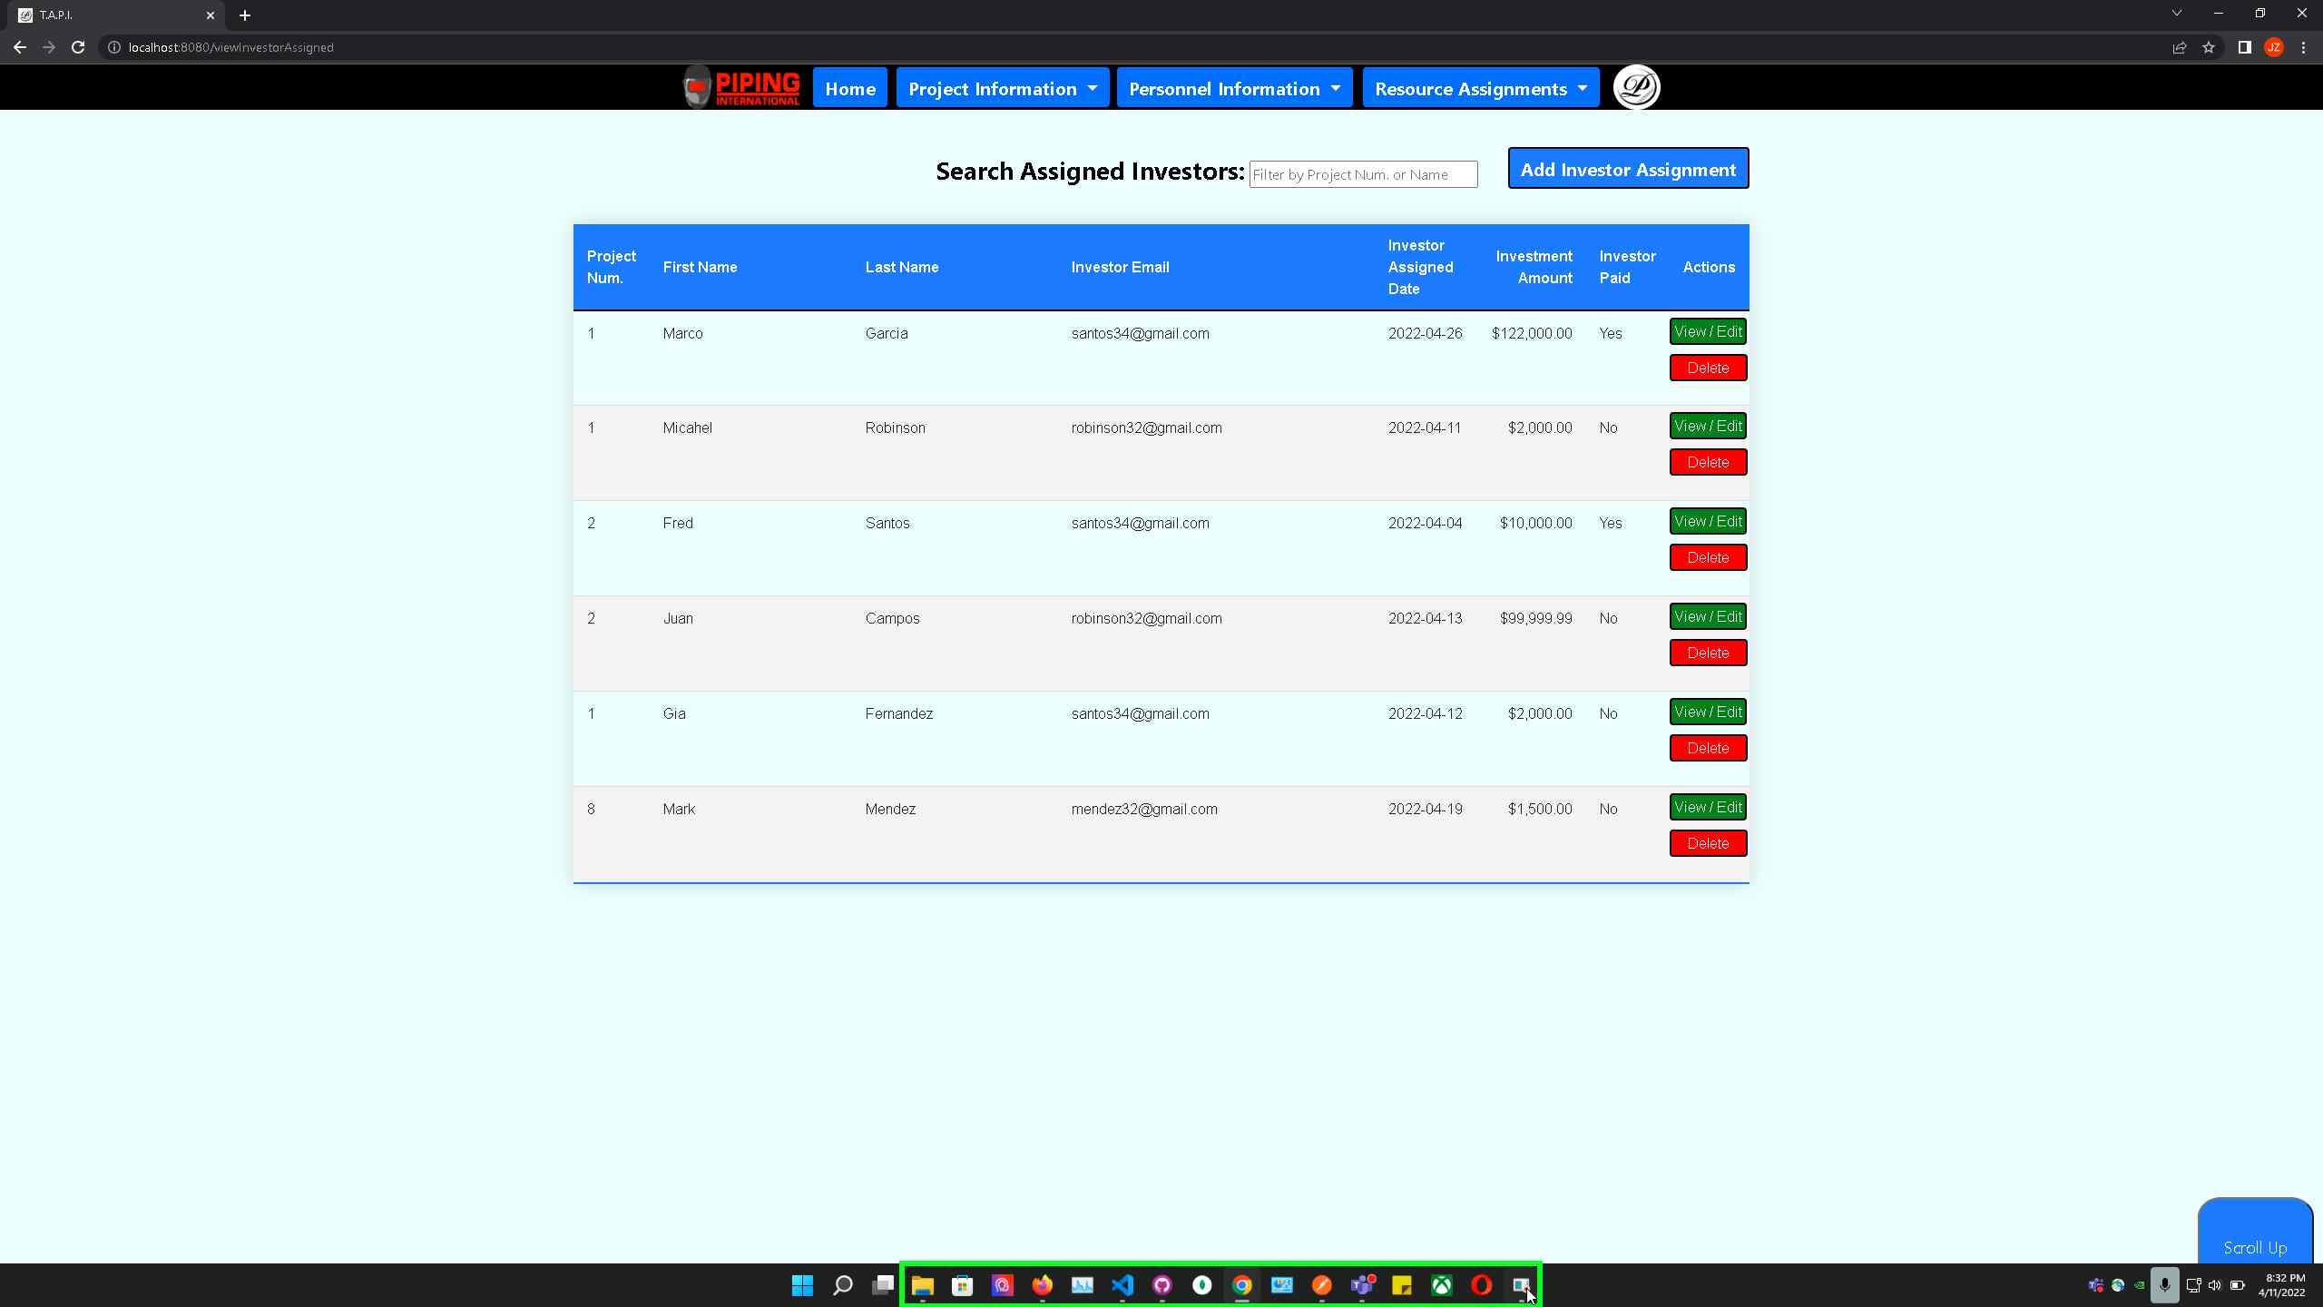 ***Screenshot 78: You will see your updated changes in the report above.***

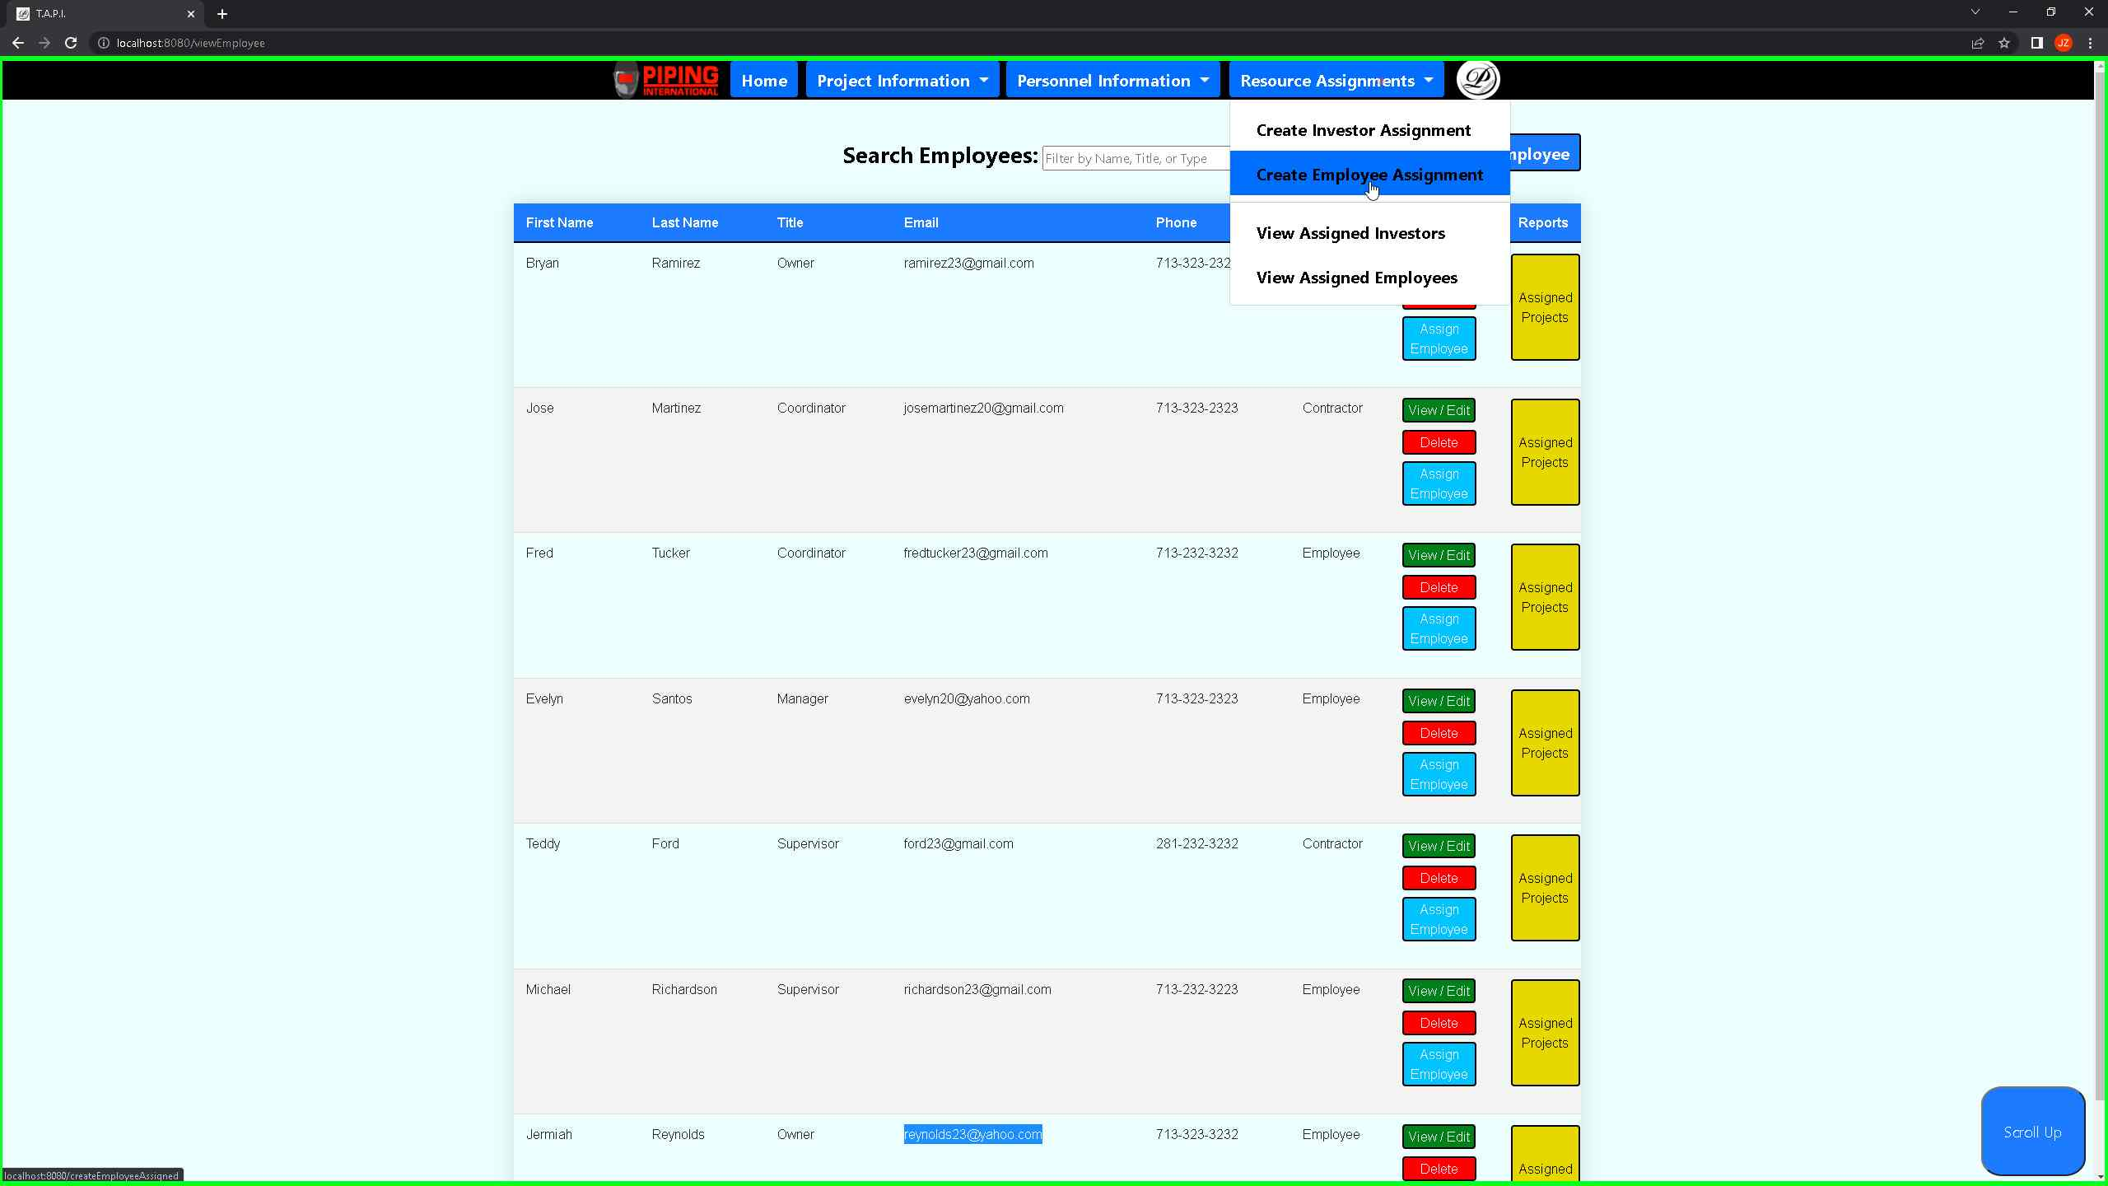***Screenshot 79: If you would like to create an employee assigned to a project, you may do so from the resource assignments > create employee assignment.***

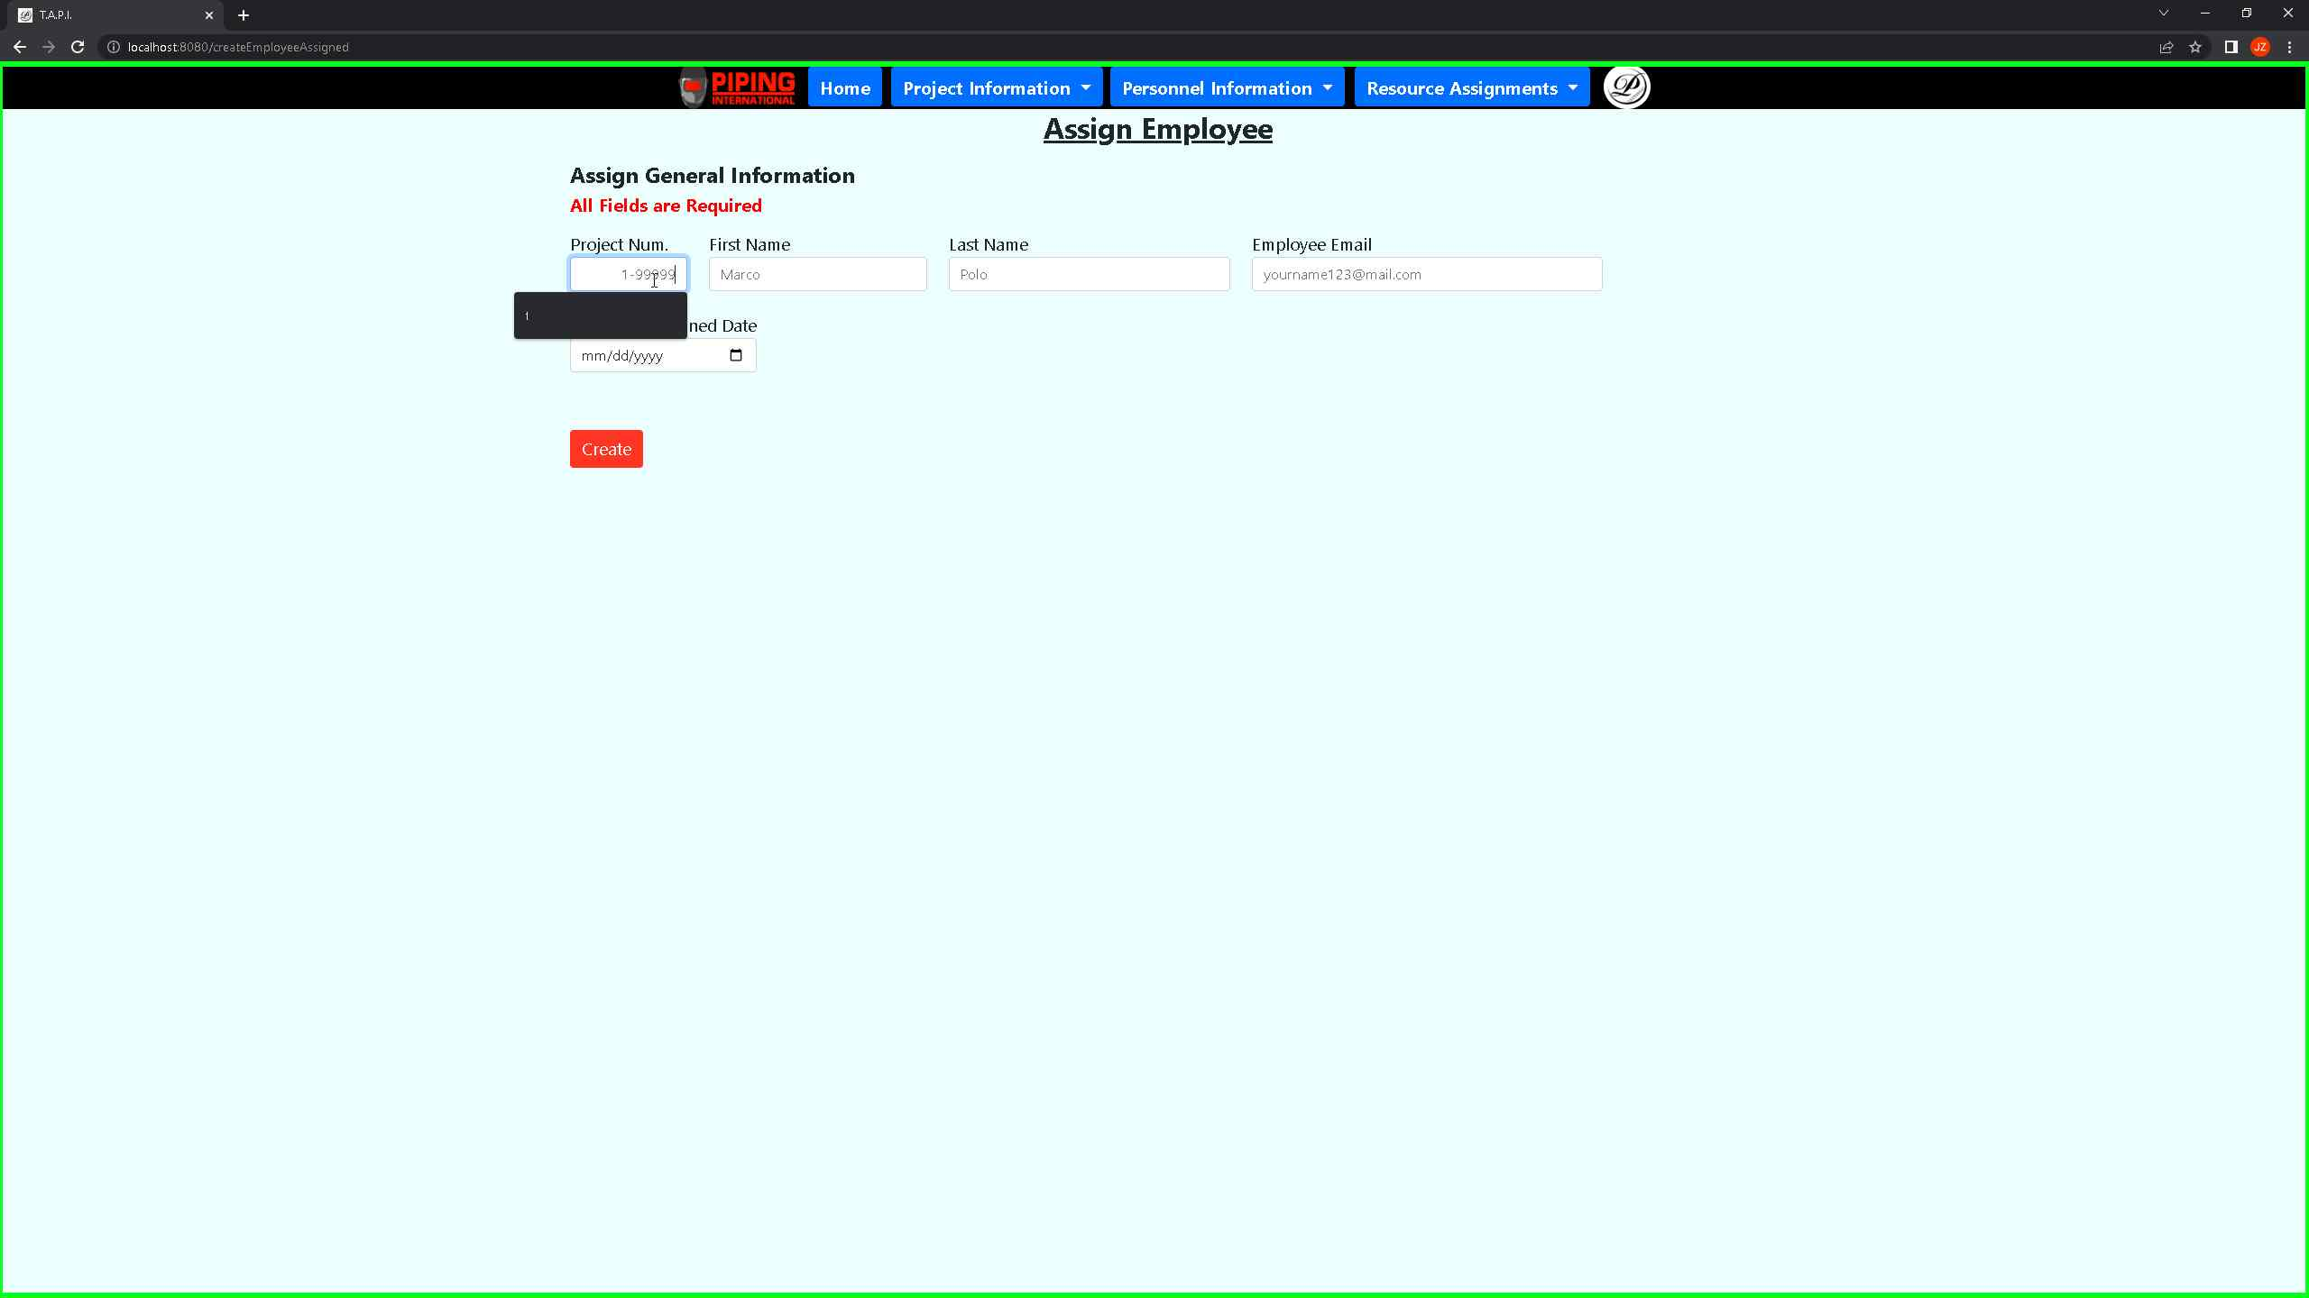 ***Screenshot 80: By entering the assign employee intake form, you may change any of the fields you see fit so that you can generate a new record.***

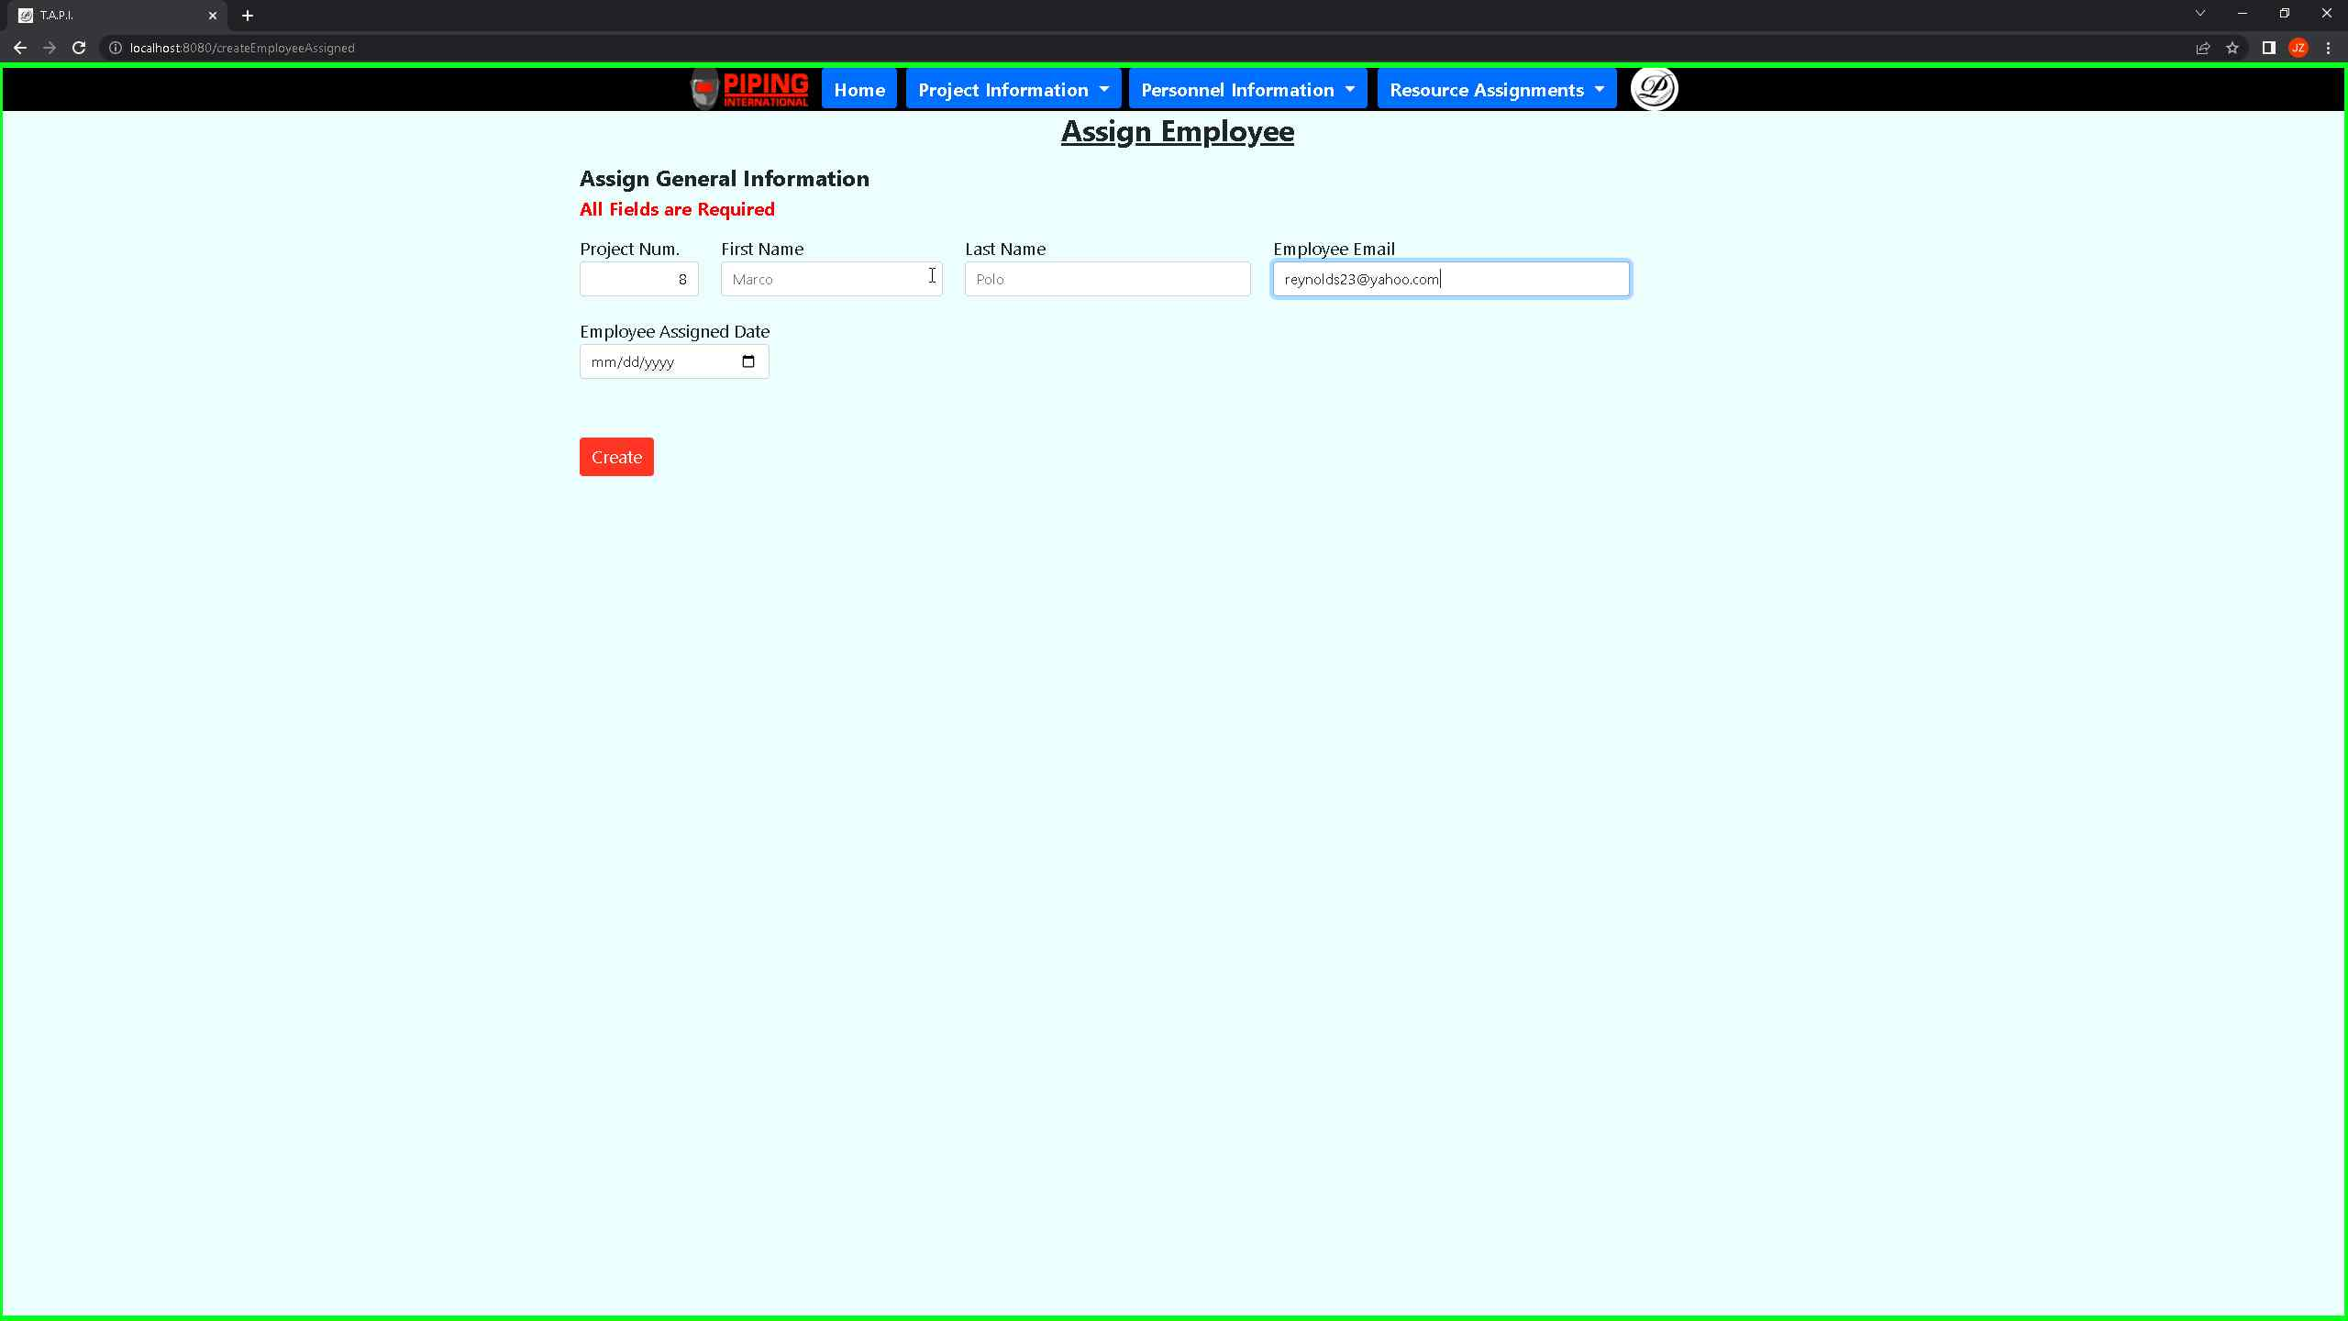***Screenshot 81: It is required to have the employee email when you assign an employee to a project. This ensures data integrity between the two tables.***

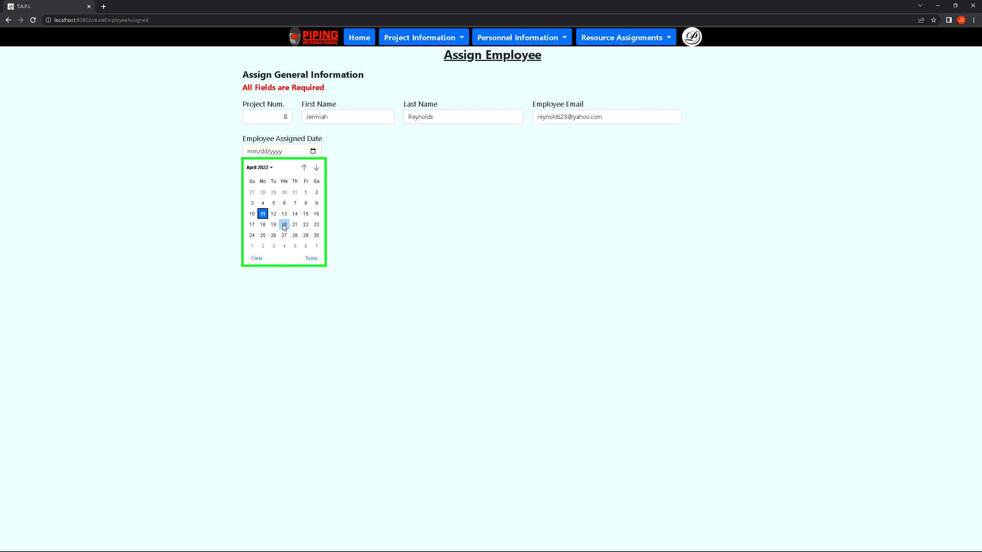 ***Screenshot 82: You will need to identify the employee by their email and the project number so that it can be validated correctly.***

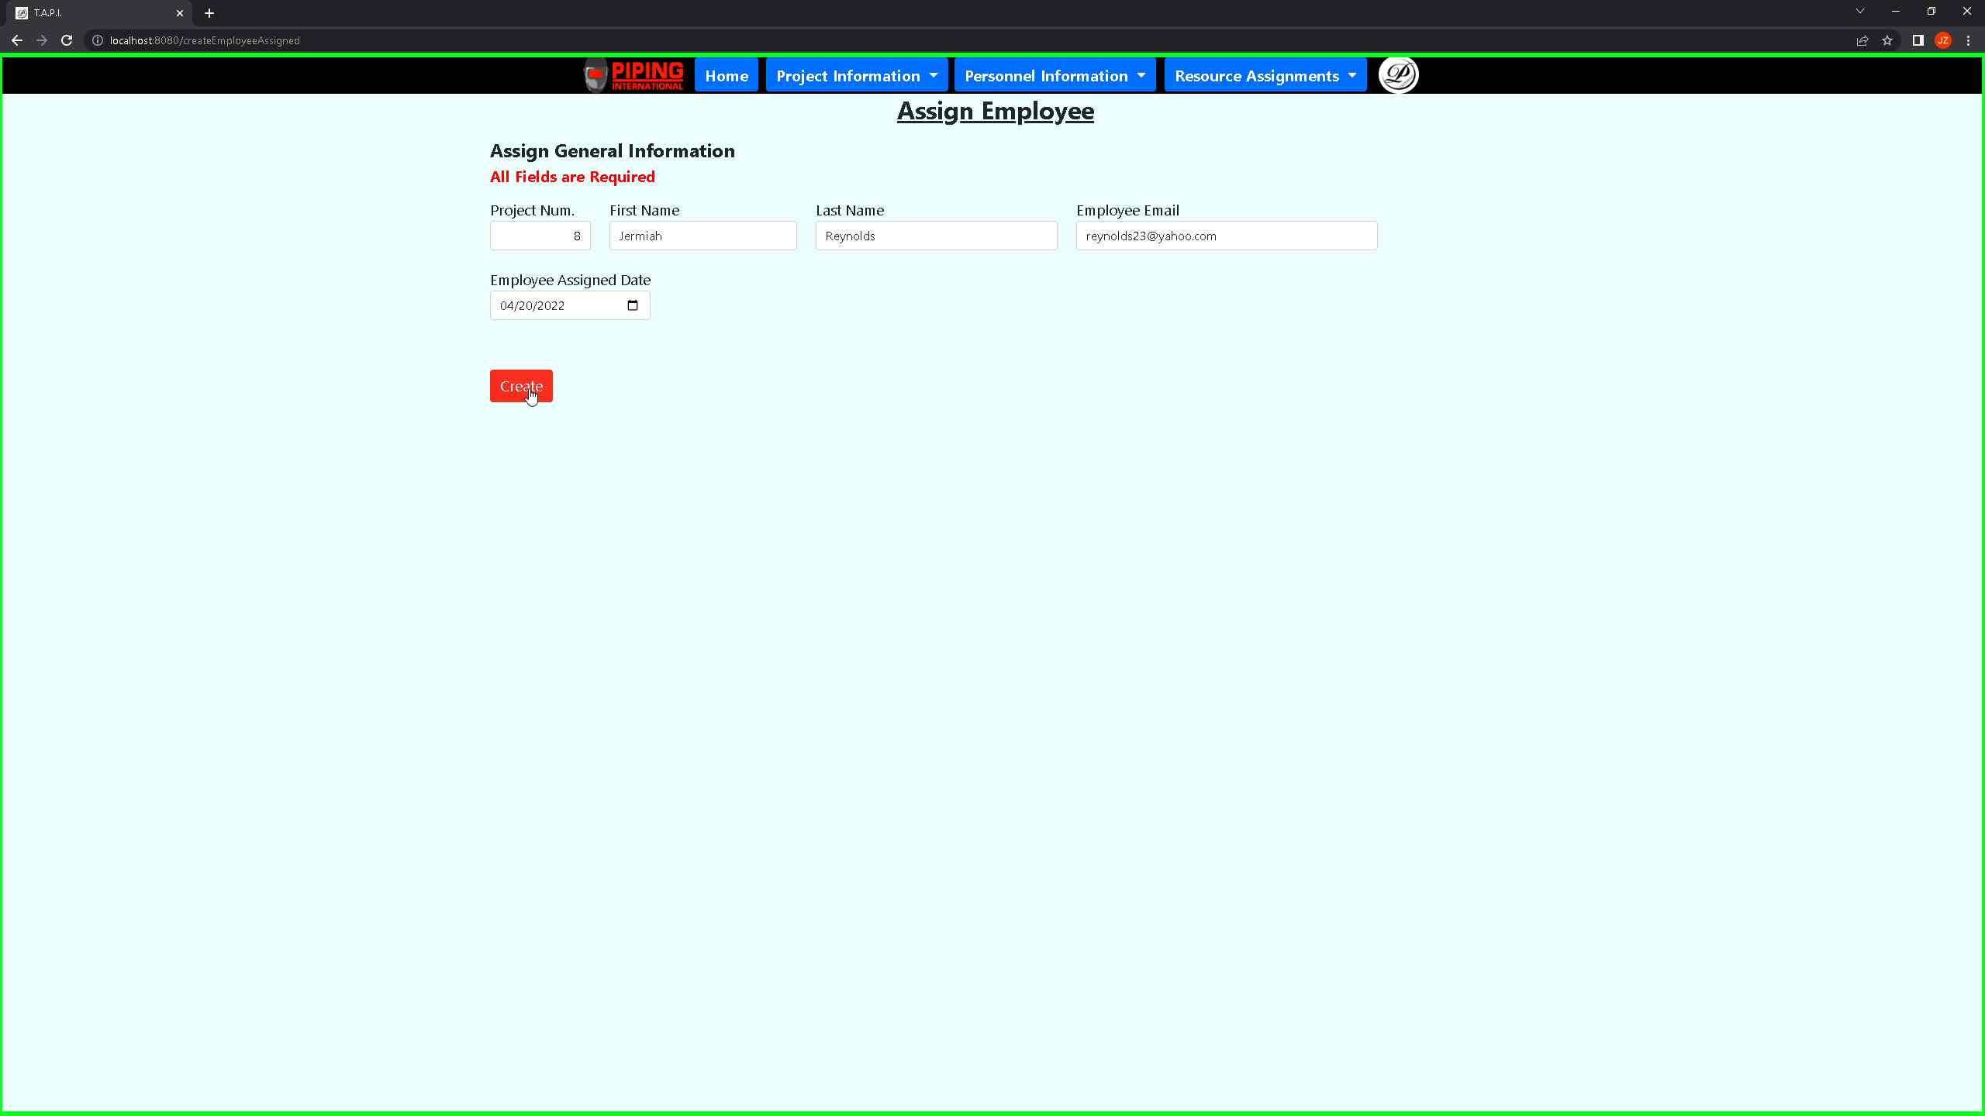***Screenshot 83: Once you are satisfied with the changes, you can press on the button to generate the record***

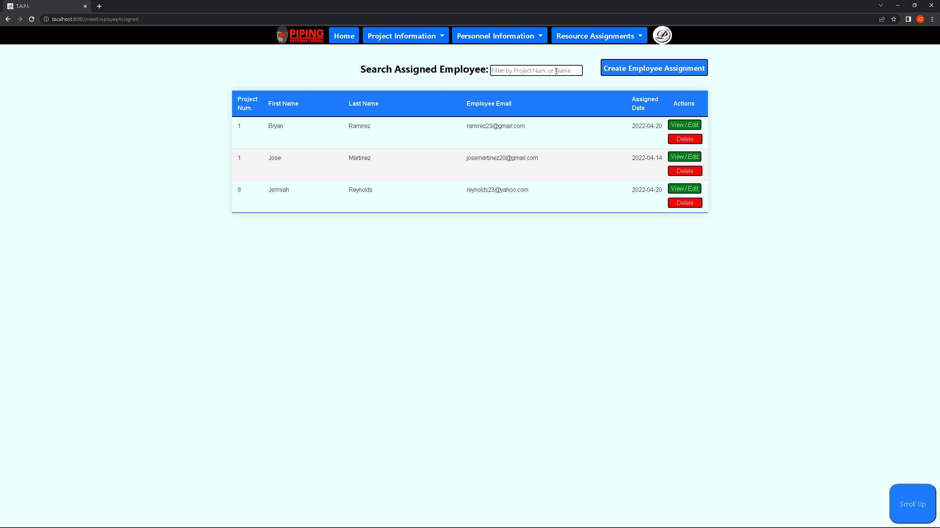 ***Screenshot 84: You will see your record from the report above.***

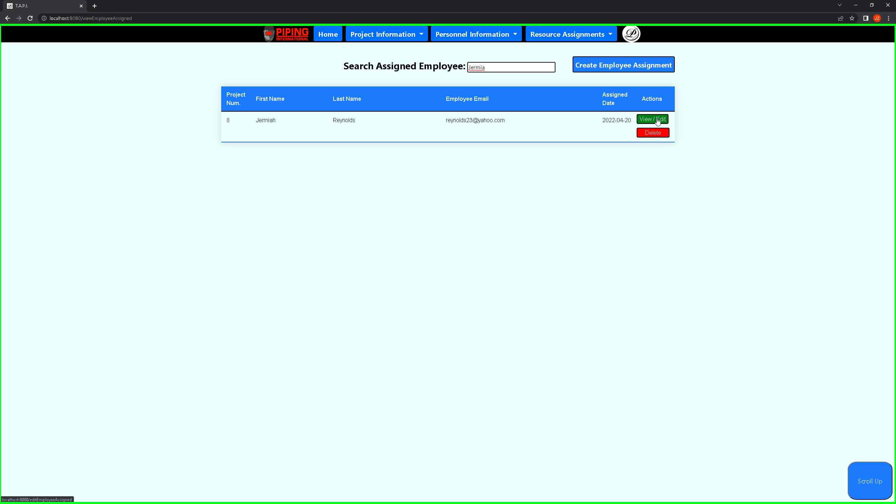 ***Screenshot 85: You can also search for an employee by their name or project number. If you would like to change an existing record, you can press on the view/edit button to update its values.***

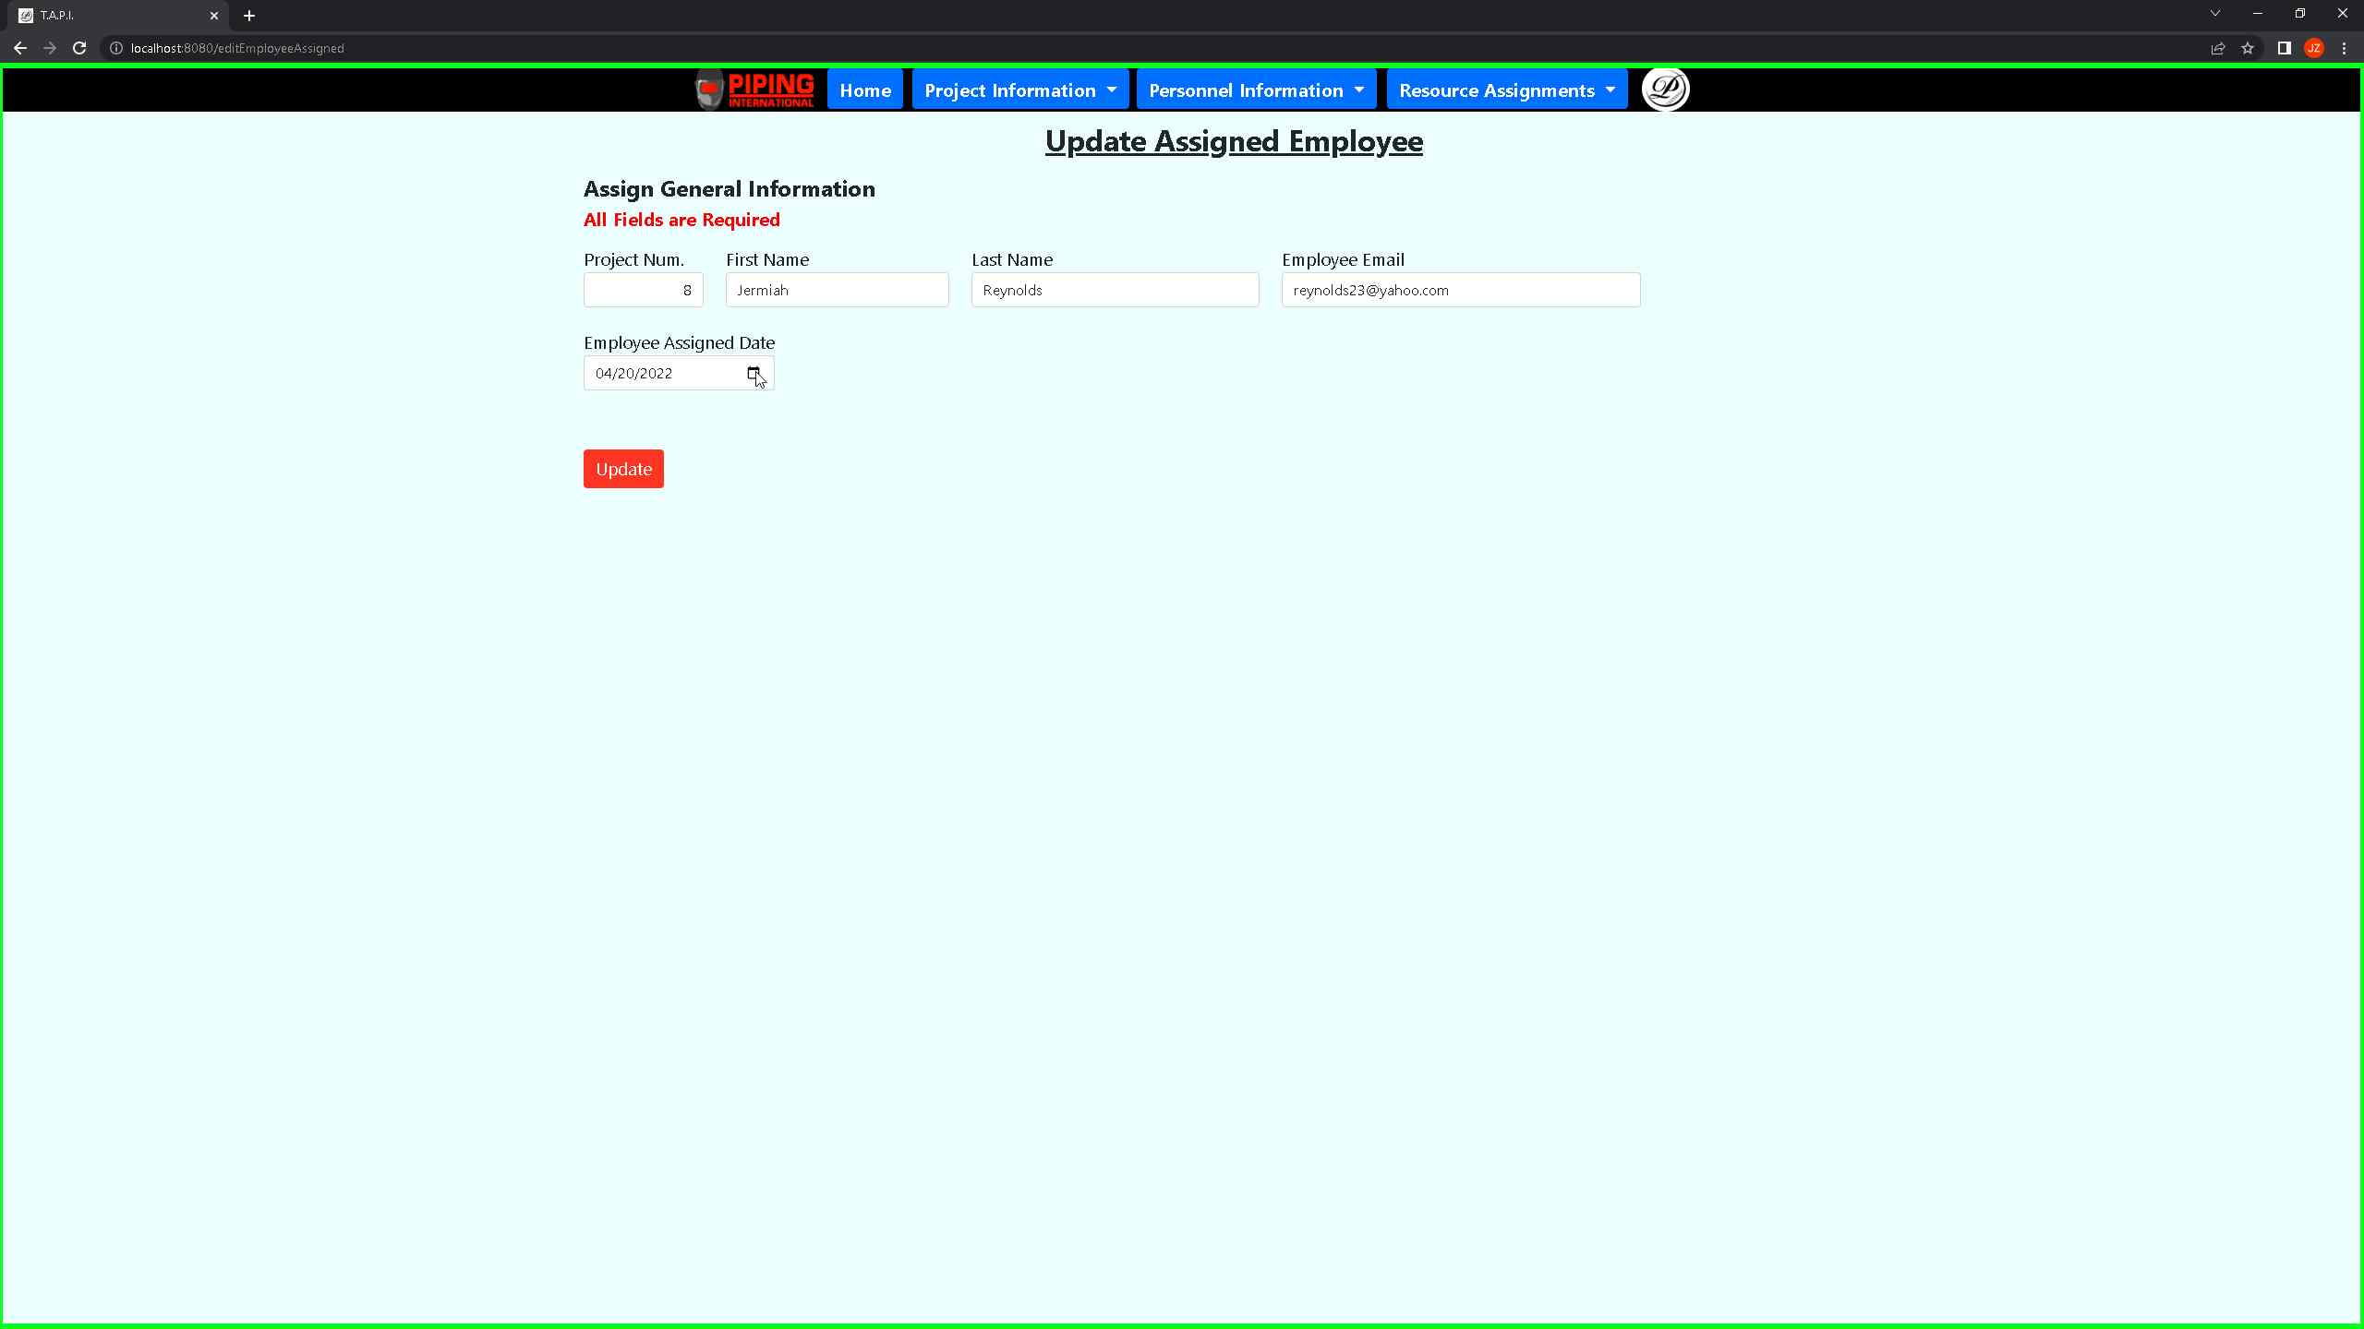 ***Screenshot 86: You will be taken to the update intake form which will help you change your record again.***

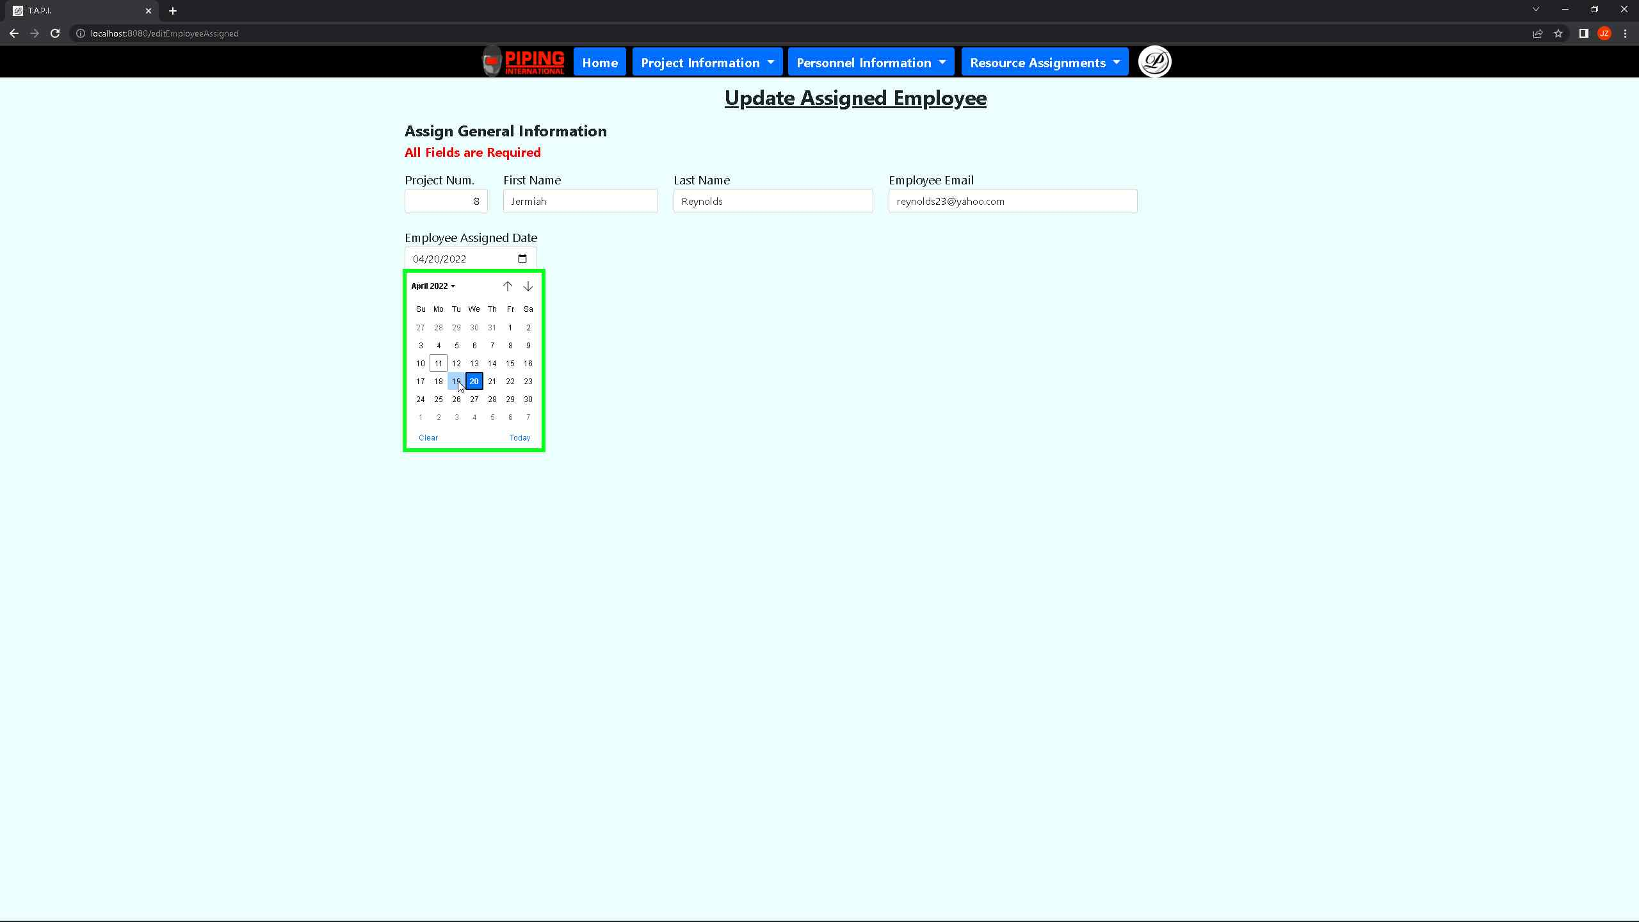 ***Screenshot 87: The employee assigned date must be used to show when the employee was assigned to the project.***

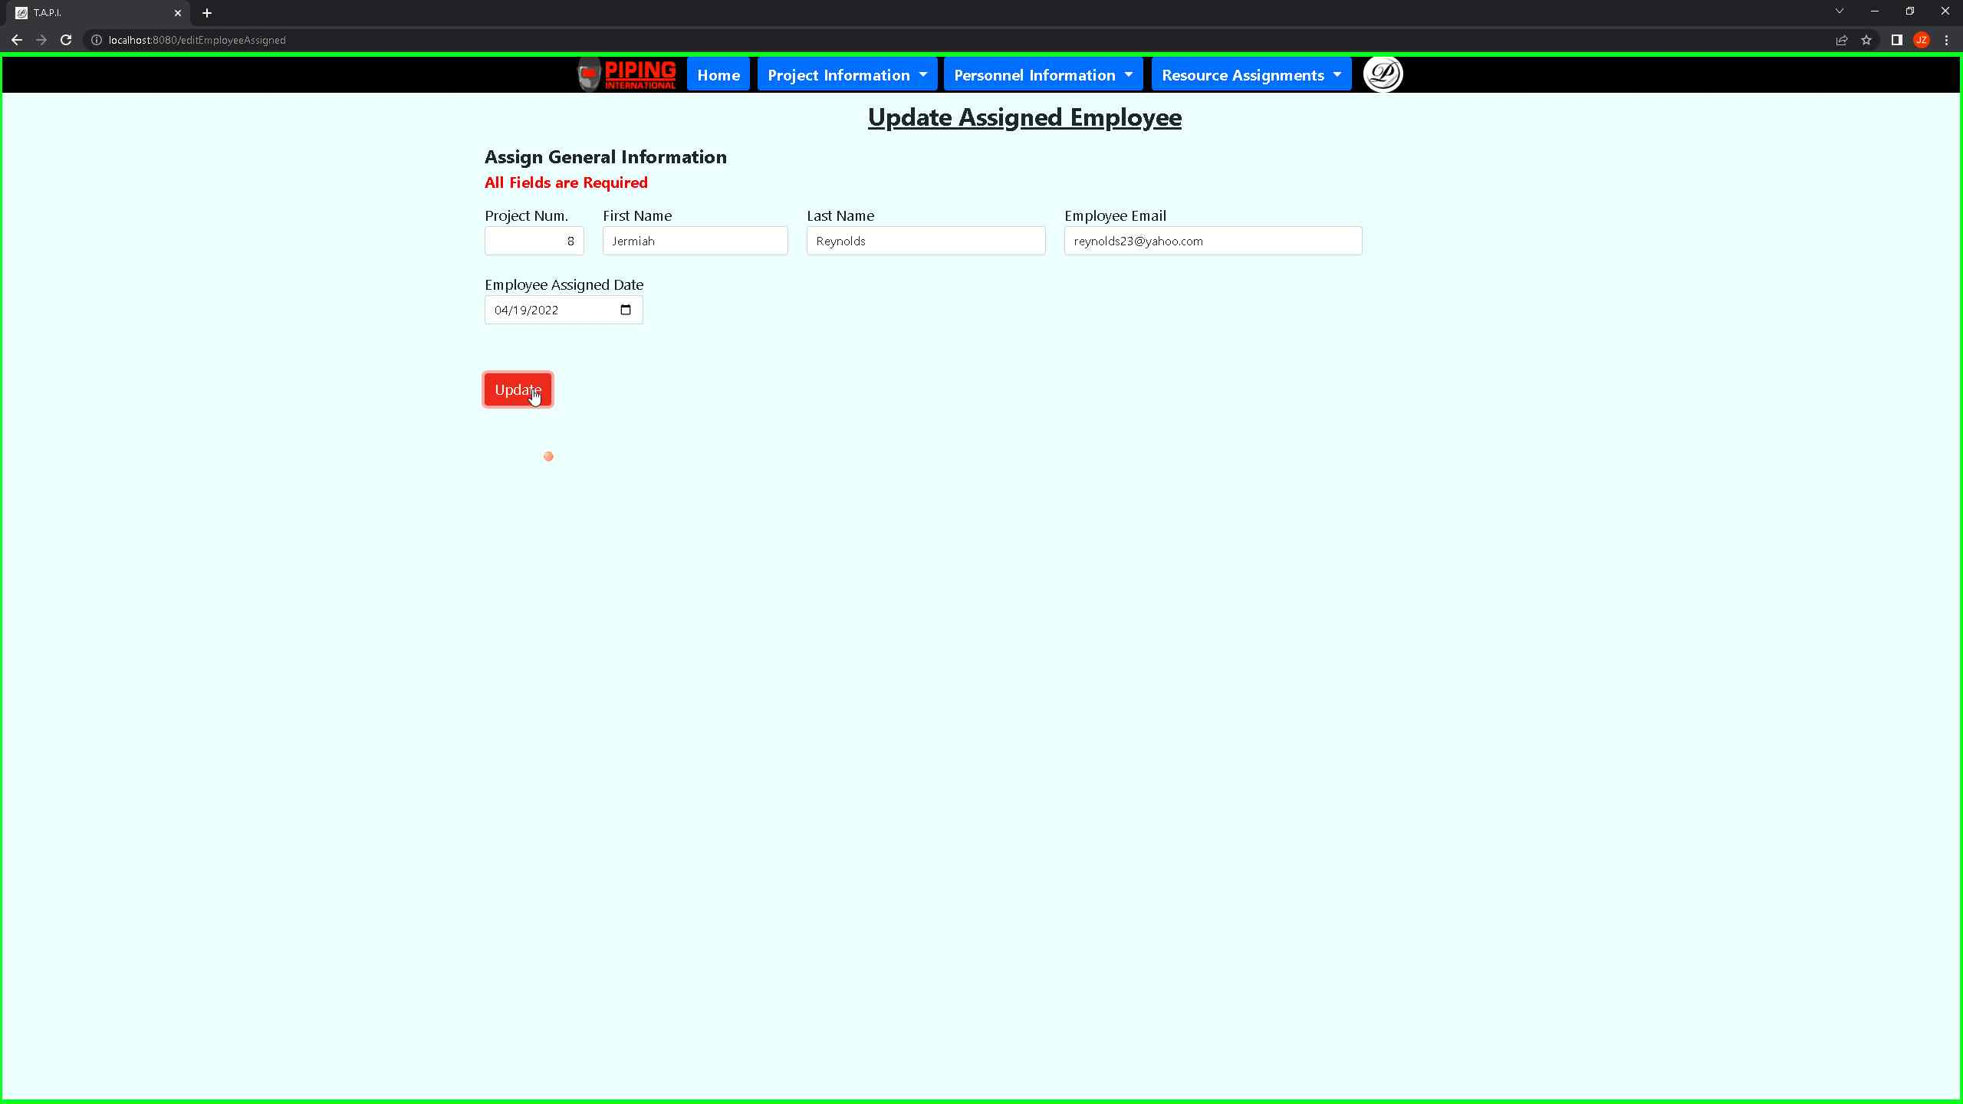 ***Screenshot 88: Once you are satisfied with the changes, you can update your record by pressing the update button.***

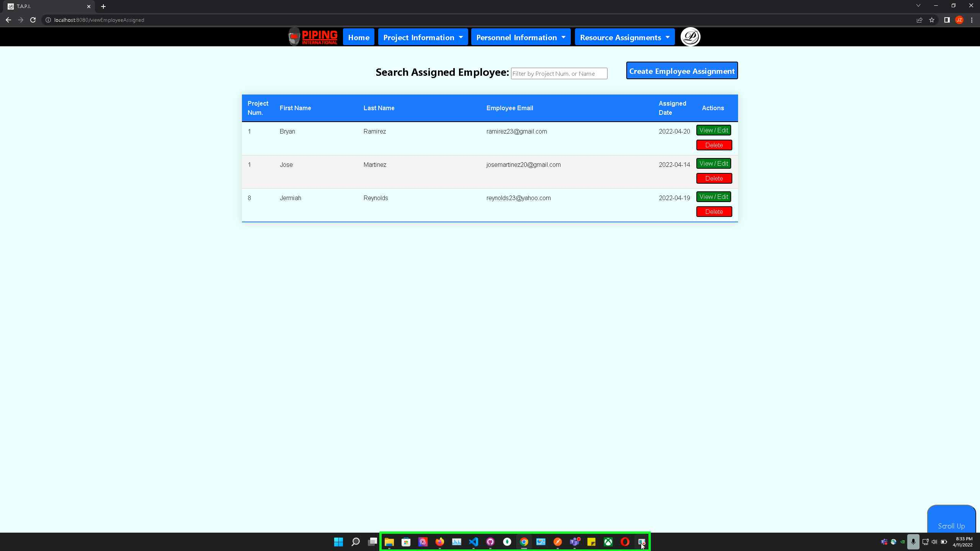 ***Screenshot 89: Your updated record will show on the report above.***